BEASLEY PRUITT - HIS DESCENDANTS

By Richard A. Prewitt

2007

PRUITT

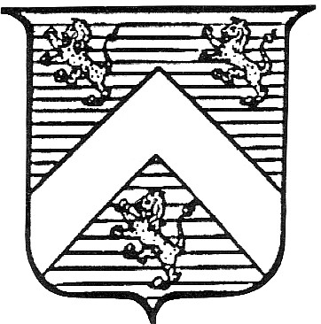

Some say the family was an armorial family and bore arms: “Azure a Chevron between three lions rampant Or”. A sky blue shield with the chevron and lions in gold. The motto means: “Loyal and Trustworthy.
The fighting man of the middle ages wore a suit of armor for protection. Since this suit of armor included a helmet that completely covered the head, a knight in full battle dress was unrecognizable. To prevent friend from attacking friend during the heat of battle, it became necessary for each knight to somehow identify himself. Many knights accomplished this by painting colorful patterns on their battle shields. It is impossible to date with any precision the time when coats of arms were first used, but it is generally agreed that heraldry originated in western Europe in the 12th century.
The name, PRUITT, is spelled variously: Pruett, Prewet, Prewitt, etc., all thought to be derived from the Anglo-Saxon word “pryte”, the meaning of which was: that of which is justly proud, self respect, etc.. Bardsley’s book gives the etymology of Pruett as coming from Anglo-Saxon “prut”, meaning: haughty or arrogant. It is interesting to note that in both England and America, the name is pronounced the same (Pru-itt) no matter how it is spelled.

Some branches of the family believe the family originates with the French Huguenots. The Huguenot movement had their first national council in France in 1559. However records of the family have been found in England as early as the 13th century.
In England in 1202, Mathew Pruet was listed in the “Pipe Rolls” (P.H. Reney, Dict. Of British Sur-names, London, 1958, p. 259). In 1249, It was found that William Pruwet and Adam, his son, did damage to the King’s property in Winchester (Inquest Calendar, Vol. II, p. 127). On Dec. 12, 1251 (The Feast of St. Gregory), the Earl of Derby released Reginald Pruet and his issue and their lands and holdings from “servitutem” and made them freemen (Vol. 1, p. 327, Charter Rolls, Henry III). In 1273, Andrew Pruet and William Pruet were mentioned in the “Hundred Rolls of Cambridge”. In 1275, Henry Pruet was pardoned a twelve shilling fine for contempt (Close Rolls, Edward I, p. 175 & 520). In 1278, Hugh Pruet of Somerset went surety for 40 Pounds (Westminister Record of Oct. 23, 1278). In 1317, Thomas Pruwet of Devon was mentioned in “Dwelly’s Name Indices”. On May 18, 1322 (Tuesday after Barnadas), at a council held at Old Sarum, Christiana Prewet sold land reserving a rent for her son, Nicholas (Close Roll Cal., p. 62).
In 1327, Richard Pruet and Thomas Pruwet, both of Somerset, were mentioned in Dwelly’s Names. In the Somerset Plea Rolls for Easter Term 4, Henry VI (1422-1461), Richard Pruet and Alice, his wife, sued John Seyntclere, the elder, for land and rents in Cruk and Eastham. In Feb. 1538, John Prewett received a A.B. Degree from the University of Oxford; and became a fellow at Exter College in 1539.

In 1552, John Pruet married Tamsen Smith at Stockland Gaunts in Somerset (Boyd’s Master Index).
In 1558, two with the spelling Prewett were mentioned in the “Bristol Wills”. There was a Prewet family in Hampton, Middlesex in 1600. In 1624, Stephen Pruet gave up rental of church land in West Monkton of Somerset (Weavers Somerset, p. 403). John Pruit of Somerset sued John Green in 1627 (Somerset Society, Vol. 24, p. 53). In 1636, two Pruets were buried from Covent and Benet Wharf in London.

THOMAS PRUITT was born at Salisbury, Wiltshire, England in 1616. In 1636, Thomas Prewitt and seven others were transported to Charles River Co., Virginia (Patent Bk 1). Early Virginia Immigrants, by G. C. Greer, Clerk of the VA State Land Office, contains a list of some 25,000 persons who came to Virginia from 1623 to 1666, together with the patentee or person who brought them over. In this list is: Thomas Prewitt, 1636, by Joane Bennet, to Charles River County. In the early days, there was no set spelling for names. The person would give his or her name, and the scribe or recorder who would then spell the name how it sounded to them. Hence: Seyntclere for Sinclair, etc.
On May 6, 1636, Joane Bennett, widow, received 450 acres in Charles River Co., VA., upon the new Poqueson River, east towards the bays, west into the woods, north upon the Pinye Swamp (River) and south upon Robert Thrasher. 50 acres due for transfer of 8 persons: Ann Winter, John Roote, Jon Marshall, Thomas Prewitt, Andrew Chant, Jon Morris and Pole Carplights (Patent Bk 1, part 1, p. 346).
At first, land could only be had by paying the passage of settlers too poor to pay their own; the man who paid the transportation costs got 50 acres of land for each person brought into Virginia. The transported person usually had to spend five years in working out the costs of his passage, but at the end of that time, he or she also received 50 acres of land.
On June 2, 1636, Thomas Privett was granted 50 acres of land in Charles River Co., VA., being a neck of ground at the New Poqueson, west upon William Clarke a creek, then east upon Thomas Harwood a creek. The said 50 acres of land being due upon him the said Thomas Privett for the transportation of one servant into this colony (Patent Bk 1, p. 357). This seems strange that an indentured servant would be transporting an indentured servant to do his work for him. Much has been written about the indentured servants that came to the colonies. Like most immigrants, they were of all classes, but they were mostly young men with little or no material goods, believing that they could make a killing quickly in the new world and return home. There were some who, for political or religious beliefs, chose to come as indentured servants because, in doing so, they would not have to take an oath to support Church or King. No doubt many Quakers were among these, for this sect was a problem for Gov. Berkley. The records indicate Thomas Prewitt and wife were Quakers and not married by the rules of the established church.
Charles River Co., VA was renamed York County. In 1646, Thomas Privet confessed he borrowed a canoe from John Wilson and lost it. Ordered that he pay Wilson 2 bushels of corn for it, 1st November next (York County Records, Virginia Colonial Abstracts, Vol. 25, p. 14).
In 1647, John Thomas has an attachment against Thomas Privett to secure debt of 600 lbs tobacco (Virginia Colonial Abstracts, Vol. 25, p. 284).
On May 24, 1648, Thomas Pruitt confesses judgment to Robert Abrall for 1202 lbs of tobacco to be paid the 10th of October next at the house of Pruitt. Three cows bound in security (York Order Bk 2, p. 87; & Virginia Colonial Abstracts, Vol. 25, p. 356). Cattle were very valuable to the early settlers. They were expensive to bring over by ship and scarce.
In 1648, Thomas Privett confessed judgment to Mr. William Hockaday, 1 ½ bushel of corn and 56 lbs tobacco (York Order Bk 2, p. 383).

On July 25, 1648, Whereas Thomas Privett and has wife were presented to this court for committing fornication and thereof found guilty. Court ordered that they shall do a pennance in the Parish Church
on the New Pawqueson and during the tyme of devine servis the next Sabbath Day. The church wardens

ordered to see this done. Pruitt and his wife to appear at the next Court to abine further censure (York Order Bk 2, p. 387; & Virginia Colonial Abstracts, Vol. 26, p. 9). This was undoubtedly persecution of the Quakers.
On Dec. 6, 1648, Thomas Privitt binds himself to pay John Madison 600 lbs of tobacco before 1st October next, a steer and heifer as security (York Order Bk 2, p. 436).
It is thought that Thomas Pruitt and wife had:

(W) William Pruitt, b. 1651 York Co., VA; m. Mary Stone ?; and died in Caroline Co., VA in 1748
(H) Henry Pruitt, b. 1654 York Co., VA; m. 1st: Ann Fields; m. 2nd: Rebecca Dabbs in Henrico Co.,
VA on Aug. 20, 1691; and died in Henrico Co., VA in 1722
(J) John Pruitt, b. ca 1660 York Co., VA; on 1690 Tax List, Henrico Co., VA

(H) HENRY PREWITT was born in York Co., VA in 1654, and is thought to have been the son of Thomas Prewitt.
On April 25, 1679, Henry was listed with the heads of families in Henrico Co., VA, when he was taxed to support an army to defend against the Indians. In the same group of 40 neighbors was Col. William Byrd. Henry evidently owned land at that time, since he was taxed. He was not a large land owner by comparison to the Carter’s, Byrd’s, Randolph’s or Washington’s, who owned thousands of acres, but for Henry Prewitt to be a land owner at age 25, was of some importance (See William & Mary Quarterly, Oct. 1915; & History of Pittsylvania Co., p. 13).
It is believed that Henry married first: a Field. A researcher in the Field line believes an older sister of John Field (Ann Field) married Henry Prewitt. That Henry Prewitt was married first to a daughter of Thomas Field, Sr. is strongly suggested by Henry’s location in 1679 near Edward Jones (who married Mary Field) and the joint patent with John Field in 1687. It was the custom to live on the land before recording a patent. In the case of Edward Jones, John Field and Henry Prewitt, it seems likely they settled on Thomas Field, Sr’s land for which he had not yet recorded.
On Aug. 25, 1681, Hen. Prewett was summoned to testify, and having attended one day, was granted 40 pounds of tobacco against Hugh Jones. Court held in Varina Parish, Henrico Co., VA in the action between Hugh Jones and Edw. Jones (Henrico Bk 2, p. 384).
On Feb. 1, 1685, Hen. Prewett and John Field witnessed the Will of Gilbert Jones of Henrico Co., VA (Bk 1, p. 350).
On April 20, 1687, Henry Prewitt and John Fields were granted 440 acres of land in Varina Parish, Henrico Co., VA on the North side of the James River, beginning at Almond Creek (this area is now within the city limits of Richmond, VA) (Patent Bk 7, p. 569; & Crozier Vol. 4, p. 128). Often in the patents involving two people, we find they were brothers-in-law.
Henry Prewitt was involved with the Fields and Jones families throughout the records of Henrico Co., Virginia. Mary Fields, sister of John Fields, married Edward Jones, and Henry Prewitt administered the estate of Edward Jones in 1695. Henry Prewitt sold his half of the above 440 acre patent to Mary (Field) Jones in 1697.
In 1688, Henry Pruitt patented 411 acres (Patent Bk 7, p. 637). On Oct. 1, 1690, at a Court held at Varina for the County of Henrico first day of 7, 1690, Jury: Fra Reeves, Foreman; Jno Cannon, Tho. East, William Ballow, John Watson, Michl Turpin, Phil Turpin, Hen. Prewett, Thos Cardwell, John Field, Robert Easly and John Coates (Henrico Bk 2, p. 350).

The 1690 tithables list Henry Pruitt and John Pruitt in Henrico County. On Aug 1, 1691, Hen. Prewett, aged about 37 years (deposition) that some time before John Low went away, Hugh Jones demanded of Low that he put his gun in the loft of Edward Jones, as security for corn John Low had bought of Hugh Jones (Henrico Bk 5, p. 219).
On Aug. 3, 1691, Hen. Prewett being supported by John Field in the suit brought against him by the

Hon. William Byrd, Esq., having attended one day, hath order granted against the said Field for 40 pounds of tobacco according to law (Henrico Bk 2, p. 364). Henry Prewitt’s land on Almond Creek was about 20 miles up the James River from William Byrd’s plantation “Westover”. However, William Byrd also operated a trading post near Henry Prewitt’s land.
Henry married second: Rebecca Dabbs in Henrico Co., VA in Aug. 1691. On Aug. 20, 1691, an account of licenses granted in this County since last account, etc. Henry Prewett marriage with Rebecca Dabbs (Henrico Bk 5, p. 253). According to depositions taken in Court that month, Henry was 37 years old. Rebecca is believed to be a dau. of James Dabbs. James Dabbs and Edward Palmer were transported to Henrico Co., VA on Dec. 6, 1652 by John Greenhough. James Dabbs settled on Four Mile Creek, and was probably the father of Rebecca Dabbs and Joseph Dabbs.
Henry and Rebecca are believed to be the parents of:

(H1) Thomas Prewitt, Sr., b. ca 1693 Henrico Co., VA; m. Mary Ducray, widow of Nicholas Ducray;
and died in Halifax Co., VA in 1759
(H2) Andrew Prewitt, b. ca 1695 Henrico Co., VA; m. Agnes; and died in Bedford Co., VA in 1763
(H3) Hugh Prewitt, b. ca 1697 Henrico Co., VA (was probably named for Hugh Jones, who wrote the
first history of VA); lived in Goochland and Lunenburg Co., VA
(H4) Richard Prewitt, b. ca 1698 Henrico Co, VA; m. Frances Murrell; lived in Goochland, Lunenburg
and Bedford Co., VA
(H5) Uriah Prewitt, b. ca 1699 Henrico Co., VA; lived in Goochland and Lunenburg Co., VA
(H6) Rebecca Prewitt, b. ca 1702 Henrico Co., VA; m. James McGehee in Henrico Co., VA on Dec. 9,
1721

On Aug. 25, 1691, Hen. Prewett having attended two days as a witness, being summoned for Ed Jones in his suit against Fra Reeves, hath orders against the said Jones for 80 pounds of tobacco according to law. Court held Varina Parish (Henrico Bk 2, p. 383). On Sept. 1, 1691, Hen. Prewett aged about 37 years depozeth that crossing James River sometime since, he did see a black bull of Thomas Field’s mark which belonged to Ed Jones floating upon the river against Mr. Reeves low ground (Henrico Bk 5, p. 229).
On April 17, 1693, Mr. Hen. Prewett on Grand Jury (Henrico Bk 5, p. 408). On April 1, 1694, Giles Webb conveyed land to Thomas Cardwell, both of Varina, 100 acres bounded by lines of Cardwell and Henry Pruitt (Henrico Bk 5, p. 528).
On Feb. 1, 1695, Henry Prewitt having attended one day as a witness in behalf of Mr. Jno Pleasants in his suit against Nathaniel Cardwell, has an order for 40 pounds of tobacco against the said Pleasants according to law (Henrico Bk 3, p. 85). Also on Feb. 1, 1695, the estate of Barth paid Hen. Prewett 15 shillings (Henrico Order Bk 5, p. 620).
In Feb, 1695, Hen. Prewett and three others made inventory of Edward Jones (Henrico Order Bk 5, p. 628). Inventory of Edward Jones listed Feb. 19, 1695 (Henrico Order Bk 5, p. 630).
On June 1, 1695, Henry Prewett being summoned as a witness in behalf of Allanson Clarke against Mr Frances Reeves, has an order granted against said Clarke for 40 pounds of tobacco, he having attended one day (Henrico Bk 3, p. 59).
On April 1, 1697, Henry Prewett of Henrico sold 220 acres to Mary Jones. Land on the North side of James River, John Higledy, Edward Jones, part of the land patented by Henry in 1686, “and upon which I now live; it being the southernmost end of the said tract next to Thomas Field’s Creek”. Witnessed by: Giles Webb and John Wilson; recorded April 17, 1697 (Henrico Bk 5, p. 701). Henry Prewett comes into Court and acknowledges conveyance of 220 acres of land to Mary Jones (Henrico Bk 3, p. 141).
On Dec. 1, 1699, Hen. Prewett was a Grand Juror (Henrico Bk 1697-1699, p. 153). Several people have thought that the Prewitt’s of Virginia originated with the French Huguenot, Roger Pratt, and his wife Mary. When Roger and Mary Prouit or Pratt, settled at Manakin Virginia in 1699 (The Huguenot,

1926, Vol. 2, p. 15), the Prewitt’s had been recorded in Henrico Co., VA records for over 20 years. John Prewitt donated to a fund to help “the poverty stricken settlement of French Huguenots at Manikin Town in 1700” (Virginia Historical Collections, No. 5, Huguenot Emigration to Virginia, p. 65).
On April 3, 1702, Henry Prewitt sold land (LDS Library, F Va pt 2 (pt 1) 7559, p. 278). June Court 1711, Henry Pruet, over aged person exempt from paying poll tax (Orders 1710-1714, p. 73; Reel 66, pt 1, Richmond).
Henry Prewitt died in Henrico Co., VA before June 1722. In the June Court, 1722, Rebecca Pruit, widow of Henry Pruit, late of this County, dec’d, being summoned to adm. Estate of dec’d husband and failing to do so, on motion of Teston Woodson, a Quaker, it is granted him letters of adm. of estate of Henry Pruit. William Kent, John Huckaby, John Lewis, William Womack or any three of these to appraise the estate. John Woodson is also included (Minutes 1719-1722, p. 182; Reel 66, pt 2, Richmond).
In 1739, the vestry proceeds to lay the parish levy; to the church wardens for Rebecca Pruett, 698 pounds tobacco (History of Henrico Parish and Old St. John’s Church, Richmond, 1611-1904, by Moore, p. 50).
Rebecca died in Henrico Co., VA in 1748. Henrico Parish for the year 1748, to Robert Morris for burying Rebecca Pruitt, 200 Pounds (History of Henrico Parish and Old St. John’s Church, Richmond, 1611-1904, by Moore, p. 83).

(H5) URIAH PREWITT, SR. (son of Henry Prewitt and Rebecca Dabbs) was born in Henrico Co., VA about 1699. He married, and is believed to have had the following children:

(H51) Uriah Prewitt, Jr., b. ca 1720 Henrico Co., VA; m. Elizabeth ? ; and lived on the Banister
River in Pittsylvania Co., VA
(H52) Henry Prewitt, b. ca 1722 Henrico Co., VA; m. Rebecca ? ; and lived in Pittsylvania Co.,
VA and Burke Co., NC
(H53) Joseph Prewitt, b. ca 1724 Henrico Co., VA; m. Rachel ? ; and died in Wilkes Co., NC in
1790
(H54) Isham Prewitt, Sr., b. ca 1725 Henrico Co., VA; m. Frances Maddox ca 1748; and died in
Mercer Co., KY in 1806
(H55) Thomas Prewitt, b. ca 1728 Goochland Co., VA; lived in Wilkes Co., NC in 1792

In the 1724 Sept. Court, Henrico Co., VA., Uriah Pruit vs. Robert Mosey (Roll 6, p. 357). In 1727, the western portion of Henrico Co., VA where Uriah resided, was placed in the newly organized Goochland Co., Virginia.
In the 1740 May Court, Goochland Co., VA., Uriah Pruit was mentioned (Order Bk 4, p. 484). In the 1742 May Court, Goochland Co., VA., Uriah Pruit vs. John Allen (Order Bk 5, p. 46,254,246).
On Dec. 20, 1743, John Maddox of Goochland, sold James Knott of Goochland, one dividend of land in Goochland on the south side of James River and on or near the east branch of Crooms Quarter Creek, a branch of Willis’s River, and joining the land of the said James Knott, and is the land whereon Uriah Pruit now lives, containing about 200 acres for 20 Pounds. Signed: John (his mark) Maddox. Witnessed by: Richard Maning, Josiah Burton, Robert Burton, John Alexander and William Taylor. Recorded Dec. 20, 1743. Elizabeth, wife of John Maddox, relinquished her right of dower to the conveyed lands (Deed Bk 4, p. 287).
On Dec. 18, 1744, James Knott of Goochland, sold John Merriman of Goochland, a certain tract of land in Goochland on the south side of James River and on the head of Muddy Creek, and being the plantation whereon Huriah Prewett now dwells, about 200 acres for 12 Pounds. Signed: James (his mark) Knott. Witnessed by: William Johns and Jacob Winfree. Recorded Jan. 15, 1744.

Mary, wife of James Knott, relinquished her right of dower to the conveyed lands (Deed Bk 4, p. 480).
Uriah Prewitt moved to Lunenburg Co., VA about 1745. His sons, Henry Prewitt and Isham Prewitt, were listed on the 1746 tithables of Goochland Co., VA., Southern Parish.
On Feb. 6, 1746, Uriah Pruit enters 400 acres in Lunenburg Co., VA., adjoining the tract of Booker Pott, which was purchased of Mattox Mays (Order Bk 1, p. 78).
On Feb. 6, 1746, Uriah Prewitt enters 340 acres in Lunenburg Co., VA on Frank’s Branch (Folio 12). In 1752, the portion of Lunenburg Co., VA., south of the Roanoke River where Uriah resided, was placed in the newly organized Halifax Co., Virginia.
In the 1752 Dec. Court, Halifax Co., VA., Uriah Prewet was sued by Joseph Mays on debt (Order Bk 1, p. 50), and Uriah Prewit sues William Daniel, defendant not found (Order Bk 1, p. 55).
In the 1753 March Court, Halifax Co., VA., Uriah Prewett was a plaintiff (Pleas Bk 1, p. 78).

(H51) URIAH PRUITT, JR. (son of Uriah Pruitt, Sr.) was born in Henrico Co., VA about 1720. He married Elizabeth ? And are believed to have had the following children:

(H511) Beasley Pruitt, b. 1740 VA; m. 1st: Eleanor Humpherys in Virginia ca 1770; m. 2nd: Lucy
(Sims) Rogers in Rapides Parish, LA in 1808; and died in Liberty Co., TX in 1839
(H512) Benjamin Pruitt
(H513) Uriah Pruitt III, b. ca 1750 VA; resided Gloucester Co., VA in 1810, age over 45
(H514) Agnes Pruitt
(H515) Jeremiah Pruitt

On Nov 29, 1762, Uriah Pruit enters the vacant land between the lines of Henry McDaniel and Henry Pruit on the south side of Banister, not exceeding 400 acres, Halifax Co., Virginia.
The Halifax Co., VA list of Polls taken for election to House of Burgesses, Nov. 28, 1764, votes for Mr. Edward Booker: Uriah Prewitt, p. 390, no. 186; Henry Prewitt, p. 390, no. 198.
On Nov. 20, 1765, Uriah Pruit enters 400 acres in Halifax Co., VA between Henry Prewet and Henry McDaniel.
In 1766-67, the western portion of Halifax County, where Uriah resided, was formed into Pittsylvania Co., Virginia.
On Nov. 27, 1767, Beasley, Benjamin and Uriah Prewitt were bound out to Thomas Townsend in Pittsylvania Co., VA (Order Bk 1, p. 23). On Feb. 26, 1768, Agnes and Jeremiah Pruet were bound out to Samuel Harris in Pittsylvania Co., VA (Order Bk 1, p. 28).
On Aug. 12, 1768, Uriah Pruit enters 400 acres on White Oak Creek, beginning at his upper line, Pittsylvania Co., Virginia.
On June 23, 1769, Agnes Pruet, dau. of Uriah Pruet, bound out to John Watson in Pittsylvania Co., VA (Order Bk 1, p. 96).
The 1777 list of tithes for Pittsylvania Co., VA, by George Carter, lists: Uriah Pruet - 1 tith. The 1777 Oaths of Allegiance to Commonwealth of Virginia, list of George Carter, Persons refusing to take oath - Uriah Pruitt (Magazine of Virginia Genealogy, Vol. 23, Feb. 1985).
On July 16, 1782, at a vestry held for Camden Parish, Pittsylvania Co., VA, Uriah Prewett, per accounting, 1,800 pounds of tobacco.
The 1782 Halifax Co., VA Property Tax List shows Uriah Prewitt with: 1 male, 3 horses and 16 cows. Also listed was Fields Prewit, Byrd Prewitt, Michael Prewitt and Alexander Prewett.
In Halifax Co., VA in 1783, Elizabeth Prewit vs. Uriah Prewit, Chauncery for Alimony (so a divorce was issued or considered)(Order Bk 10, p. 359) There are no further records of Uriah Pruitt in Halifax or Pittsylvania Counties.
Uriah may have moved to North Carolina, where his brothers, Henry Pruitt, Joseph Pruitt, and Thomas Pruitt had moved. On Julu 29, 1796, a Uriah Puitt and James Holt were mentioned in Burke Co., North Carolina.

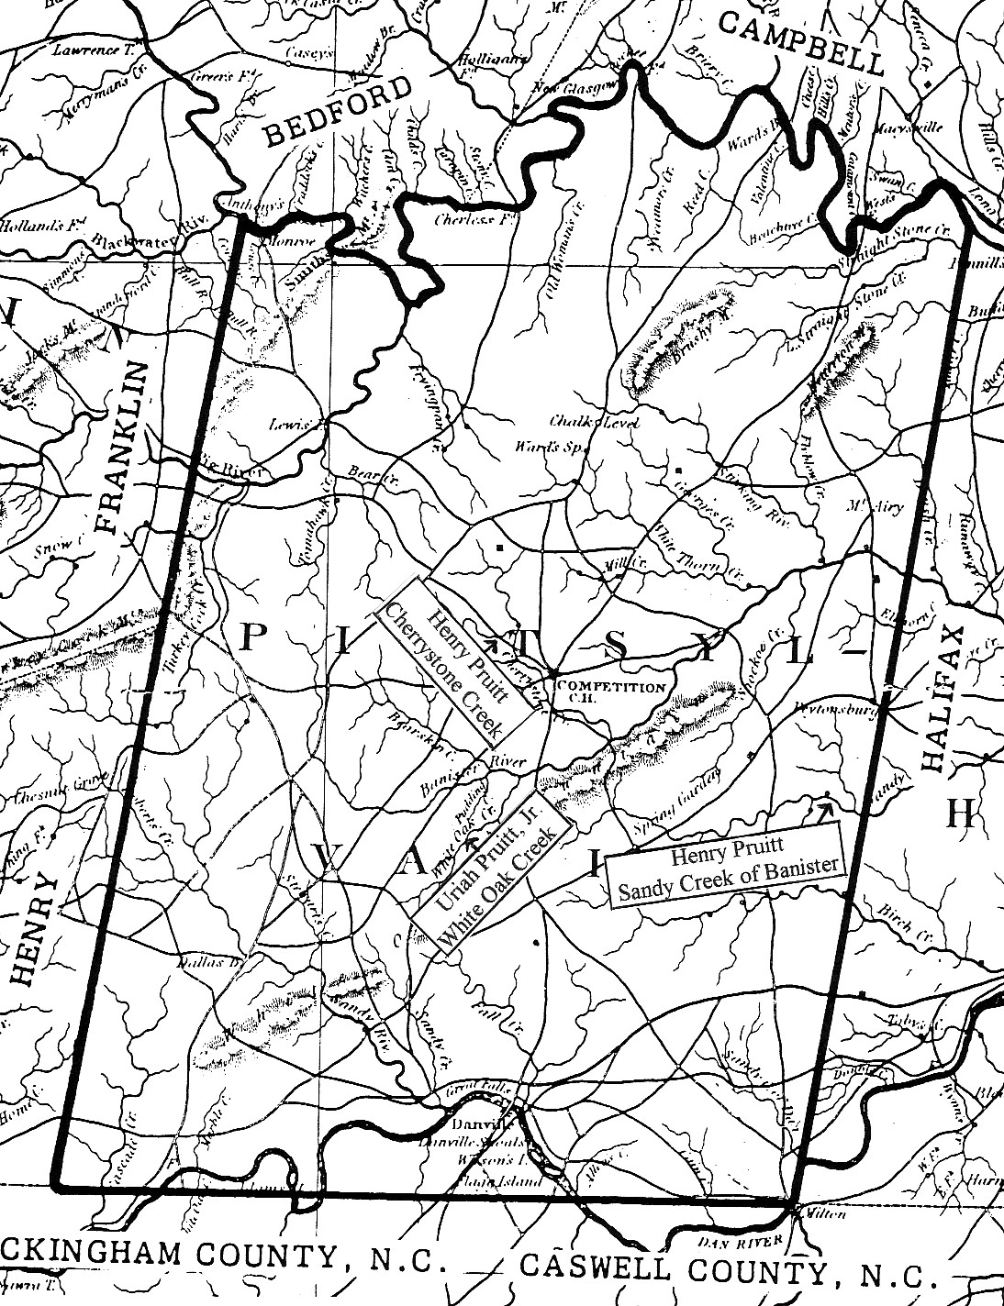

EXPLANATION OF NUMBERING SYSTEM

No number is assigned to our subject, BEASLEY PRUITT, it is his descendants that are numbered. The FIRST GENERATION, Beasley Pruitt’s children, are identified by a single digit (1 to 10) corresponding to the order of birth. Beasley’s grandchildren, being the SECOND GENERATION, are listed with two digit numbers. Each succeeding generation has one more digit than the last one. Each INDIVIDUAL bears his parents number with his own placed after it. No. 5234 has his parents number 523, then his own number 4. To find the parents of No. 5234, you would look up No. 523 in a preceding paragraph.

An (*) asterisk after the child indicates that there is no further information on that child.

BEASLEY PRUITT

BEASLEY PRUITT (son of Uriah Pruitt, Jr. and Elizabeth) was born in Virginia in 1740. His will states he was a native of Essex Co., VA, however his family appears to have lived in Goochland Co., VA at that time. In Pittsylvania Co., VA on Nov. 27, 1767, Beasley, Benjamin and Uriah Prewitt were bound out to Thomas Townsend (Order Bk 1, p. 23).
Beasley married first: Eleanor Humpherys (b. ca 1750) in Virginia about 1770, and had seven children:

(1) James Pruitt, b. ca 1775; died before 1831*
(2) Sistena Pruitt, b. ca 1777; died before 1831*
(3) Sarah "Sally" Pruitt, b. ca 1779 ; m. William Read in Avoyelles Parish, LA on March 1, 1810; and
died before 1831*
(4) Charity Pruitt, b. ca 1781; died before 1831*
(5) Elizabeth Pruitt, b. ca 1783; m. John Campbell*
(6) Hugh Uriah Pruitt, b. Sept. 10, 1786 Natchez Dist., MS
(7) Jesse Pruitt, b. 1793 Natchez Dist., MS

Beasley moved to Natchez Dist., MS in 1783. In 1789, Beasley Pruet received Spanish Land Grant no. 1158 for 440 acres on Sandy Creek.
The March 2, 1790 report on the tobacco growers at Natchez, during the year shows: Buzeles Pruett. On Oct. 2, 1791, Beasley Pruett appeared as a witness in a case in court (Natchez Court Records 1767-1805). The 1792 Spanish Census of Sandy and Second Creek, Dist. of Natchez lists: Beasley Pruett.
In 1803, Beasley Pruitt moved to Rapides Parish, Louisiana. Eleanor died in Rapides Parish, LA about 1805, and Beasley married second: Lucy (Sims) Rogers in Rapides Parish, LA in 1808. Lucy was born in East Florida about 1786.
The 1810 Census of Rapides Parish, LA, p. 285, lists:

Beasley Prewet 1 m over 45 1 fe 16-26
9 slaves

Beasley and Lucy were the parents of three children:

(8) Cynthia Riley "Cinderella" Pruitt, b. Dec. 19, 1812 Rapides Parish, LA
(9) Beasley Pruitt, Jr., b. Dec. 25, 1816 Rapides Parish, LA
(10) Edmond Pruitt, b. Sept. 5, 1819 Rapides Parish, LA

In 1824, Beasley Pruitt moved to Atascosita Dist., Texas (now Liberty Co.) and took up land on the Trinity River. The 1826 Census of Atascosita Dist. (Vol. 1, no. 4, 1963 Texana), July 31, 1826, lists:

Beasley Prewitt 86 VA 13 slaves
Lucy Sims 40 E. FL
Cynthia R. 13 LA
Beasley Jun. 10 LA
Edmond 7 LA

On April 10, 1830, Beasley Prewitt applied for a land grant to Commissioner General Jose Antonio Padilla, who represented the Mexican State of Coahuila and Texas in the issuing of land titles. In his petition Prewitt stated that he had emigrated in 1824 and was one of the individuals authorized to settle

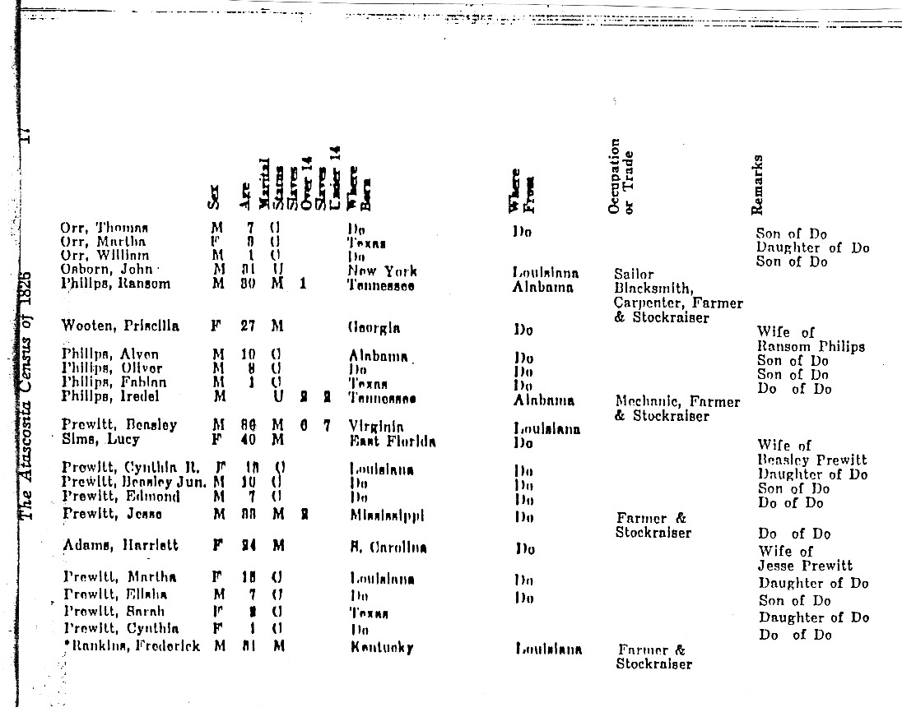

- - - - - - - - - - - - - - - - - - - - - - - - - - - - - - - - - - -

between the Trinity and the San Jacinto under an 1828 resolution of the Mexican Government. The petition bears Prewitt's signature. Comm. Padilla was removed from his position, but Prewitt eventually received title to one league of land (4,428.4 acres) from Commissioner Jose Francisco Madero on April 23, 1831. The land is located in what is now Liberty County. This document is in Spanish (Box 106, Folder 28).
On May 2, 1831, Beasley Prewitt received title to a town lot, 60 varas on each side, on Hidalgo Street in the town of Liberty. His lot was adjoined on the west by a lot granted to his daughter, Cinderella. This document is in Spanish. (Box 107, Folder 29).

BEASLEY PRUITT

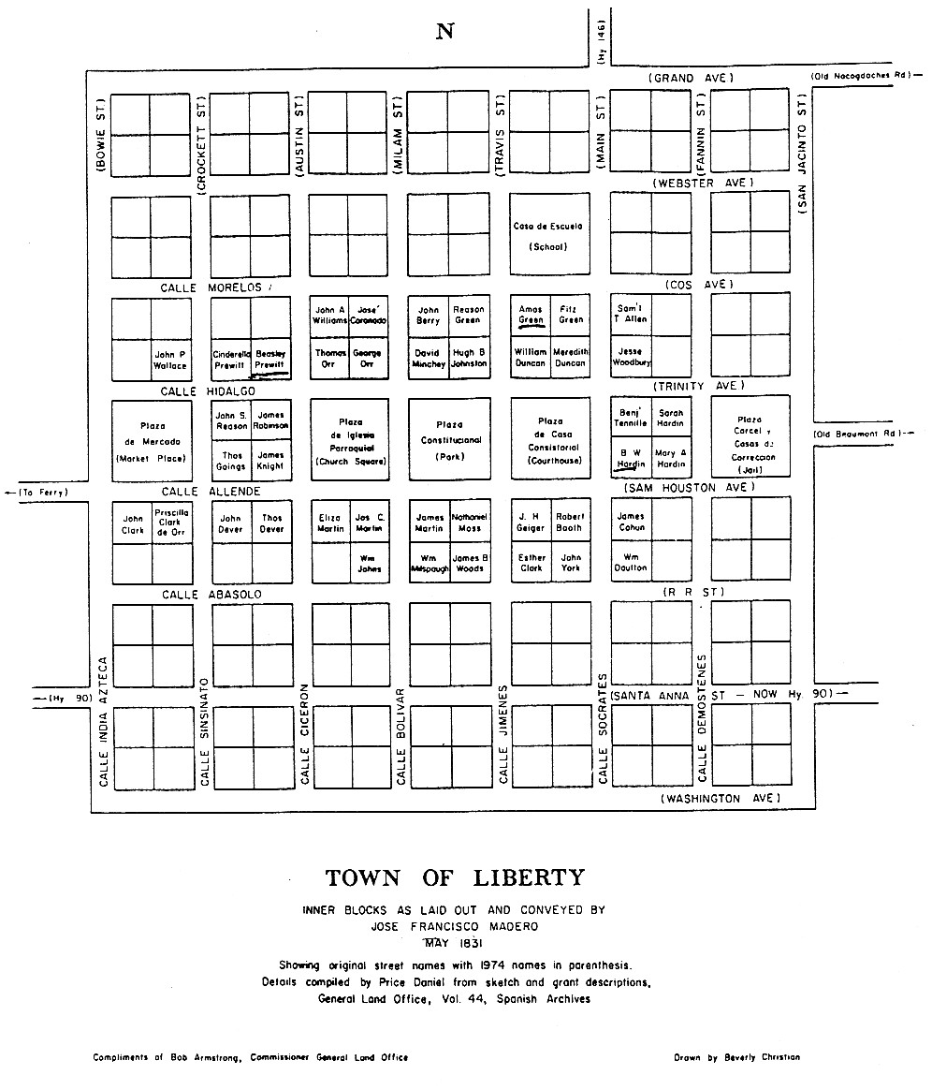

- - - - - - - - - - - - - - - - - - - - - - - - - - - - - - - - - - - - - - -

In 1836, the area where Beasley Pruitt lived, was formed into Liberty Co., Texas. Beasley died at West Liberty (now Dayton), Liberty Co., TX in 1839. His will was written on April 2, 1831:
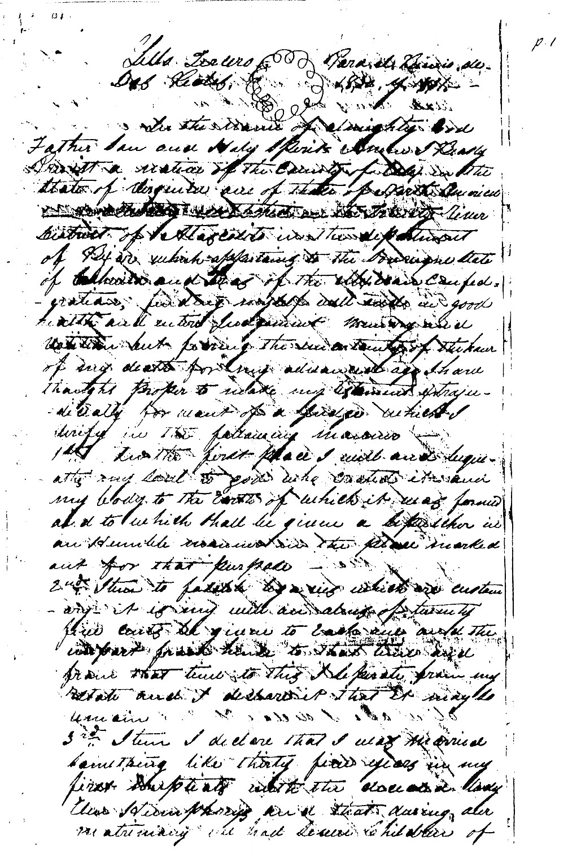

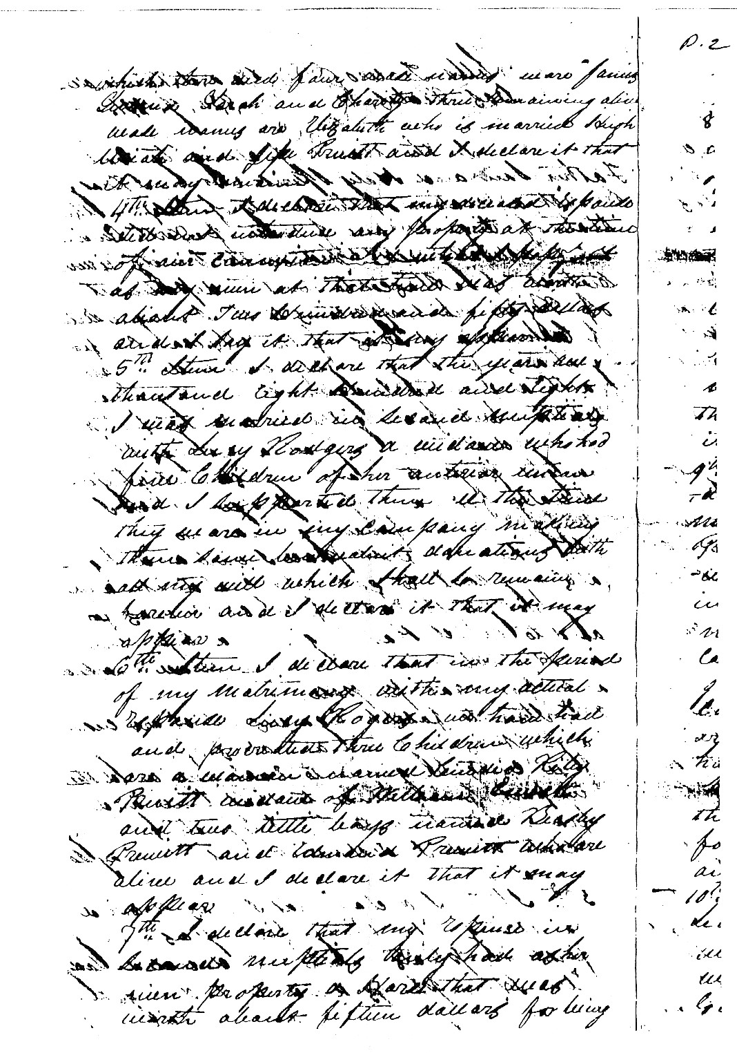
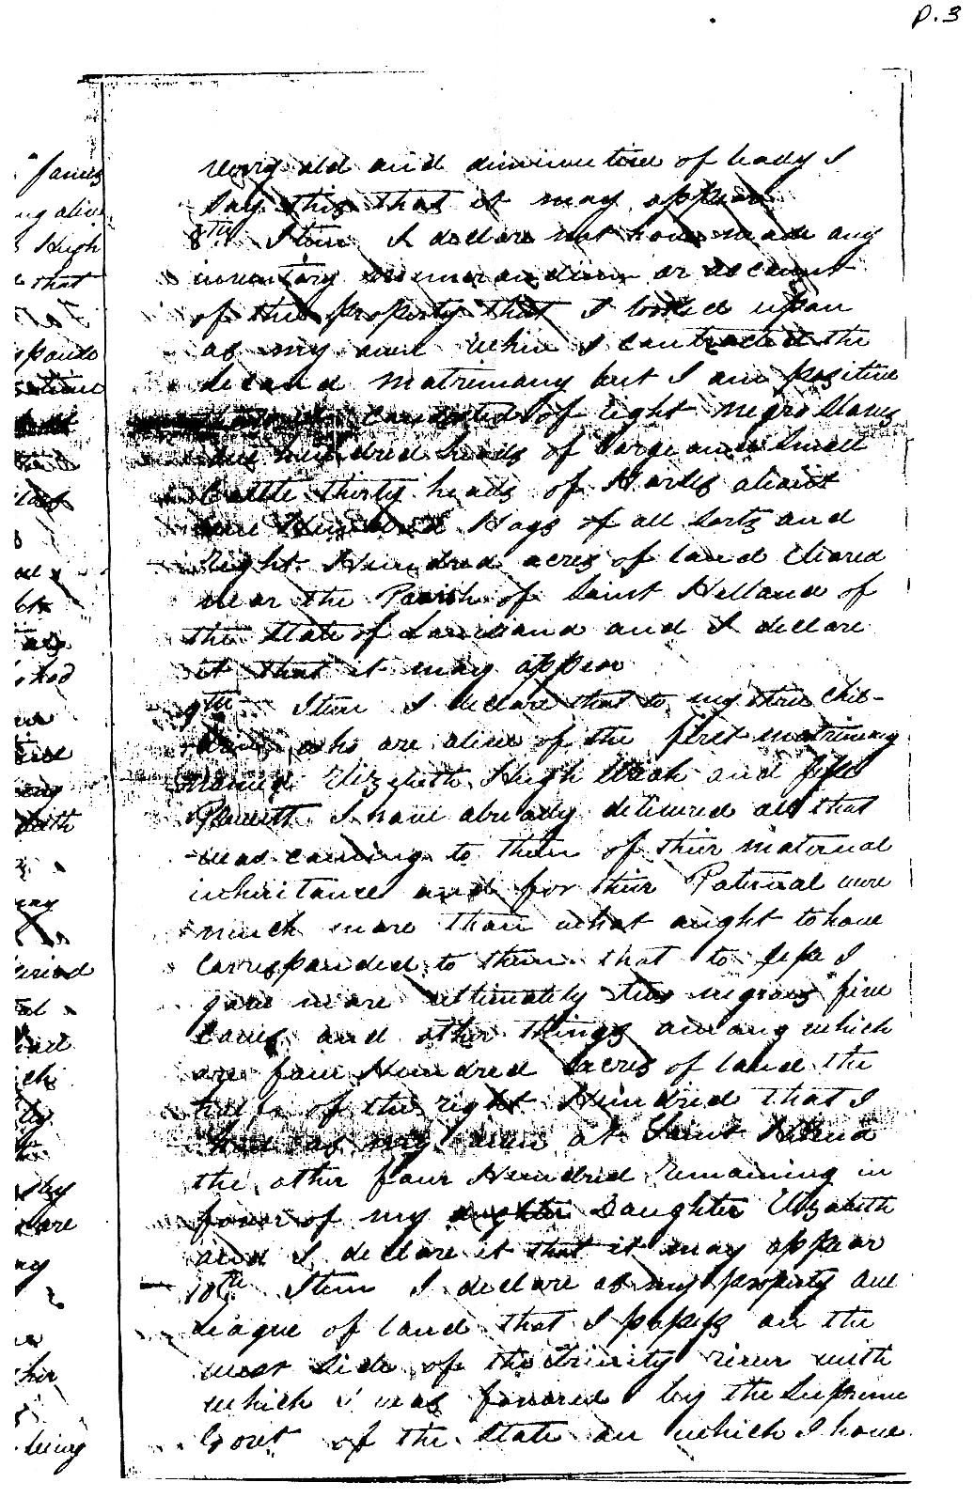
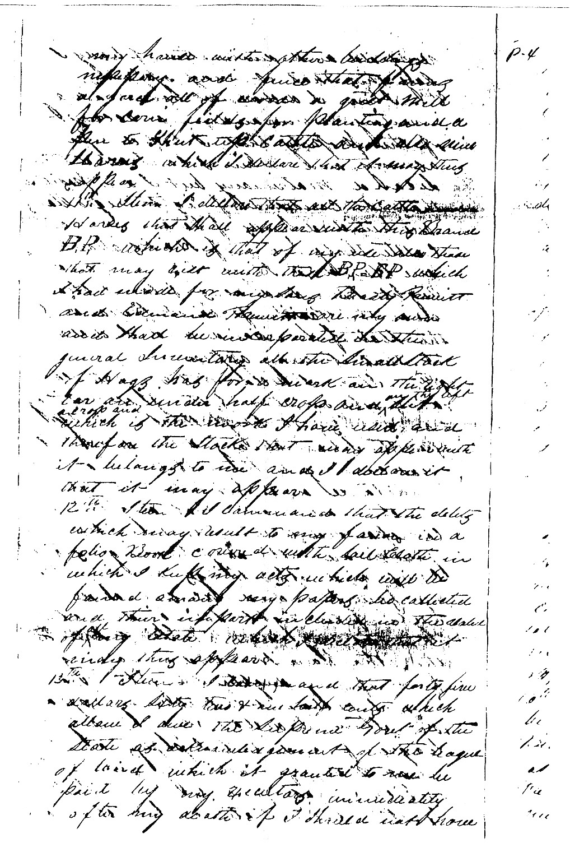
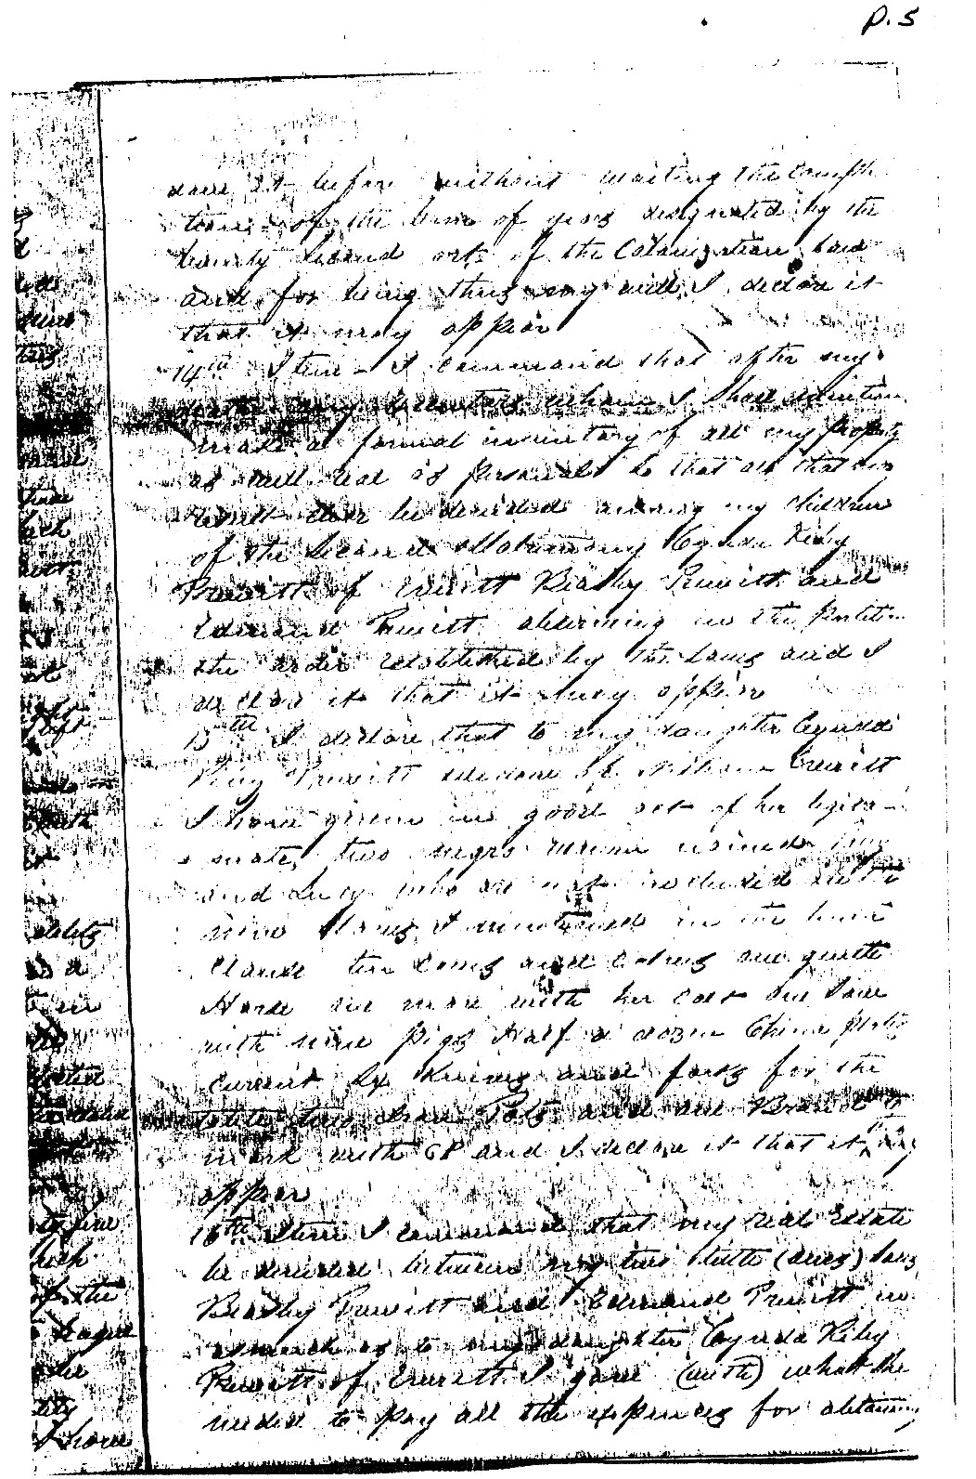

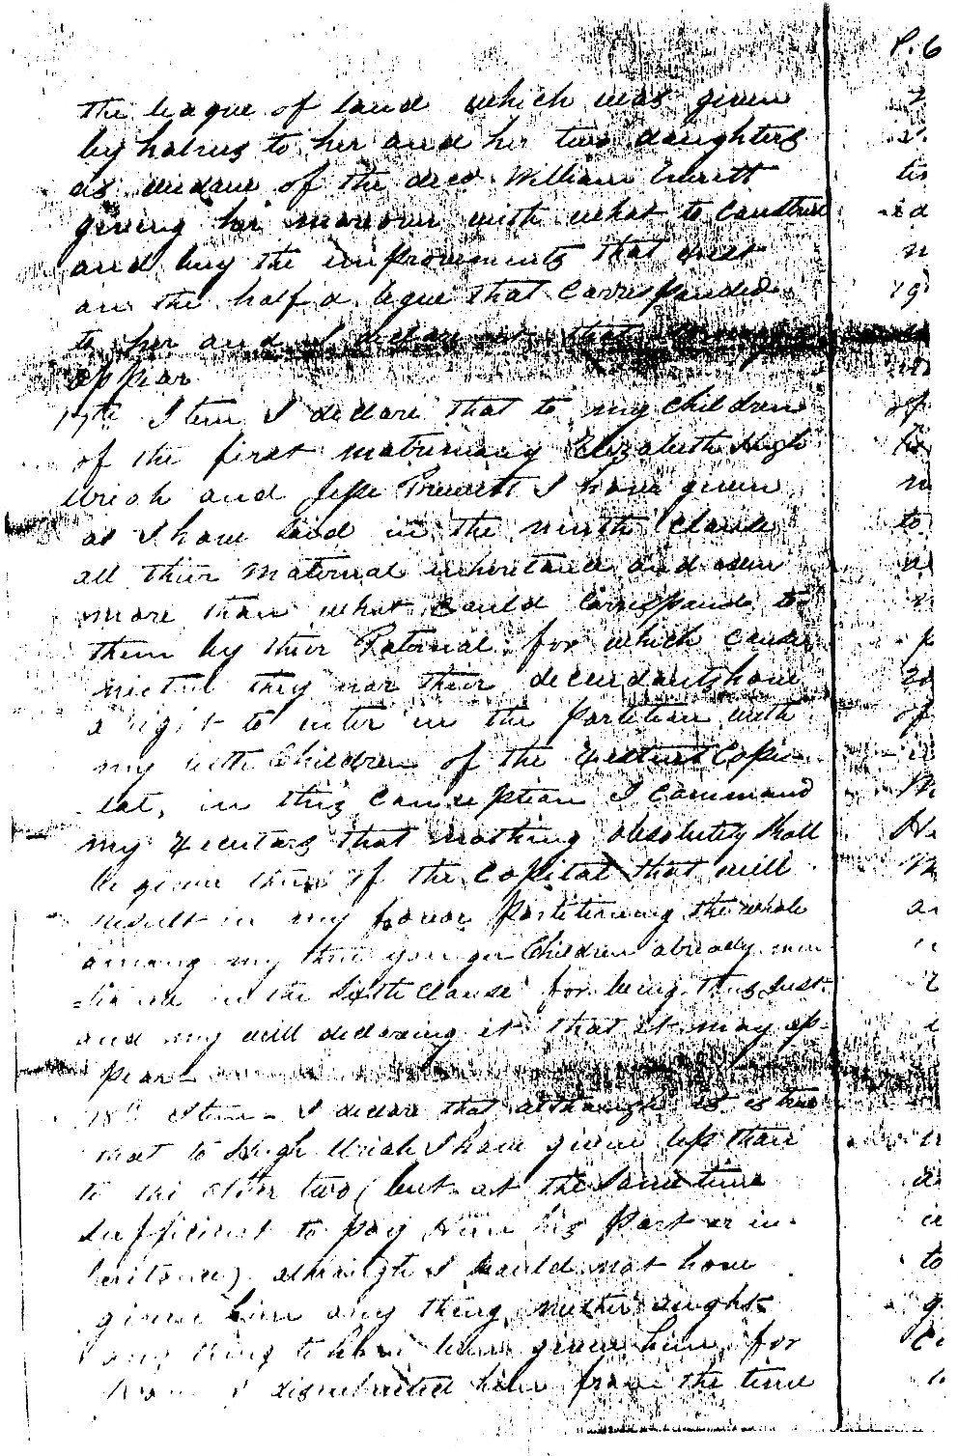

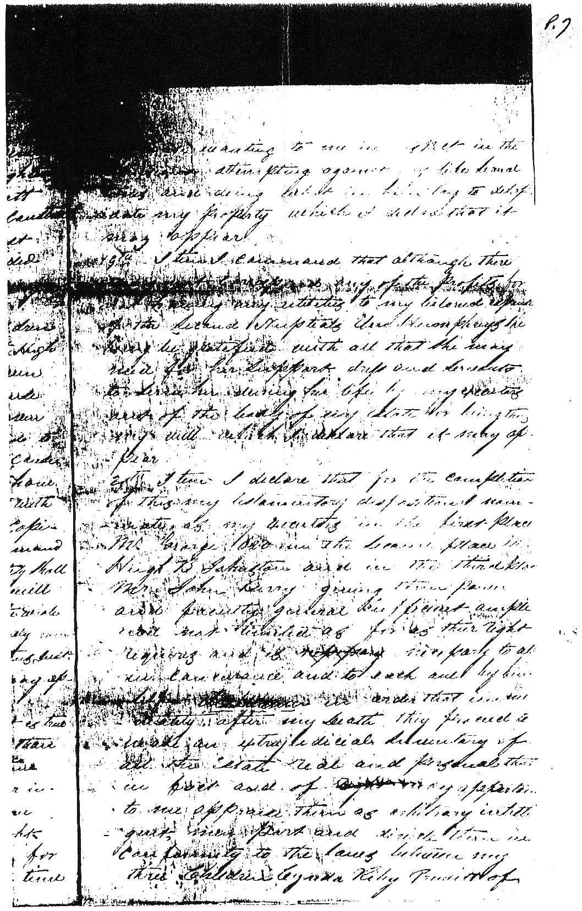

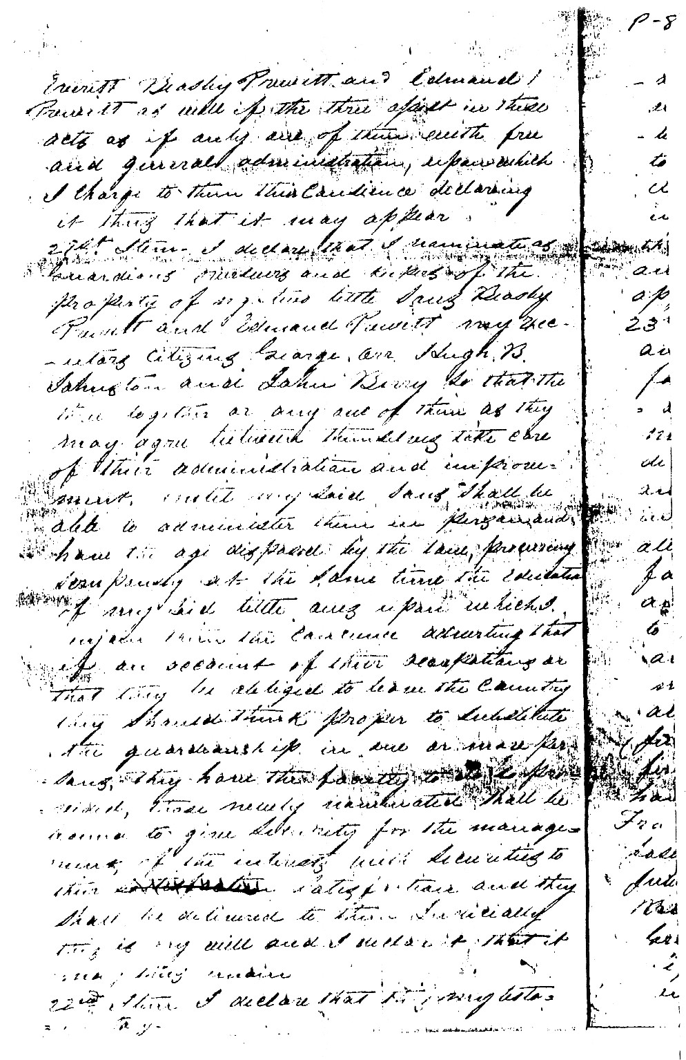
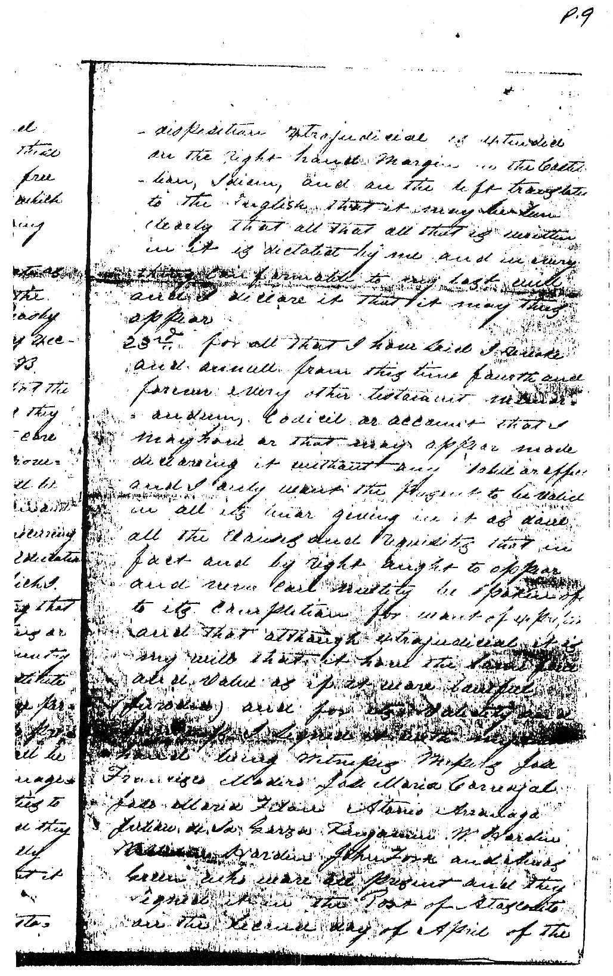
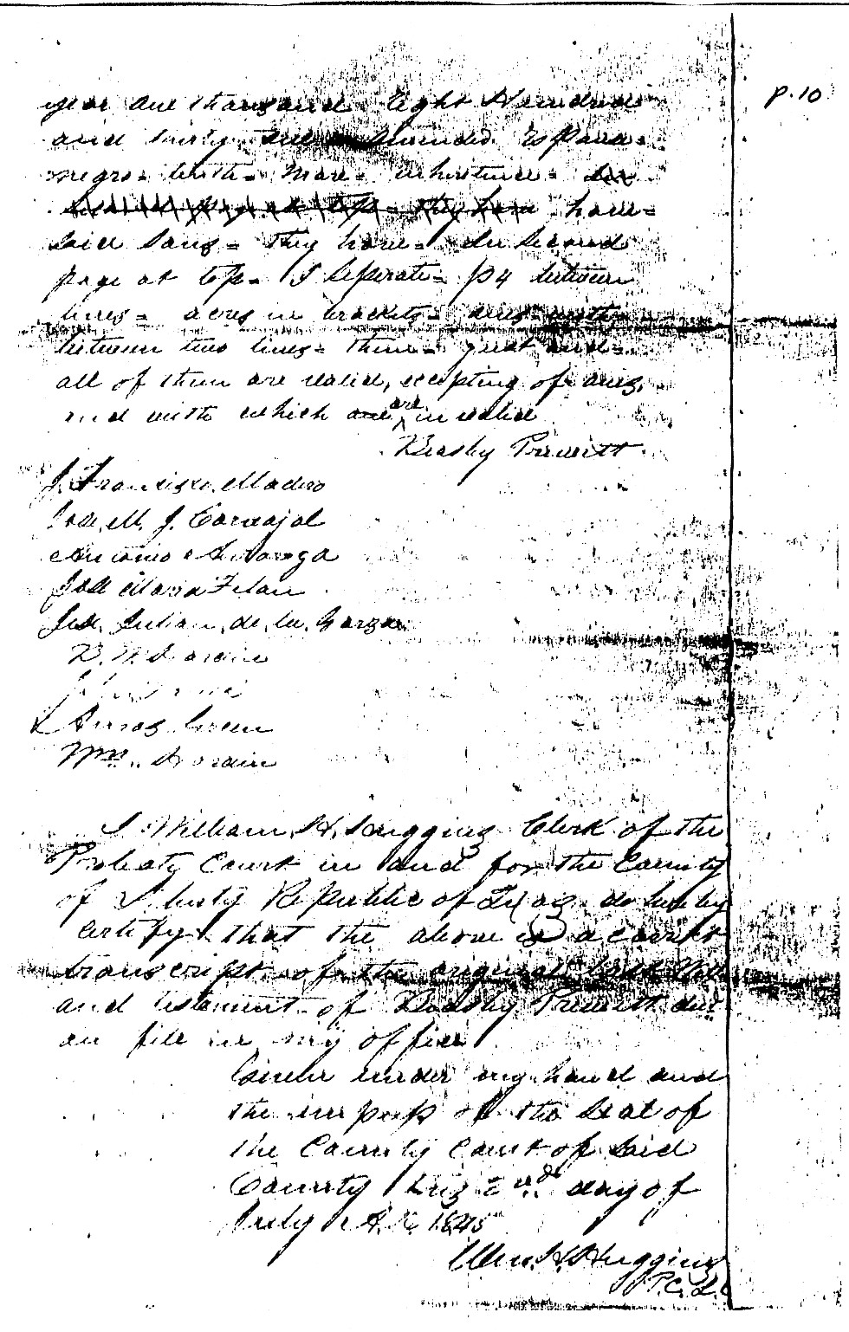
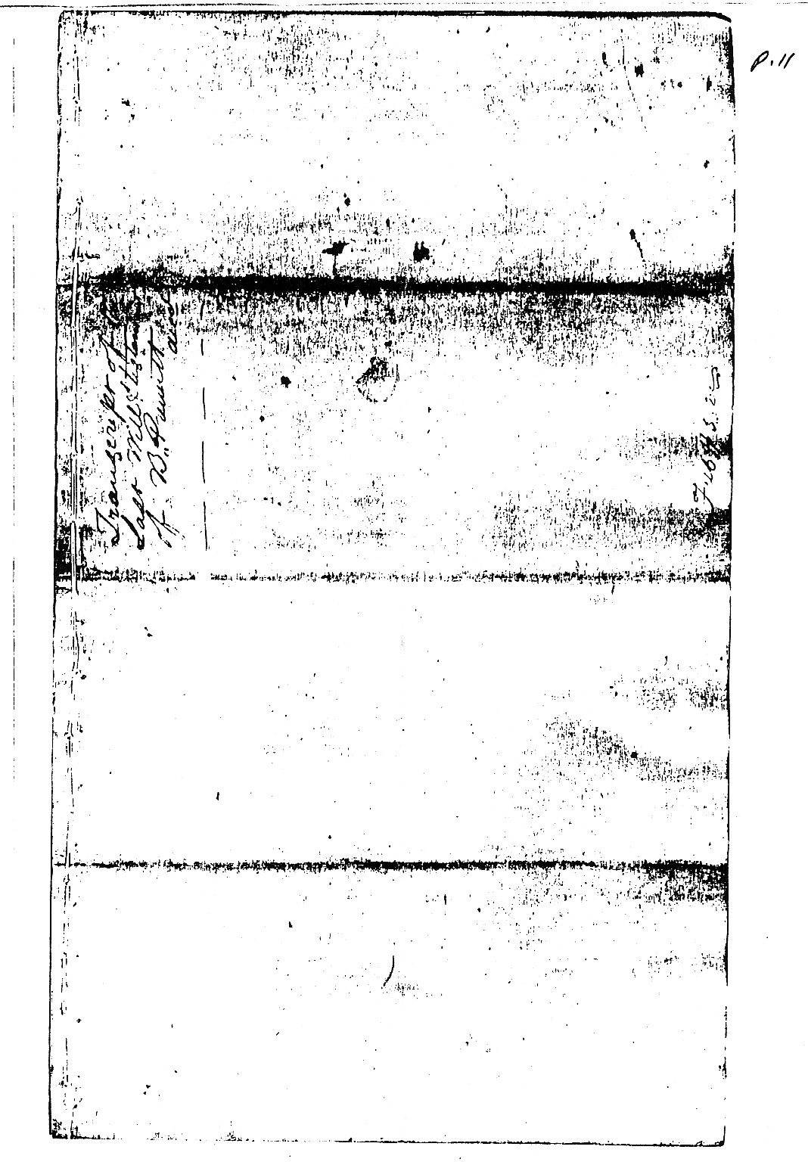

BEASLEY PRUITT

In the name of almighty God. Father, Son and Holy Spirit know I Beasley Prewitt a native of the County of Essex in the State of Virginia one of those of North America and actually established on the Trinity River District of Atascosita in the Department of Bexar which appertains to the Soverigne State of Coahuila and Texas of the Mexican Confederation, finding myself well and in good health and entire Judgment Memory and realtion but fearing the uncertainty of the hour of my death for my advanced age I have though proper to make my testament extrajudicially for want of a Judge which I verify in the following manner.--
1st. In the first place I will and bequest my soul to God who created it and my body to the earth of which it was formed and to which shall be given a sepulcher in an Humble manner in the place marked out for that purpose.
2nd. Item. to publish (?) legacies which are customary it is my will an alms of twenty five cents be given to each one and the impart (imput?) from hence to that time and from that time to this I seperate from my estate and I declare it that it may so remain.
3rd. Item. I declare that I was married something like thirty five years in my first nuptials with the deceased lady Elen Humphreys and that during our matrimony we had seven children of which there died four whose names were James, Sistena (sec), Sarah and Charity three remaining alive whose names are Elizabeth who is married, Hugh Uriah and Jesse Pruitt and I declare that it may remain.
4th. Item. I declare that my deceased spouse did not introduce any property at the time of our connexion and what I possessed as my own at that time was worth about Two Hundred and fifty dollars and I say it may appear.
5th. Item. I declare that the year one thousand and eight hundred and eight I was married in second nuptials with Lucy Rogers a widow who had five children of her anterior union and I supported them all the time they were in my company making them same benovalent donations with all my will which shall so remain forever and I declare it that it may appear.
6th. Item. I declare that in the period of my matrimony with my actual spouse Lucy Rogers we have had and procreated three children which are a woman named Cindie Riley Pruitt widow of William Everett and two little boys named Beasley Prewitt and Edmond Prewitt who are alive and I declare that it may appear.
7th. I declare that my spouse in second nuptials only had as her own property a horse that was worth about fifteen dollars for being verry (sic) old and diminutive (sec) of body I say this that it may appear.
8th. Item. I declare not have made any inventory, memorandum or account of the property that I looked upon as my own when I contracted the second matrimony but I am positive that it consisted of eight negro slaves, one hundred head of large and small cattle, thirty heads of horses about one hundred hogs of all sorts and eight hundred acres of land cleared near the Parish of Saint Hellana of the state of Louisiana and I declare that it may appear.
9th. Item. I declare that my three (3) children, who are alive of the first matrimony named Elizabeth, Hugh Uriah, and Jesse Prewitt I have already delivered all that was coming to them of their maternal inheritance and for their paternal were much more than what ought to have corresponded to them that to Jesse I gave ultimately two negroes, five cows and other things among which are four hundred acres of land the half of the eight hundred that I had as my own at Saint Helena the other four hundred remaining in favor of my Daughter Elizabeth and I declare that it may appear.
10th. Item. I declare as my property one League of land that I possess on the West Side of the Trinity River with which I was favored by the Supreme Govt. of the State on which I have my house with other buildings necessary and fence that forms a yard all of wood, a grist mill for corn fields for planting (sic)
and a pen to shut up cattle and also nine slaves which I declare that it may thus appear.

11th. Item. I declare that all the cattle and horses that shall appear with this Brand BP which is that of my use also those that may exist with these BP:EP which I had made for my sons Beasly Prewitt and Edmond Prewitt are my own and shall be incorporated in the general Inventory all the small stock of hogs has for a mark on the right ear an under half crop and on the left slit a crop and which is the mark I have used and therefore the stock that may appear which it belongs to me and I declare that it may appear.
12th. Item. I command that the debts which may result in a folio Book covered with sail cloth in which I keep my acts which will be found among my papers be collected and their impart included in the relating of all my estate which I declare that it may thus appear.
13th. Item. I command that fourty-five dollars sixty-two and one half cents which all sum I owe the Supreme Govt. of the State as acknowledgment of the league of land which it granted to me be paid by my executors immediately after my death if I should not have done so before without waiting the completion of the term of years designated by the County Courts out of the colonization laws for being thus my will I declare it that it may appear.
14th. Item. I command that after my death my executors whom I shall in writing make a formal inventory of all my property as well real as personal so that all that may result clear be divided among my children of the Second Matrimony Cynthia Riley Prewitt of Everett, Beasley Prewitt and Edmond Prewitt Sharing in the partition the order established by the laws and I declare it that it may appear.
15th. I declare that my daughter Cynthia Riley Prewitt widow of William Everett I have given in good act of her ligitimate two negro women named Polly and Lucy who are not included in the nine slaves I mentioned in the tenth clause, two cows and calves, one gentle horse, one mare with her colt, one sow with nine pigs, Half a dozen china plates current six knives and forks for the table two iron Pots and one Brand the mark with CP and I declare it that it thus may appear.
16th. Item. I command that my real estate be divided between my two little (ones)(sic) sons Beasley Prewitt and Edmond Prewitt inasmuch as to my daughter Cynda Riley Prewitt of Everett I gave (with)(sic) what she needed to pay all the expences for obtaining the League of land which was given by halves to her and her two daughters as widow of the decd. William Everett giving her moreover with what to constrew and buy the improvements that exist on the half legue (sic) that correspond to her and I declare it that it may appear.
17th. Item. I declare that my children of the first matrimony Elizabeth, Hugh Uriah and Jesse Prewitt I have given as I have said in the ninth clause all their maternal inheritance and no more than what could correspond to them by their Paternal for which cause neither they nor their descendants have a right to enter in the partition with my little children of the existant copitat, in this connection I command my executors that nothing absolutely shall be given them of the capital that will result in my favor partitioning the whole among my three younger children already mentioned in the sixth clause for being thus just and my will declaring it that it may so appear.
18th. Item. I declare that although it is true that to Hugh Uriah I have given less than to the other two (but at the same time sufficient to pay him his part or inheritance) although I should not have given him anything neither ought any thing to have been given him for having disinherited him from the time he was wanting to me in respect in the Louisiana attempting against my life several times and doing what in him to delapidate my property which I declare that it may appear. 19th. Item. I command that although there may not correspond any of the profits for not leaving any utilities to my beloved spouse of the second nuptials Elen Humphries (error on Beasley's part) she being (sic) be gratified with all that she may need for her support dress and servants to serve her during her life by my executors out of the body of my estate for being that my will (sic) which I declare that it may appear.

BEASLEY PRUITT

20th. Item. I declare that for the completion of this my testiamentary disposition nominate as my executors in the first place Mr. George Orr in the second place Mr. Hugh B. Johnston and in the third place Mr. John Berry giving them power and faculty general sufficient immediately after my death, they proceed to make an extrajudicial inventory of all estate real and personal that in fact and of right may appertain to me appraise them as arbitrary intelligent men part and divide them in conformity to the laws between my three children Cynda Riley Prewitt of Everett Beasley Prewitt and Edmond Prewitt as well if the three assist in these acts as only one of them with free and general administration upon which I charge them their conscience declaring it thus that it may appear.
21st. Item. I declare that I nominate as guardians overseers and keepers of the property of my two little sons Beasley Prewitt and Edmond Prewitt my executors citizens George Orr, Hugh B. Johnston and John Berry so that the three together or any of them as they may agree between themselves take care of their administration and improvement until my said sons shall be able to administer them in person and have the age imposed by law, procuring scrumpulously at the same time the education of my said little ones upon which I enjoin them the conscience (sic) adverting that if an account of their occupations or that they be obliged to leave the country they should think proper to substitute the guardianship in one or more persons, they have the faculty to do so provided those newly nominated shall be bound to give security for the management of the interests with securities to their (sic) satisfaction and they shall be delivered to them judicially this is my will and I declare th that it may thus remain.
22nd. Item. I declare that this is my testamentary disposition extrajudicial is extended on the right hand margin in the Castilian idiom and on the left translated to the English that it may be seen clearly that all that is written in it is dictated by me and in everything comfortable to my last will and I declare it that it may thus appear.
23rd. For all that I have said I revoke ans annul from this time forth and forever every other testament, memorandum, codicil or account that I may have or that may appear made declaring it without any value or effect and I only want the present to be valid in all its tenor giving in it as done all the clauses and requisites that in fact and by tight ought to appear and never cast nullity be spoken of to its completion for want of expression and although extrajudicial it is my will that it have the same force and value as if it were (sic) lawful (Juridico) (sic) and for its validity and firmness I signed it with my own hand being witness Messrs Jose Francisco Madero, Jose Maria Carbajal, Jose Maria Felan, A(n)tonio Arranaga, Julian de la Garza, Benjamin W. Hardin, William Hardin, John Fork (sic) and Amos Green who were (sic) all present and they signed it in the Post of Atascosita on the second day of April of the year one thousand eight hundred and thirty one

Beasley Prewitt
J. Francisco Madero
Jose M.J. Carbajal
Antonio Arranaga
Jose Maria Felan
Jose Julian de la Garza
B.W. Hardin
John Faulk
Amos Green
Wm. Hardin

I William H. Huggins, Clerk of the Probate Court in and for the County of Liberty Republic of Texas do hereby certify that the above is a correct transcript of the original last Will and testament of Beasley Prewitt decd. on file in my office.
Given under my hand and the impress of the Seal of the County Court of said County this 2nd day of July A.D. 1845
Wm. H. Huggins
R.C.L.C.

On Sept. 5, 1839, Liberty Co., TX, the heirs of Beasley Pruett appeared and proved he emigrated to the Republic in 1825, now deceased and his heirs are entitled to one labor of land (Headright Cert. 359).
Field Notes: discription of the metes and bounds of 177 acres in Comanche County, surveyed April 30, 1853. Final title issued Aug. 8, 1857 (Patent 616, Volume 11).
Lucy died in Liberty Co., TX about 1850.

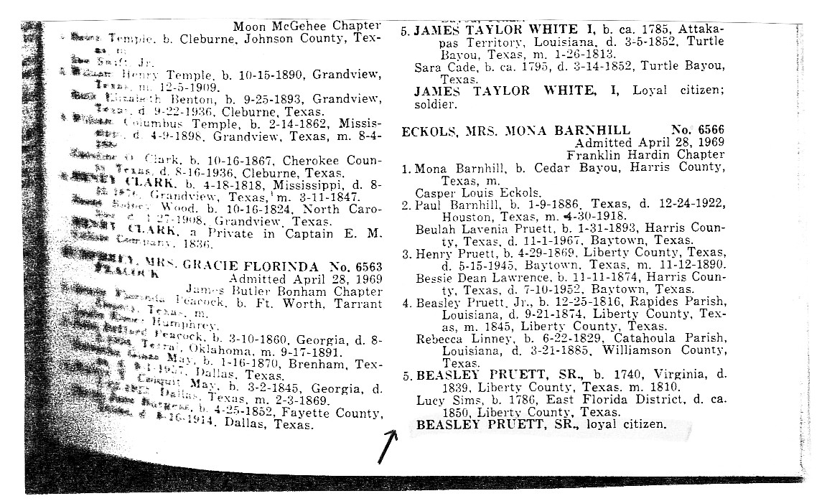

HUGH URIAH PRUITT

(6) HUGH URIAH PRUITT (son of Beasley Pruitt and Eleanor Humpherys) was born in Natchez Dist., MS on Sept. 10, 1786. He married Priscilla Hall in Amite Co., MS on May 22, 1804, by Isaac Johnson, JP. Priscilla was born in North Carolina on Feb. 14, 1786 to Henry Hall and Mary Jane Ross.
Hugh and Priscilla were the parents of twelve children:

(61) Matilda Pruitt, b. June 19, 1805; m. 1st: Jordan West on Sept. 12, 1821; m. 2nd: George S.
Garner; moved to Texas*
(62) Young Henry Pruitt, b. Oct. 16, 1806 LA
(63) Ellender "Ellen" Pruitt, b. Jan. 20, 1809 LA; m. Phillip R. Hodge on Aug. 2, 1827; later lived in
Arkansas*
(64) Jane Pruitt, b. March 3, 1810 St. Helena Parish, LA; m. James Humphries; resided Liberty Co.,
TX*
(65) Mary "Polly" Pruitt, b. Oct. 14, 1811 St. Helena Parish, LA
(66) James R. Britton Pruitt, b. Nov. 3, 1813 St. Helena Parish, LA; m. Caroline M. Story in St.
Helena Parish, LA on Dec. 19, 1850*
(67) Lucretia Pruitt, b. Jan. 31, 1815 St. Helena Parish, LA; m. Uriah Youngblood on Aug. 17, 1837;
and died on Oct. 27, 1859*
(68) Myrandah Pruitt, b. Dec. 3, 1816 St. Helena Parish, LA
(69) Elizabeth Pruitt, b. Sept. 12, 1818 St. Helena Parish, LA; m. Matthew Brunson in Amite Co., MS
on June 22, 1835 (Vol. 2, p. 141); and died on Dec. 25, 1837*
(6(10) Narcissa Pruitt, b. Dec. 21, 1820 St. Helena Parish, LA; m. Martin Youngblood in St. Helena
Parish, LA on Oct. 2, 1837*
(6(11) Moses Alexander Pruitt, b. June 26, 1823 St. Helena Parish, LA
(6(12) John Isiah Pruitt, b. June 28, 1825 St. Helena Parish, LA; m. 1st: Mary Ellen Tillman on Oct. 26,
1857; m. 2nd: Ellen Brabham in Amite Co., MS on July 3, 1865*

Hugh "Uriah" Pruitt served in the 12th & 13th Consolidated Regiments, LA Militia, Capt. Beckhams Company in the War of 1812. Uriah served from Dec. 28, 1814 to March 10, 1815 as a private in Womack's (12th) Regiment of Louisiana Militia, and was discharged "at the Navy Yard in the Parish of St. Tammany" (near Covington, LA).
They had land in Section 45 in St. Helena Parish, LA, adjoining John Guynes (Priscilla's sister's husband). Turkey Creek was the border between their farms. They were recorded on the 1820 census.
Uriah had obtained the land in Section 45 from the original settler, Beasley Prewitt (who later moved to Texas). In 1854, there was court action over this Section 45 and there are many papers on said action in St. Helena Parish, LA Court House (Styled Britton Prewitt vs Pricilla Prewitt).
Hugh died in St. Helena Parish, LA on Feb. 20, 1831. On March 3, 1831, Inventory at the residence of Uriah Prewitt, decd, presented by the widow of decd Priscilla Prewitt: 2 sections of land on Twelve Mile Creek containing 1280 acres appraised at $1280. Mrs. Pricilla Prewitt is appointed tutrix to the minors Narcissia, Moses, John Isiah. Family meeting to appoint tutor: Henry Prewitt, brother; Phillip R. Hodges, brother in law; Britton Hall, uncle; and Nathaniel Allen, friend and neighbor. Their mother Priscilla Prewitt appointed tutrix and their uncle Britton Hall appointed under tutor (Succession Records of St. Helena Parish, LA, File P-1).
On Sept. 28, 1831, Mrs Priscilla Prewitt applies for administration and is appointed. She takes the oath on Oct. 5, 1831.

On Sept. 28, 1852, Petition of James B. Prewitt shows that his father, Uriah Prewitt, died some years since leaving property in community with Mrs Priscilla Prewitt, his widow still surviving, and the following descendants: Leucretia Prewitt, wife of Uriah Youngblood; Miranda Prewitt, wife of Charles C. Lee; John Prewitt, and James B. Prewitt, all of St. Helena Parish. Narcissia Prewitt, wife of Martin Youngblood; Ellen Prewitt, wife of Phillip R. Hodges; Young H. Prewitt, and Matilda Prewitt, wife of George S. Garner; Mary Prewitt, widow of William Stephenson; Jane Prewitt, wife of James Humphreys; Moses Prewitt, all of Texas ... No partition was made; all consent to sale and partition except Leucretia Prewitt and her husband Uriah Youngblood. They desire the property to remain in possession of her mother.
On Dec. 28, 1852, Agreement that heirs shall pay James B. Prewitt $314.48 for improvements he made on land belonging to the succession of Uriah Prewitt.
On June 12, 1854, Inventory: 274 acres on Twelve Mile Creek bounded on north by Pipkik, south by Mrs Nettles, east by Thomas Clinton, west by Robert Fluker - $1200. Purchased on July 22, 1854 by Robert Williams for $1605. On Oct. 9, 1854, Partition among 11 heirs named above.

BLWT 86143-160-55 Uriah Prewitt, filed by his widow Pricilla Prewitt in St. Helena Parish, LA, under Act of Congress of March 3, 1855, for bounty land for service rendered in War of 1812. Consists of 15 or more pages of affidavits and states in various places that: Pricilla Prewitt's maiden name was Pricilla Hall and that "after refering to the family record she was married to Uriah Prewitt on the 22nd day of May A.D. 1804 just above the line of demarkation between Louisiana and Mississippi now Amite County by one Isaac Johnson, a Justice of the Peace --- in presence of John Humpers, Thomas Humpres, William West and her father Henry Hall and others all of whom have long since died." Uriah Prewitt was a resident of Mississippi at time of marriage. Priscilla stated she was 69 years of age on affidavit dated Oct. 15, 1855, and stated she was 72 years of age on affidavit dated July 3, 1857.

Priscilla died in St. Helena Parish, LA on July 12, 1860, age 74y 4m 28da.

- - - - - - - - - - - - - - - - - - - - - - - - - - - - - - - - - - -

Bible of Uriah Prewitt copied May 7, 1967 at home of Mrs. L. Gallent Lee, Zachary, LA

Uriah Prewitt His Bible
1st page
Uriah Prewitt and his wife Prissiller Prewitt was married May 22 in the year of our Lord 1804
Jordon West and his wife Metilda was married September the 12 in the year of our Lord 1821
Phylip Hodge - Ellen Prewitt his wife was married August the 2 in the year of our Lord 1827
Young H. Prewitt and Tabitha D. Prewitt was married February the 1st in the year of our Lord 1829
William Stephenson and Mary Stephenson was married July the 27 in the year of our Lord 1831
Charles C. Lee and Manady Prewitt was married April the 13 in the year of our Lord 1836
Uriah Youngblood and Lucretia Prewitt was married 17 of August AD 1837

2nd page Births
Uriah Prewitt was born September 10th in the year of our Lord 1786
Prissiller Prewitt his wife was borned February the 14 in the year of our Lord 1786
Matilda Prewitt was born June 19 in the year of our Lord 1805
Young Henry Prewitt was borned October 16 in the year of our Lord 1806

HUGH URIAH PRUITT

Elender Prewitt was borned January 20 in the year of our Lord 1809
Jane Prewitt was borne March 3 in the year of our Lord 1810
Polly Prewitt was born October 14 in the year of our Lord 1811
James R. B. Prewitt was borned November 3 the year of our Lord 1813
Leweresy Prewitt was born January 31 in the year of our Lord 1815
Myrandah Prewitt was borne December 3 in the year of our Lord 1816
Elizabeth Prewitt was borne September 12 in the year of our Lord 1818
Narcissa Prewitt was borne December the 21 in the year of our Lord 1820
Moses was borne in the year of our Lord June 26, 1823

3rd page Births
Riley Prewitt the daughter of Besley Prewitt was borne December the 9 in the year of our Lord 1812
Besley Prewitt was borne December the 15 in the year of our Lord 1816
Edmon Prewitt was borne September the 5 in the year of out Lord 1819
John Isaiah Prewitt was born June the 28 in the year of our Lord 1825
Obadiah Moses, 2nd son of C.C. Lee and his wife Maranda Prewitt was born Feb. 28, 1889 East Felicianna Parish
Alice Laura 6th daughter of D. A. Cunningham and his wife Martha Ann Kenner was born April 29, 1851 Baton Rouge
O. M. Lee and Alice L. Cunningham were married Jan. 2, 1877 Baton Rough

Of the children of O. M. and Alice L. Lee May, eldest daughter was born 6 ock AM Oct. 1, 1877
Lilian 2nd dau. was born 12 M Jan 14, 1879
Robt. Edward, eldest son born 11 PM Mar. 22, 1880
Irma 3rd dau was born 8 PM July 4, 1881
Cunningham 2nd son was born 11:30 PM Oct. 31, 1883
Henry Watkins Allen 3rd son was born 2 AM Sept. 16, 1885
Homer 4th son was born 3 PM July 10, 1888
All born in East Baton Rouge, LA

4th page Deaths
Uriah Prewitt departed this life February the 20th 1831
Elizabeth Prewitt departed this life December 25th 1837
Lucretia Youngblood died Oct. 27th 1859 ages 44 years
Priscilla Prewitt died July 12, 1860 aged 74
Myrandah Lee died Jan. 13, 1888
C. C. Lee Sept. 28, 1876
W. T. Lee June 13, 1855
Anne Millican 4th dau. of O. M. and Alice L. Lee died 2 PM July 24th, 1889

Fly Page at New Testament Section
Collin's Stereotype Edition
Printed and sold by Collins and Co.
1818

(62) YOUNG HENRY PRUITT (son of Hugh Uriah Pruitt and Priscilla Hall) was born in Louisiana on Oct. 16, 1806, and married Tabitha D. West in Amite Co., MS on Feb. 1, 1829 (Vol. 2, p. 275). Tabitha was born in Louisiana in 1806. Young and Tabitha had the following children:

(621) Joaik Pruitt, b. 1832 LA*
(622) Polly Pruitt, b. 1834 LA*
(623) Levi Pruitt, B. 1836 LA*
(624) Rhonda Pruitt, b. 1839 LA*
(625) James Fontleroy Pruitt, b. 1840 LA
(626) Levina Pruitt, b. 1842 LA*
(627) Tabitha Pruitt, b. 1844 LA*
(628) Sam Pruitt, b. 1845 LA*

The 1850 Census, Sabine Parish, LA, no. 484, lists:

Henry Pruitt 44 LA
Tabitha 44 LA
Joaik 18 LA
Polly 16 LA
Levi 14 LA
Rhonda 11 LA
Jas 10 LA
Levina 8 LA
Tabitha 6 LA
Sam 5 LA

The 1880 Census, Jasper Co., TX, Ed 36, sheet 116, lists: Young H. Prewitt.

(625) JAMES FONTLEROY PRUITT (son of Young Henry Pruitt and Tabitha D. West) was born in Louisiana in 1840. He married Martha E. Huffman (b. ca 1853 Huffman, TX to David Huffman) in Huffman, TX on Dec. 30, 1875, and had the following children:

(6251) James Taylor Pruett, b. Aug. 29, 1880; m. Mabel Elaine Jett; and died Dec. 26, 1938*
(6252) William August Pruett, b. ca 1890; m. Betty ? ; and died on Jan. 25, 1971*

(65) MARY "Polly" PRUITT (dau. of Hugh Uriah Pruitt and Priscilla Hall) was born in St. Helena Parish, LA on Oct. 14, 1811. She married William Stephenson (b. 1808) on July 27, 1831, and had seven children:

(651) Priscilla Stephenson (1832-1883)*
(652) Uriah Prewitt Stephenson (1834-1884)*
(653) Eli Sechart Stephenson (1835-1871)*
(654) Joseph William Stephenson (1837- )*
(655) Mary Stephenson (1839-1883)*
(656) Reason Green Stephenson, b. 1841
(657) Martha Stephenson (1849-1929)*

They resided in Liberty Co., Texas. Willian died in 1844, and Mary died in 1868.
HUGH URIAH PRUITT

(656) REASON GREEN STEPHENSON (son of William Stephenson and Mary Pruitt) was born in 1841. He married Martha Lorenda Wilborn (b. 1855), and had seven children:

(6561) George Mayes Stephenson (1878-1936)*
(6562) Annie Ula Stephenson (1880-1966)*
(6563) Daisy Edgar Stephenson (1883-1956)*
(6564) Adell Jeannette Stephenson (1886-1924)*
(6565) Mary Minerva Stephenson (1889-1962)*
(6566) Rupert Cleveland Stephenson (1892-1961)*
(6567) Reason Green Stephenson, Jr. (1895-1961)*

Reason died in 1895, and Martha died in 1905.

(68) MYRANDAH PRUITT (dau. of Hugh Uriah Pruitt and Priscilla Hall) was born in St. Helena Parish, LA on Dec. 3, 1816, and married Charles Coxe Lee in St. Helena Parish, LA on April 13, 1836. Charles was born in New Jersey about 1809.
Charles and Myrandah were the parents of seven children:

(681) John Pruitt Lee, b. Feb. 5, 1837 LA; m. Emily Drucilla Allen on Sept. 11, 1856; and died on
Feb. 28, 1900*
(682) Obadiah Moses Lee, b. Feb. 28, 1839 East Feliciana Parish, LA
(683) Annie C. Lee, b. ca 1841 LA; m. Calvin Durbin*
(684) James William Lee, b. June 1846 LA
(685) William E. Lee, b. ca 1847*
(686) Joseph A. Lee, b. June 1849; m. 2nd: Eda L. ? ; resided Stevens Co., TX in 1900*
(687) W. Mc Lee, b. ca 1856*

Charles died in East Feliciana Parish, LA on Sept. 28, 1876. Myrandah died in Arcola, LA on Jan. 13, 1888, and was buried in Youngblood Cem., Central, Louisiana.

(682) OBADIAH MOSES LEE (son of Charles Coxe Lee ande Myrandah Pruitt) was born in East Feliciana Parish, LA on Feb. 28, 1839. He married Alice Laura Cunningham in East Baton Rouge Parish, LA on Jan. 2, 1877. Alice was born in East Baton Rouge Parish, LA on April 29, 1851 to Daniel Ambrose Cunningham and Martha Ann Kenner.
Obadiah and Alice had the following children:

(6821) Mary Agnes "May-May" Lee, b. Oct. 1, 1877 East Baton Rouge Parish, LA; m. Dewitt T.
Denham on Dec. 12, 1914; and died at Baton Rouge, LA on Feb. 16, 1950*
(6822) Lillian Obeline "Leg-Leg" Lee, b. Jan. 14, 1879 Deerford, LA
(6823) Robert Edward Lee, b. March 22, 1880 East Baton Rouge Parish, LA
(6824) Irma Lee, b. July 4, 1881 East Baton Rouge Parish, LA
(6825) Cunningham Coxe Lee, b. Oct. 30, 1883 East Baton Rouge Parish, LA
(6826) Dr. Henry Watkins Allen Lee, b. Sept. 16, 1885 East Baton Rouge Parish, LA

(6827) Homer Lee, b. July 10, 1888 East Baton Rouge Parish, LA
(6828) Ann Millican Lee, b. July 23, 1889 East Baton Rouge Parish, LA; died on July 24, 1889*

Obadiah died in Deerford, LA on June 12, 1895, and was buried first on the home place in Deerford, LA, remains later removed to Roselawn Cem., Baton Rouge, Louisiana. Alice died in Baton Rouge, LA on Dec. 9, 1933, and was buried in Roselawn Cemetery there.

(6822) LILLIAN OBELINE "Leg-Leg" LEE (dau. of Obadiah Moses Lee and Alice Laura Cunningham) was born in Deerford, LA on Jan. 14, 1879, and married James Frederick Newman in Deerford, LA on Dec. 7, 1919. James was born at Nine Mile Creek, Cabell Co., WV on April 2, 1877 to James Harvey Newman and Malinda Susan Jefferson.
James and Lillian had a son:

(68221) James Lee Newman, b. Feb. 25, 1921 East Baton Rouge Parish, LA

James died in Baton Rouge, LA on Jan. 11, 1937, and Lillian died there on Feb. 12, 1965. Both were buried in Roselawn Cem., Baton Rouge, Louisiana.

(68221) JAMES LEE NEWMAN (son of James Frederick Newman and Lillian Obeline Lee) was born in East Baton Rouge Parish, LA on Feb. 25, 1921, and married Ethel Mae Lormand in Kinder, LA on Aug. 21, 1942. Ethel was born in Kinder, LA on March 10, 1921 to Willis Lormand and Ellen Nevils.
James and Ethel had three daughters:

(682211) Melanie Jean Newman, b. Dec. 5, 1944 Adams Co., CO
(682212) Judith Ann Newman, b. Jan. 11, 1947 Baton Rouge, LA
(682213) Mary Katherine Newman, b. April 19, 1952 Whittier, CA*

They resided in Beaumont, Texas.

(682211) MELANIE JEAN NEWMAN (dau. of James Lee Newman and Ethel Mae Lormand) was born ay Fitzsimmons Army Hosp., Adams Co., CO on Dec. 5, 1944. She married Holland Joseph Pitre in Baton Rouge, LA on Jan. 20, 1968. Holland was born in Cut Off, LA on Oct. 24, 1946 to Loulan Joseph Pitre and Amelia Chabert.
Holland and Melanie had two children:

(6822111) Gannon James Pitre, b. Sept. 6, 1971 Baton Rouge, LA*
(6822112) Laura Elizabeth Pitre, b. Sept. 29, 1976 Portsmouth Navy Hosp., Norfolk Co., VA*

Holland was a Dermatologist and a Lt. Cmdr. in the U.S. Navy in 1976.

HUGH URIAH PRUITT

(682212) JUDITH ANN NEWMAN (dau. of James Lee Newman and Ethel Mae Lormand) was born in Baton Rouge, LA on Jan. 11, 1947. She married Richard Alexander Stewart in Beaumont, TX on June 26, 1976. Richard was born in Galveston, TX on Aug. 2, 1948 to Richard Lee Stewart and Margaret Mraz. Richard and Judith had a son:

(6822121) Cody Alexander Stewart, b. June 6, 1980 Beaumont, TX*

Richard was a Newspaper Reporter and Judith was a Nurse.

(6823) ROBERT EDWARD LEE (son of Obadiah Moses Lee and Alice Laura Cunningham) was born in East Baton Rouge Parish. LA on March 22, 1880. He married Jennie Alettia Gallent in Centerville, MS on Dec. 30, 1913, and had two children:

(68231) Llewlyn Gallent Lee
(68232) Alice Caroline Lee

Robert died in Batchelor, LA on Feb. 25, 1960.

(68231) LLEWLYN GALLENT LEE (son of Robert Edward Lee and Jennie Alettia Gallent) married Hilda Norton, and had two children:

(682311) Robert Edward Lee II, b. 1940; m. Margaret Griffin*
(682312) Barbara Elaine Lee, b. 1945

(682312) BARBARA ELAINE LEE (dau. of Llewlyn Gallent Lee and Hilda Norton) was born in 1945. She married Steve Kirby (b. 1944), and had the following children:

(6823121) Heidi Kirby, b. 1968*
(6823122) Stacie Kirby, b. 1972*
(6823123) Steven Bean Kirby, b. 1977*

(68232) ALICE CAROLINE LEE (dau. of Robert Edward Lee and Jennie Alettia Gallent) married Louis Lynn, and had:

(682321) Louis Lynn, Jr.*
(682322) Robert Lynn*
(682323) Jane Carolyn Lynn; m. Timothy Drost Stine*

(6824) IRMA LEE (dau. of Obadiah Moses Lee and Alice Laura Cunningham) was born in East Baton Rouge Parish, LA on July 4, 1881. She married William Argyle Gilliam, and had two children:

(68241) Paula Lee Gilliam, b. 1916
(68242) Argyle Lee Gilliam, b. 1919; m. Frances Dent (b. 1923)*

Irma died in West Helena, Arkansas.

(68241) PAULA LEE GILLIAM (dau. of William Argyle Gilliam and Irma Lee) was born in 1916. She married James Hilliard Rose, Jr. (b. 1915), and had two children:

(682411) James Hilliard Rose III, b. 1940
(682412) Paula Gilliam "Penny" Rose, b. 1943

(682411) JAMES HILLIARD ROSE III (son of James Hilliard Rose, Jr. and Paula Lee Gilliam) was born in 1940. He married first: Kathryn Kidd and had two daughters:

(6824111) Kimberly Rose, b. 1965*
(6824112) Hallie Ruth Rose, b. 1968*

James married second: Lorraine Webb, and had two children:

(6824113) Amy Rose, b. 1974*
(6824114) James Hilliard Rose IV, b. 1979*

(682412) PAULA GILLIAM "Penny" ROSE (dau. of James Hilliard Rose, Jr. and Paula Lee Gilliam) was born in 1943. She married Samuel Wale Irby, and had one child:

(6824121) Gilliam Lee Irby, b. 1970*

(6825) CUNNINGHAM COXE LEE (son of Obadiah Moses Lee and Alice Laura Cunningham) was born in East Baton Rouge Parish, LA on Oct. 30, 1883, and married Mattie Allena Edwards (1888-1972) in East Baton Rouge Parish, LA on June 27, 1910.
Cunningham and Mattie were the parents of six children:

(68251) Cunningham Coxe Lee, Jr., b. 1912*
(68252) Eugene Earl Lee, b. 1914*
(68253) Archie Cecil Lee (1915-1916)*
(68254) Iva Edwina Lee, b. 1918
(68255) Harold Douglas Lee, b. 1920
(68256) Elbert Frank Lee, b. 1922

Cunningham died in Central, Louisiana.

HUGH URIAH PRUITT

(68254) IVA EDWINA LEE (dau. of Cunningham Coxe Lee and Mattie Allena Edwards) was born in 1918. She married Ralph Strahn (b. 1924), and had a daughter:

(682541) Patricia Jean Strahn, b. 1948

(682541) PATRICIA JEAN STRAHN (dau. of Ralph Strahn and Iva Edwina Lee) was born in 1948. She married William Herd Stone (b. 1946), and had:

(6825411) Ashley Ida Stone, b. 1979*

(68255) HAROLD DOUGLAS LEE (son of Cunningham Coxe Lee and Mattie Allena Edwards) was born in 1920. He married Joyce Dujay, and had two children:

(682551) Nancy Lee
(682552) Mark Lee*

(682551) NANCY LEE (dau. of Harold Douglas Lee and Joyce Dujay) married Isidro Giannakakkis, and had two children:

(6825511) Emily Giannakakkis*
(6825512) Andrew Giannakakkis*

(68256) ELBERT FRANK LEE (son of Cunningham Coxe Lee and Mattie Allena Edwards) was born in 1922, and married first: Malrie Laws. Elbert married second: Eva Byrd, and had two children:

(682561) Sydney Anne Lee, b. 1952
(682562) Edgar Lee*

(682561) SYDNEY ANNE LEE (dau. of Elbert Frank Lee and Eva Byrd) was born in 1952. She married Gerald David Stone, and were the parents of two children:

(6825611) Gerald David Stone, Jr., b. 1978*
(6825612) Sabrina Anne Stone, b. 1980*

Gerald died in 1981.

(6826) Dr. HENRY WATKINS ALLEN LEE (son of Obadiah Moses Lee and Alice Laura Cunningham) was born in East Baton Rouge Parish, LA on Sept. 16, 1885. He married Mary Elvira "Elma" Morgan (b. 1887) in East Baton Rouge Parish, LA on Dec. 8, 1915

Henry and Mary had two children:

(68261) Ivan Morgan Lee, b. 1916
(68262) Ruth Allen Lee, b. 1921; died in 1937*

Henry died in Baton Rouge, LA on July 22, 1968.

(68261) IVAN MORGAN LEE (son of Henry Watkins Allen Lee and Mary Elvira Morgan) was born in 1916. He married Sydney Harris, and had the following children:

(682611) Allison Lee*
(682612) Laurie Lee*
(682613) Morgan Lee*

(6827) HOMER LEE (son of Obadiah Moses Lee and Alice Laura Cunningham) was born in East Baton Rouge Parish, LA on July 10, 1888. He married Myrta Roe in East Baton Rouge Parish, LA about 1925, and had a son:

(68271) Homer Lee, Jr., b. 1927; died in 1993*

Homer died in York, AL on March 9, 1979.

(684) JAMES WILLIAM LEE (son of Charles Coxe Lee and Myrandah Pruitt) was born in Louisiana in June 1846. He married Sallie Florence Lankford (b.1853) about 1876, and had six children:

(6841) William Ivon Lee, b. 1877
(6842) James L. Lee, b. 1879*
(6843) John C. Lee, b. 1881*
(6844) Lula Bertral Lee, b. 1884*
(6845) Robert E. Lee, b. 1889*
(6846) Ida Nita Lee, b. 1896; m. Charles Seradino (b. 1890); both died in 1954*

James died at Parkland Hosp., Dallas, TX in 1916. Sallie died in 1940.

(6841) WILLIAM IVON LEE (son of James William Lee and Sallie Florence Lankford) was born in 1877. He married Ella Byrd Bell (b. 1885), and had a son:

(68411) Ivon Lee, Jr., b. 1910

William died in 1938, and Ella died in 1962.

HUGH URIAH PRUITT

(68411) IVON LEE, JR. (son of William Ivon Lee and Ella Byrd Bell) was born in 1910. He married Alice Marguerite Buchanan (b. 1915), and had a son:

(684111) Ivon Lee III, b. 1936.

Ivon died in 1954.

(684111) IVON LEE III (son of Ivon Lee, Jr. and Alice Marguerite Buchanan) was born in 1936, and married Barbara Sue Smith (b. 1938). Ivon and Barbara were the parents of five children:

(6841111) Ivon Lee IV; m. Cindy Zimbardi*
(6841112) Leslie Ann Lee*
(6841113) Richard Henry Lee*
(6841114) Sterling Scott Lee*
(6841115) Lamar Christopher Lee*

(6(11) MOSES ALEXANDER PREWITT (son of Hugh Uriah Pruitt and Priscilla Hall) was born in St. Helena Parish, LA on June 26, 1823, and married Jane Elizabeth Carruth in St. Helena Parish, LA on Dec. 1, 1843. Jane was born in St. Helena Parish, LA on Jan. 21, 1828 to Walter Carruth and Elizabeth Wales. Moses and Jane had six children:

(6(11)1) Alexander Moses "Eckie" Prewitt, b. Sept. 4, 1844 St. Helena Parish, LA
(6(11)2) Walter J. Prewitt, b. Aug. 15, 1850 Newton Co., TX
(6(11)3) Priscilla Elizabeth Prewitt, b. Sept. 30, 1853 Jasper Co., TX; m. Augusta Adams in Jasper
Co., TX on May 4, 1892; and died in Jasper Co., TX on Aug. 12, 1927; br. Zion Hill Cem.,
Jasper Co., TX*
(6(11)4) Larkin M. Prewitt, b. June 9, 1856 Jasper Co., TX
(6(11)5) Martha J. Prewitt, b. Jan. 7, 1858 Jasper Co., TX; never married; died on May 12, 1919; br.
Zion Hill Cem., Jasper Co., TX*
(6(11)6) Henry M. Prewitt, b. Aug. 2, 1868 Jasper Co., TX; m. Osie Read; and died on Oct. 22, 1924;
br. Zion Hill Cem., Jasper Co., TX*

They moved from Calcasieu Parish, LA to Newton Co., Texas in 1845. The 1850 Census, Newton Co., TX, No. 7, lists:

Moses A. Prewett 27 LA farmer $200
Jane E. 21 LA
Alexander M. 6 LA
Walter 1/12 TX

They moved to Jasper Co., TX between 1851 and 1854, and settled on Thickety Creek. The 1860 Census, Jasper Co., TX, P.O. Newton, p. 413, lists: M.A. Prewitt. The 1870 Census, Jasper Co., TX, Jasper Sub 23, p. 534, lists: Alexander Prewett. The 1880 Census, Jasper Co., TX, Ed 38, sheet 148, lists: M.A. Prewitt.

Jane died in Jasper Co., TX on April 10, 1896, and Moses died there on Oct. 31, 1897. Both were buried in Zion Hill Cem., Jasper Co., Texas.

(6(11)1) ALEXANDER MOSES "Eckie" PREWITT (son of Moses Alexander Prewitt and Jane Elizabeth Carruth) was born in St. Helena Parish, LA on Sept. 4, 1844, and served in the Civil War 1862-1865, Co. E, Whitfield's Legion.

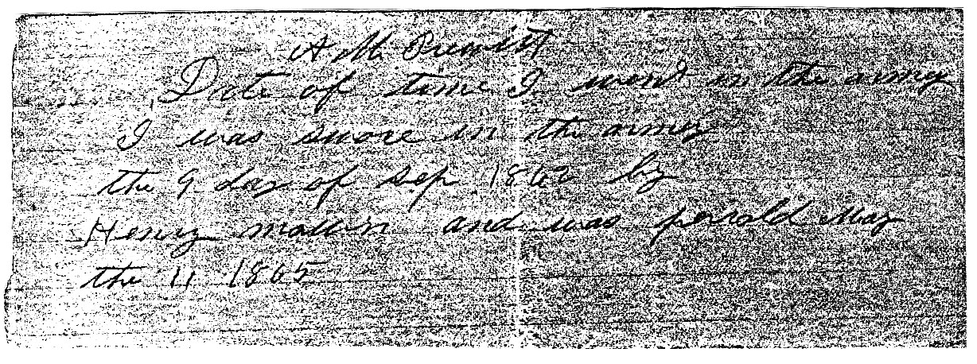

Alexander married Christi Ann Turner at her fathers house in Jasper Co., TX on Sept. 19, 1867. Christi was born in Jasper Co., TX on Dec. 16, 1848 to Maddison A. Turner and Catherine McFarland.
Alexander and Christi were the parents of twelve children:

(6(11)11) William Moses Prewitt, b. July 17, 1869 Jasper Co., TX
(6(11)12) John Matthew Prewitt, b. June 11, 1870 Jasper Co., TX
(6(11)13) Mathilda J. Prewitt, b. June 21, 1872 Jasper Co., TX; died in Jasper Co., TX on Nov. 2,
1883; br. Zion Hill Cem., Jasper Co., TX*
(6(11)14) Elizabeth "Lizzie" Prewitt (twin), b. March 11, 1875 Jasper Co., TX; never married; died on
Sept. 25, 1969; br. Zion Hill Cem., Jasper Co., TX*
(6(11)15) M. James "Jim" Prewitt (twin), b. March 11, 1875 Jasper Co., TX; m. 1st: Dicie McLeod; m.
2nd: Annie Hayes; and did not have children; died in Jasper Co., TX on April 7, 1964; br.
Magnolia Springs Cem., Jasper Co., TX*
(6(11)16) Larkin Camuel Prewitt, b. Dec. 27, 1877 Jasper Co., TX
(6(11)17) Dora C. Prewitt (twin), b. April 12, 1881 Jasper Co., TX
(6(11)18) Cora Ann Prewitt (twin), b. April 12, 1881 Jasper Co., TX
(6(11)19) infant, b. & d. 1884 Jasper Co., TX; br. Zion Hill Cem., Jasper Co., TX*
(6(11)1(10) Andrew O.K. Prewitt, b. March 8, 1885 Jasper Co., TX
(6(11)1(11) Charlie Alexander Prewitt, b. April 25, 1888 Jasper Co., TX
(6(11)1(12) Della Prewitt, b. Nov. 10, 1891 Jasper Co., TX

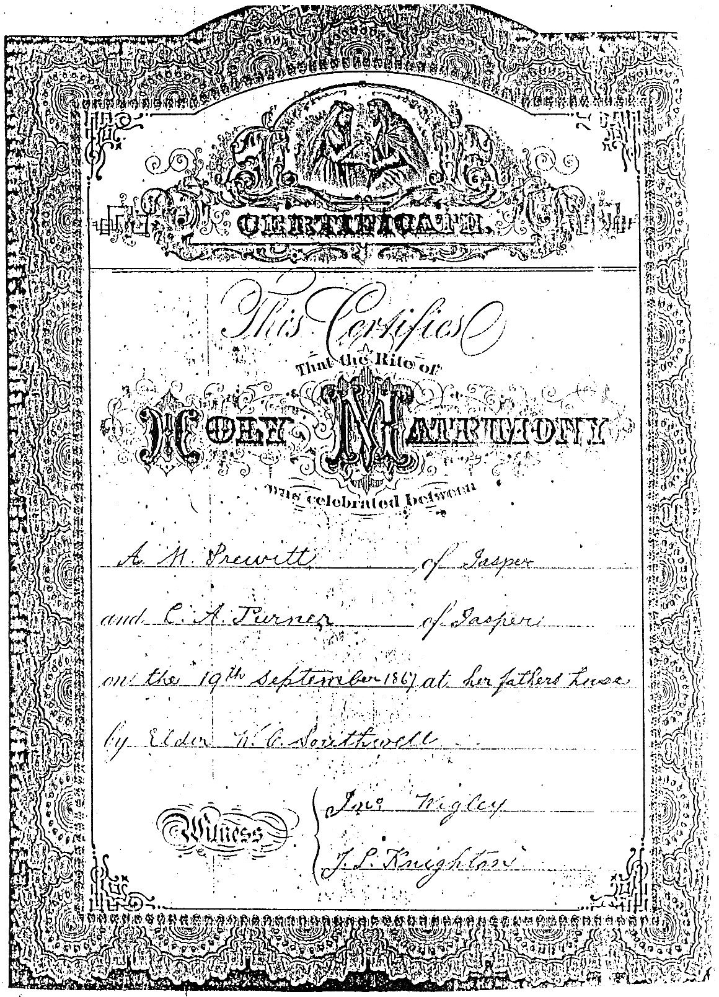
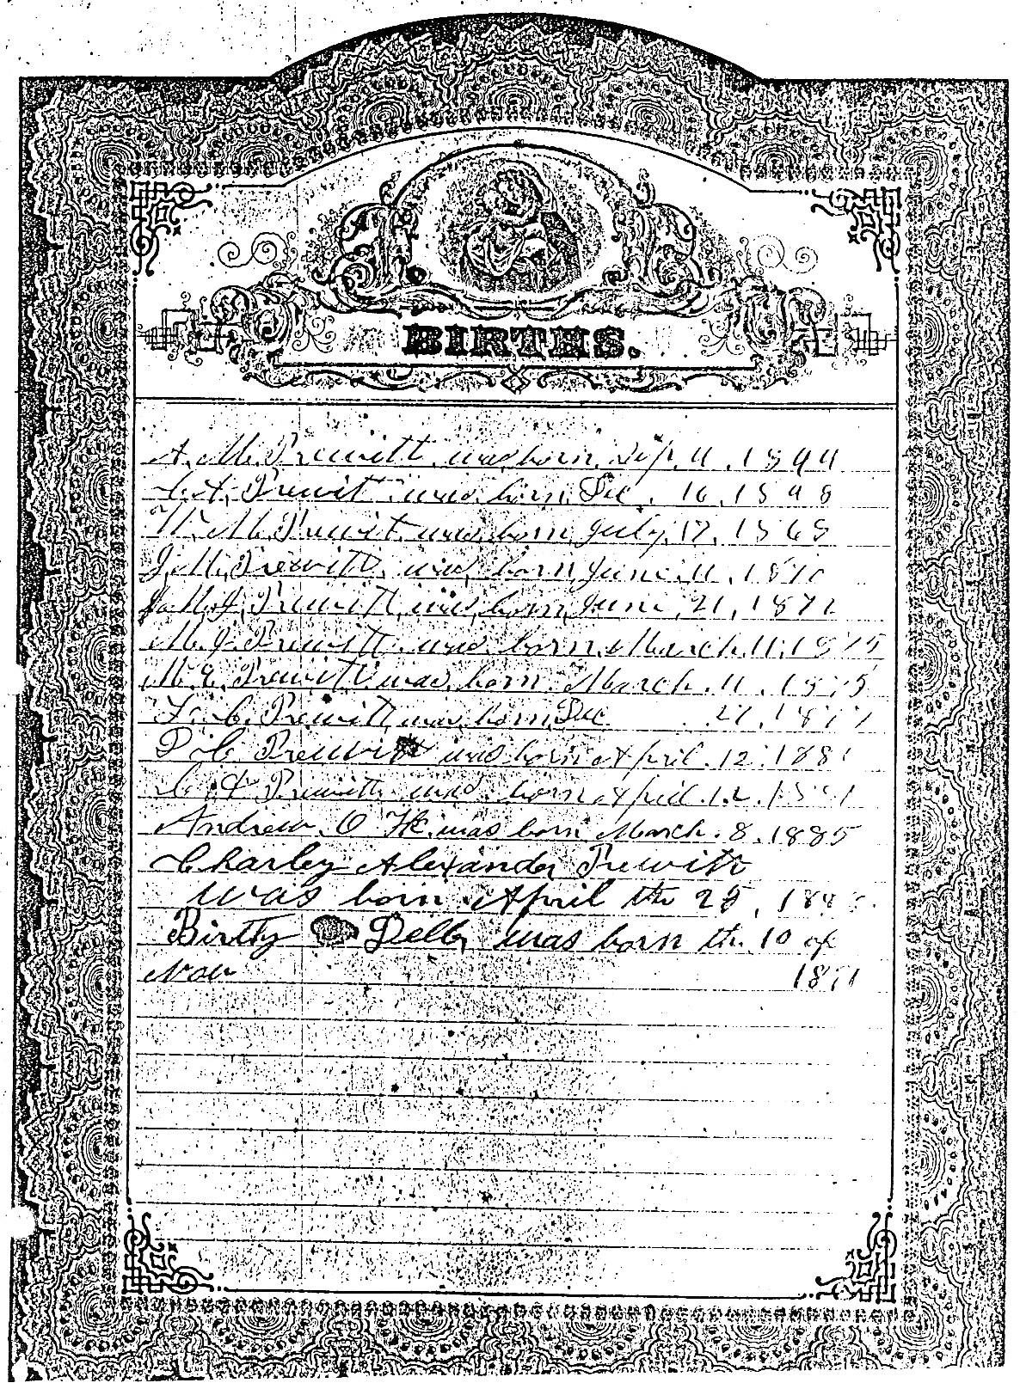

HUGH URIAH PRUITT

The 1880 Census, Jasper Co., TX, Vol. 19, Ed 38, sheet 7, line 3, Justice Prec. 3, lists:

Alexander M. Prewitt 30 LA
Crissa 30 TX
William 13 TX
John 10 TX
Matilda 8 TX
James 6 TX
Elizabeth 6 TX
Larkin 3 TX

Alexander died at his home in the Beech Grove Community, Jasper Co., TX on Feb. 21, 1935, and Christi died there on March 10, 1941. Both were buried in Zion Hill Cem., Jasper Co., Texas.

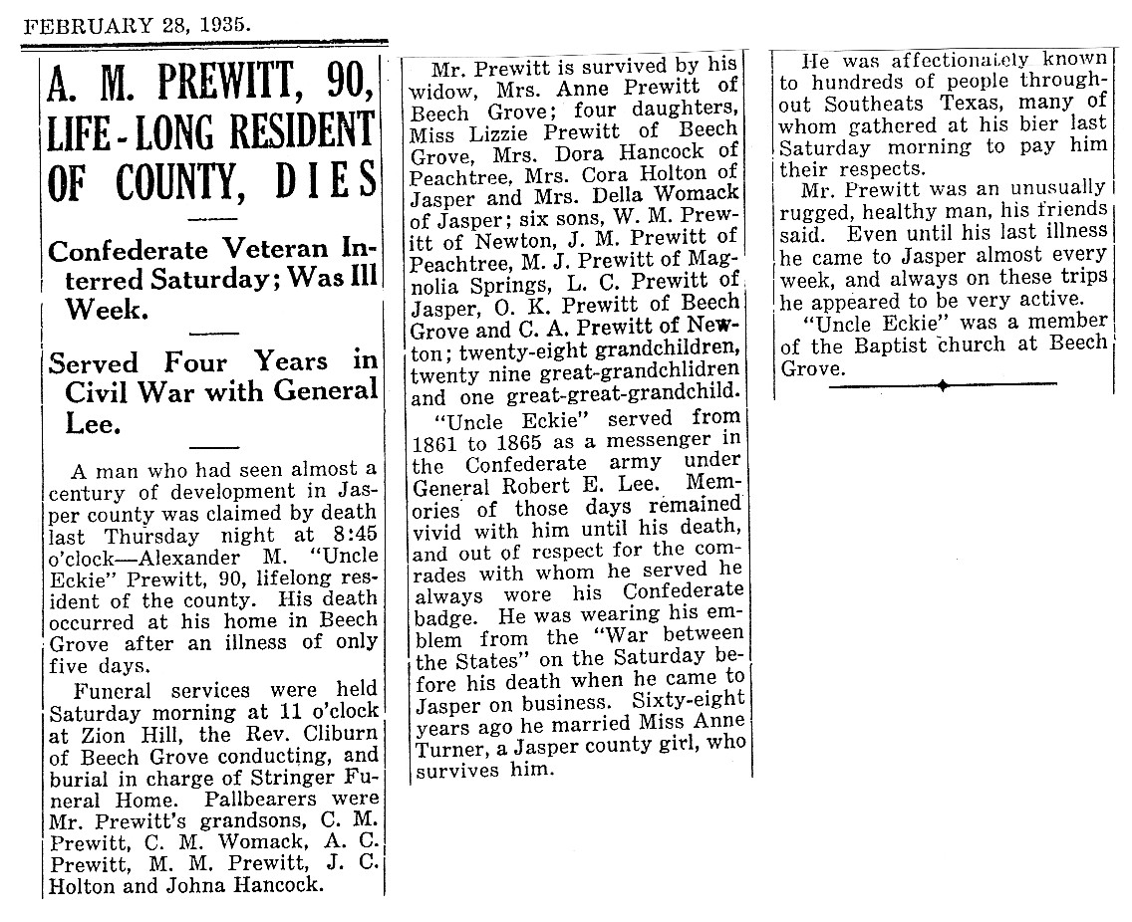

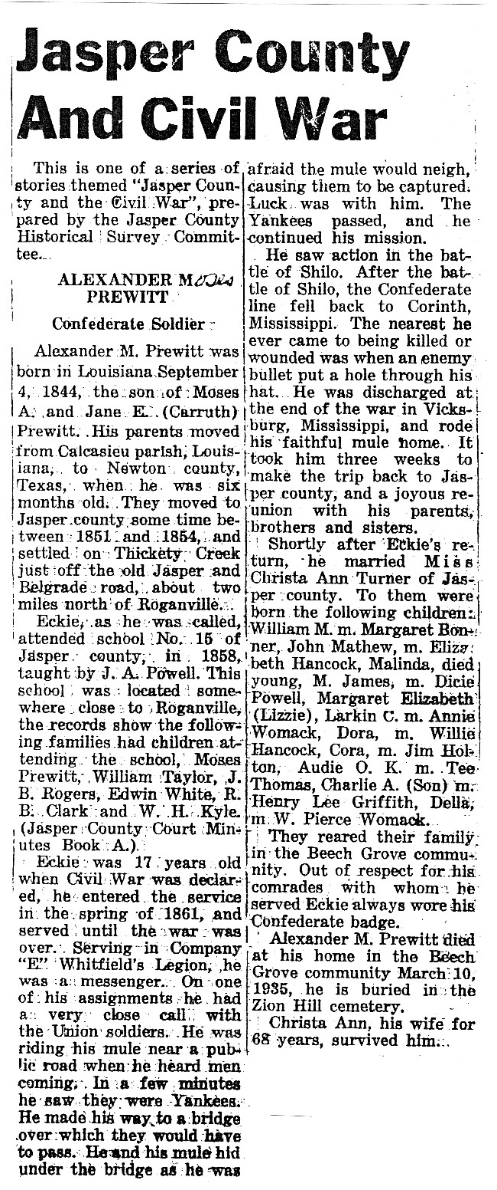

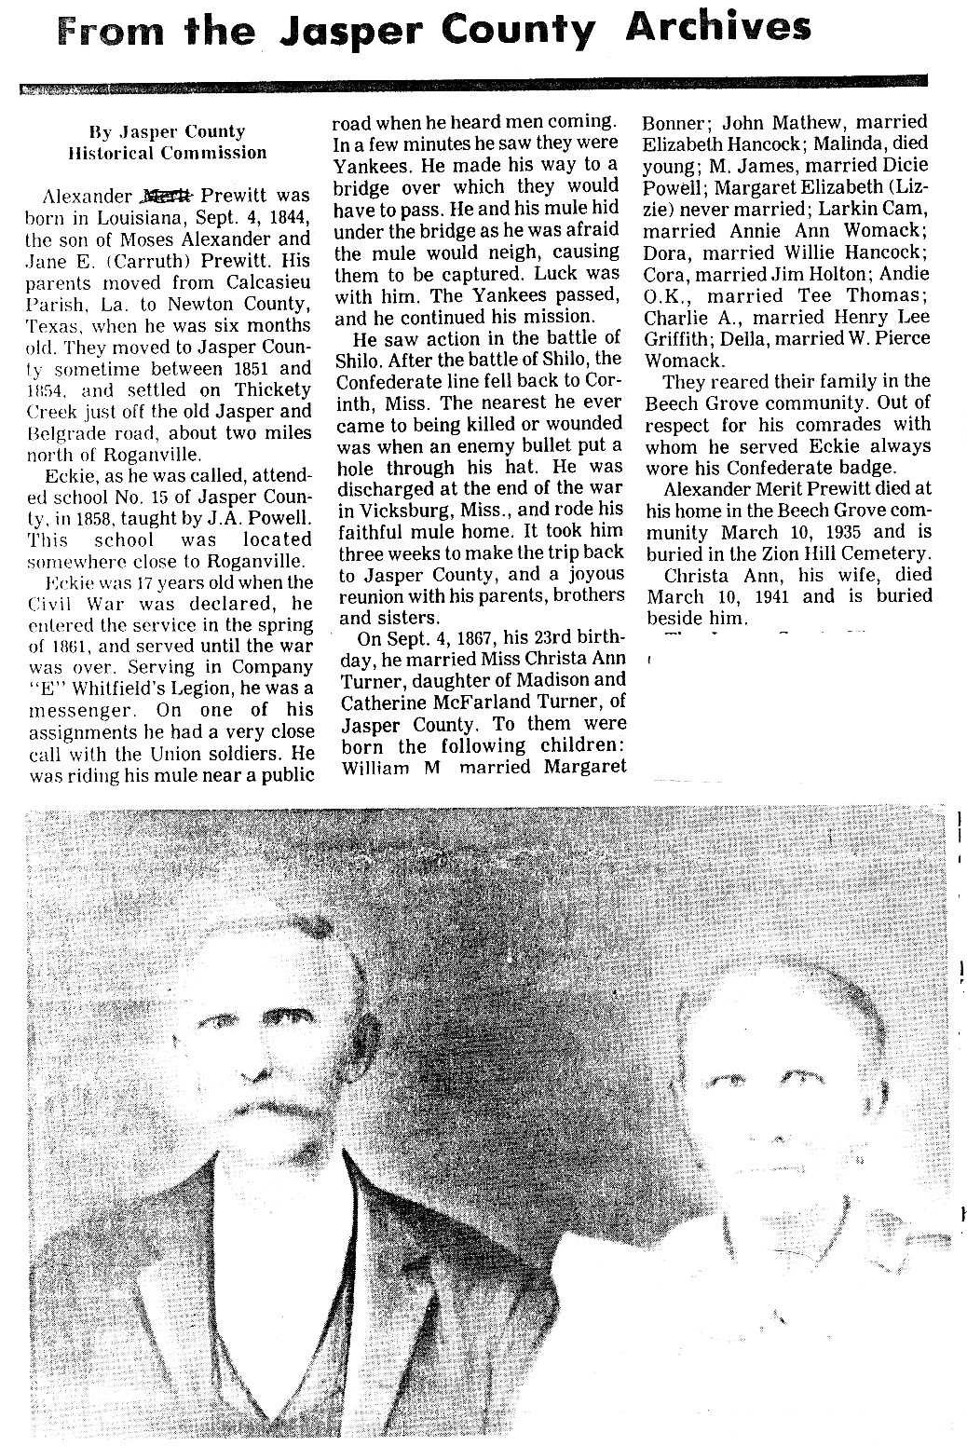

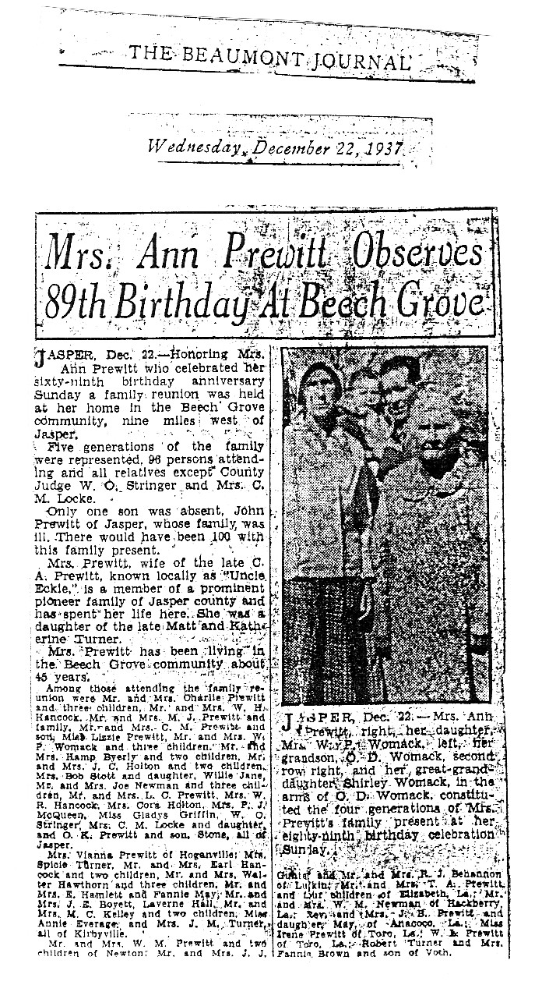

HUGH URIAH PRUITT

(6(11)11) WILLIAM MOSES PREWITT (son of Alexander Moses Prewitt and Christi Ann Turner) was born in Jasper Co., TX on July 17, 1869, and married first: Margaret Bonner on Dec 22, 1892. Margaret was born on Aug. 24, 1865. William and Margaret had three children:

(6(11)111) Thomas Alvin Prewitt, b. 1893 LA
(6(11)112) Mathilda Prewitt, b. 1895
(6(11)113) William Cade Prewitt, b. April 26, 1898

Margaret died on Sept. 8, 1916, and was buried in Merryville, Louisiana. William married second: Hattie Robbins.
William died in Newton Co., TX on May 12, 1947, and was buried in Merryville, Louisiana.

(6(11)111) THOMAS ALVIN PREWITT (son of William Moses Prewitt and Margaret Bonner) was born in Louisiana in 1893. He married Mae McDonald, and had four children:

(6(11)1111) Roy Alvin Prewitt, b. 1918*
(6(11)1112) Agnes Prewitt, b. 1920*
(6(11)1113) Hazel Prewitt, b. 1922*
(6(11)1114) Thomas Prewitt, b. 1924*

(6(11)112) MATHILDA PREWITT (dau. of William Moses Prewitt and Margaret Bonner) was born in 1895. She married Henry Parker, and had the following children:

(6(11)1121) Ann Parker*
(6(11)1122) Marjorie Parker*
(6(11)1123) Frank Parker*
(6(11)1124) William C. Parker*
(6(11)1125) Ruth Parker*
(6(11)1126) Lois Mae Parker*
(6(11)1127) Henry Parker, Jr.*
(6(11)1128) Douglass "Peck" Parker*

(6(11)113) WILLIAM CADE PREWITT (son of William Moses Prewitt and Margaret Bonner) was born on April 26, 1898, and married Irene Coward on Dec. 26, 1919,
They were the parents of six children:

(6(11)1131) Alvin Ray Prewitt, b. 1920*
(6(11)1132) Christine Prewitt, b. 1923*
(6(11)1133) Blewitt Prewitt, b. 1925*
(6(11)1134) Donald Prewitt, b. 1929*
(6(11)1135) Peggy Jane Prewitt, b. 1932*
(6(11)1136) Brenda Sue Prewitt, b. 1940*

William died on March 23, 1940, and was buried in Merryville, Louisiana.

(6(11)12) JOHN MATTHEW PREWITT (son of Alexander Moses Prewitt and Christi Ann Turner) was born in Jasper Co., TX on June 11, 1870, and married Elizabeth "Betty" Hancock in Jasper Co., TX on Dec. 13, 1894. Elizabeth was born in 1871 to John Hancock and Sallie Griffin.
John and Elizabeth had two children:

(6(11)121) Marvin M. Prewitt, b. Oct. 26, 1895 Jasper Co., TX
(6(11)122) Minnie E. Prewitt, b. July 21, 1898 Jasper Co., TX

Elizabeth died in Jasper Co., TX on March 14, 1939, and John died there on Feb. 22, 1962. Both were buried in Hancock Cemetery, Jasper Co., Texas.

(6(11)121) MARVIN M. PREWITT (son of John Matthew Prewitt and Elizabeth Hancock) was born in Jasper Co., TX on Oct. 26, 1895. He married Evelyn Graham in Jasper Co., TX on Sept. 5, 1917, and had four children:

(6(11)1211) Lela Mae Prewitt*
(6(11)1212) Marvin Allen Prewitt*
(6(11)1213) James Edward Prewitt*
(6(11)1214) Betty Sue Prewitt*

Marvin died on Jan. 17, 1973, and was buried in Hancock Cemetery, Jasper Co., Texas.

(6(11)122) MINNIE E. PREWITT (dau. of John Matthew Prewitt and Elizabeth Hancock) was born in Jasper Co., TX on July 21, 1898. She married Thomas Stott in Jasper Co., TX on May 12, 1921, and had a son:

(6(11)1221) Thomas Stott, Jr.*

Minnie died on Aug. 7, 1993, and was buried in Hancock Cemetery, Jasper Co., Texas.

(6(11)16) LARKIN CAMUEL PREWITT (son of Alexander Moses Prewitt and Christi Ann Turner) was born in Jasper Co., TX on Dec. 27, 1877, and married Annie Womack in Jasper Co., TX on May 8, 1904. Annie was born on Aug. 26, 1882 to Franklin G. Womack and Dixie Hancock.
Larkin and Annie had the following children:

(6(11)161) infant, b. & d. 1905 Jasper Co., TX*
(6(11)162) Carvis Prewitt, b. 1906; died in 1962*
(6(11)163) Charles Ruel Prewitt, b. March 25, 1908
(6(11)164) A. C. Prewitt, b. 1909; m. Edith Gordon on May 24, 1934*
(6(11)165) Camuel Otis Prewitt, b. 1912

HUGH URIAH PRUITT

(6(11)166) Elton Lequin Prewitt, b. 1918
(6(11)167) M. Catherine Prewitt, b. 1923; died in Jasper Co., TX in 1930; br. Jasper City Cem.*

Larkin died in Jasper Co., TX on Aug. 18, 1944, and was buried in Jasper City Cemetery.

(6(11)163) CHARLES RUEL PREWITT (son of Larkin Camuel Prewitt and Annie Womack) was born on March 25, 1908. He married Geneva Lively on Jan. 19, 1928, and had a son:

(6(11)1631) Charles Ray Prewitt*

Charles died in Jasper Co., TX, and was buried in the Jasper City Cemetery.

(6(11)165) CAMUEL OTIS PREWITT (son of Larkin Camuel Prewitt and Annie Womack) was born in 1912. He married Georgia Scarborough on Nov. 20, 1937, and had a son:

(6(11)1651) Dewayne Prewitt*

(6(11)166) ELTON LEQUIN PREWITT (son of Larkin Camuel Prewitt and Annie Womack) was born in 1918. He married Velvia Wright, and had a daughter:

(6(11)1661) Linda Gay Prewitt*

(6(11)17) DORA C. PREWITT (dau. of Alexander Moses Prewitt and Christi Ann Turner) was born in Jasper Co., TX on April 12, 1881, and married William H. Hancock in Jasper Co., TX on Feb. 10, 1904. William was born in Jasper Co., TX on Dec. 17, 1875 to John Hancock and Rebecca Pace.
William and Dora had seven children:

(6(11)171) Earl Hancock, b. 1904
(6(11)172) Loree Hancock, b. 1906
(6(11)173) Sadie Hancock, b. Dec. 9, 1907; died on May 10, 1910; br. Hancock Cem.*
(6(11)174) Bertie F. "Bootie" Hancock, b. 1909; m. Herman Clark on June 11, 1932*
(6(11)175) John A. Hancock, b. 1913*
(6(11)176) Lena Hancock, b. Dec. 21, 1917; m. a Good; and died on Feb. 4, 1939; br. Hancock Cem.*
(6(11)177) Rebecca Ann Hancock, b. March 1921; m. 1st: ? ; m. 2nd: William Carr*

William died in Jasper Co., TX on Nov. 28, 1963, and Dora died there on Aug. 31, 1976. Both were buried in Hancock Cemetery, Jasper Co., Texas.

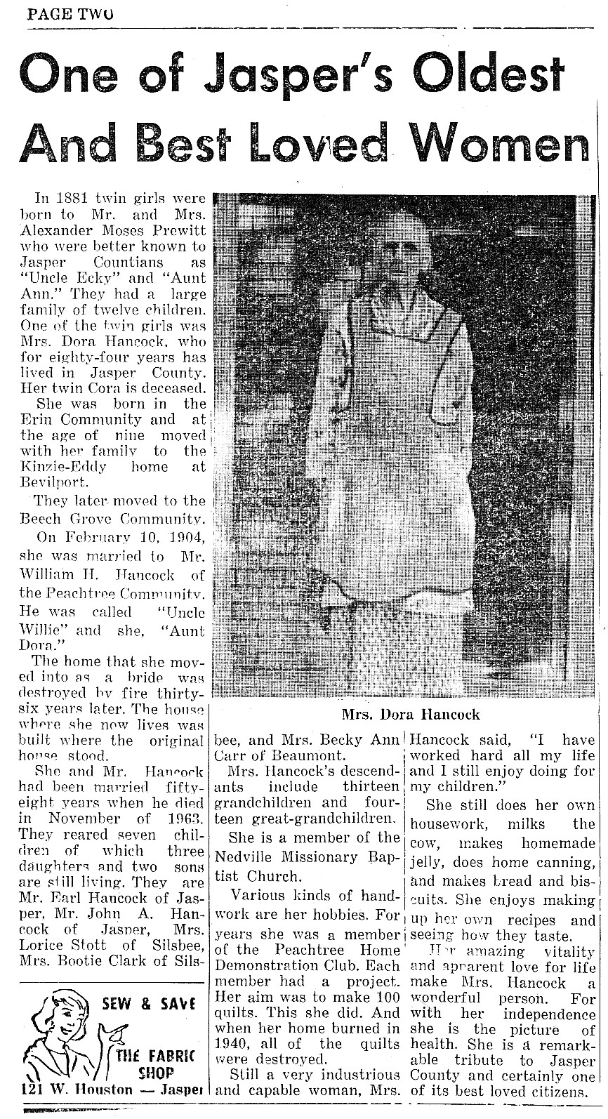
HUGH URIAH PRUITT

(6(11)171) EARL HANCOCK (son of William H. Hancock and Dora C. Prewitt) was born in 1904. He married Mattie Faulkner, and had two children:

(6(11)1711) John Earl Hancock*
(6(11)1712) Austine Hancock*

(6(11)172) LOREE HANCOCK (dau. of William H. Hancock and Dora C. Prewitt) was born in 1906. She married Robert E. "Bob" Stott, and had a daughter:

(6(11)1721) Willie Jane Stott*

(6(11)18) CORA ANN PREWITT (dau. of Alexander Moses Prewitt and Christi Ann Turner) was born in Jasper Co., TX on April 12, 1881, and married James Lucas Holton in Jasper Co., TX on Oct. 17, 1901. James was born in 1880 to William H. Holton and Laura Elizabeth Smith.
James and Cora had five children:

(6(11)181) Clara Holton, b. 1902; died in 1938*
(6(11)182) J.C. Holton, b. Oct. 17, 1903; m. Cordia Coward; and died on April 29, 1963; br. Jasper
City Cem.*
(6(11)183) Albert Holton, b. 1905; died in 1906; br. Zion Hill Cem., Jasper Co., TX*
(6(11)184) Della Holton, b. & d. 1906; br. Zion Hill Cem., Jasper Co.,TX*
(6(11)185) Mildred Holton, b. 1914; m. P.J. McQueen; resided Beaumont, TX; died in 1994*

Cora died in Jasper Co., TX on March 26, 1938, and James died in 1959. Both were buried in Zion Hill Cem., Jasper Co., Texas.

(6(11)1(10) ANDREW O.K. PREWITT (son of Alexander Moses Prewitt and Christi Ann Turner) was born in Jasper Co., TX on March 8, 1885, and married Tee Thomas in Jasper Co., TX on Jan. 25, 1905. Tee was born in Texas on Feb. 27, 1885 to David M. Thomas and Sallie A. Gaigsby.
Andrew and Tee had four children:

(6(11)1(10)1) Ray Prewitt, b. 1906 Jasper Co., TX; died in 1907*
(6(11)1(10)2) Andrew Jackson Prewitt, b. Sept. 16, 1907 Jasper Co., TX; never married; died on Feb.
28, 1967; br. Holton Cem., Jasper Co., TX*
(6(11)1(10)3) Charles M. Prewitt, b. 1910 Jasper Co., TX
(6(11)1(10)4) Sallie Ann Prewitt, b. 1911 Jasper Co., TX; died in 1915*

Tee died in Jasper Co., TX on April 22, 1913, and Andrew died there on May 8, 1977. Both were buried in Holton Cem., Jasper Co., Texas.

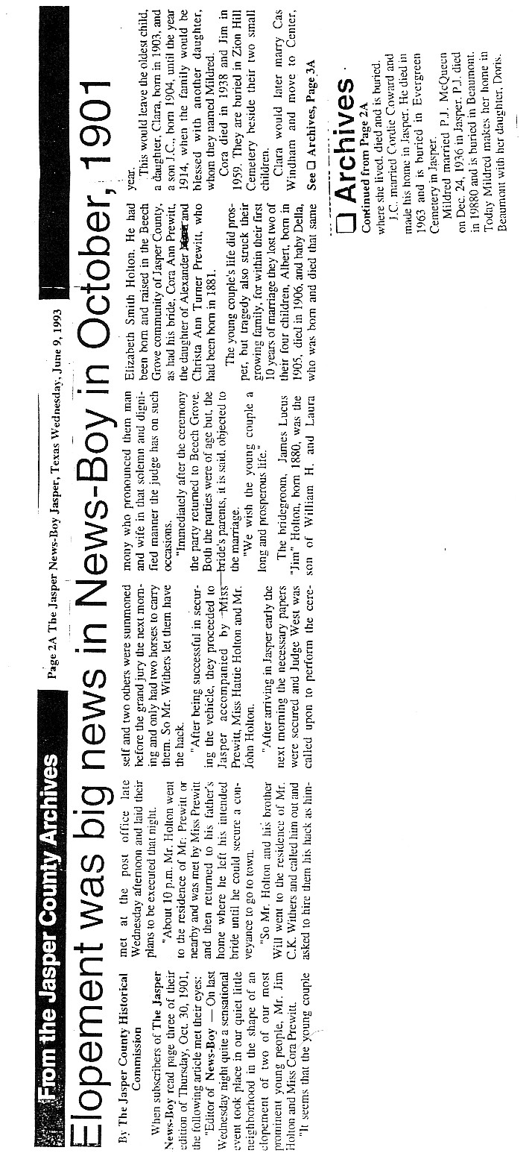
HUGH URIAH PRUITT

(6(11)1(10)3) CHARLES M. PREWITT (son of Andrew O.K. Prewitt and Tee Thomas) was born in Jasper Co., TX in 1910. He married Annie Dean in Jasper Co., TX on March 4, 1933, and had a son:

(6(11)1(10)31) Robert Lee Prewitt, b. 1934; died in 1954*

Charles died in 1969.

(6(11)1(11) CHARLIE ALEXANDER PREWITT (son of Alexander Moses Prewitt and Christi Ann Turner) was born in Jasper Co., TX on April 25, 1888, and married Henry Lee Griffith in Castor, LA on July 6, 1921. Henry was born in Bienville Parish, LA on Dec. 20, 1899 to John Henry Griffith and Julia Ann Elizabeth Foster. Charlie and Henry had three children:

(6(11)1(11)1) Ganata Prewitt, b. April 17, 1922 Claiborne Parish, LA
(6(11)1(11)2) George Donald Prewitt, b. June 25, 1925 Jasper Co., TX; never married*
(6(11)1(11)3) Jimmie Lee Prewitt, b. Aug. 23, 1930 Sabine Co., TX

Charlie died in Jasper Co., TX on May 18, 1975, and Henry died on Nov. 20, 1976. Both were buried in Hancock Cem., Jasper Co., Texas.

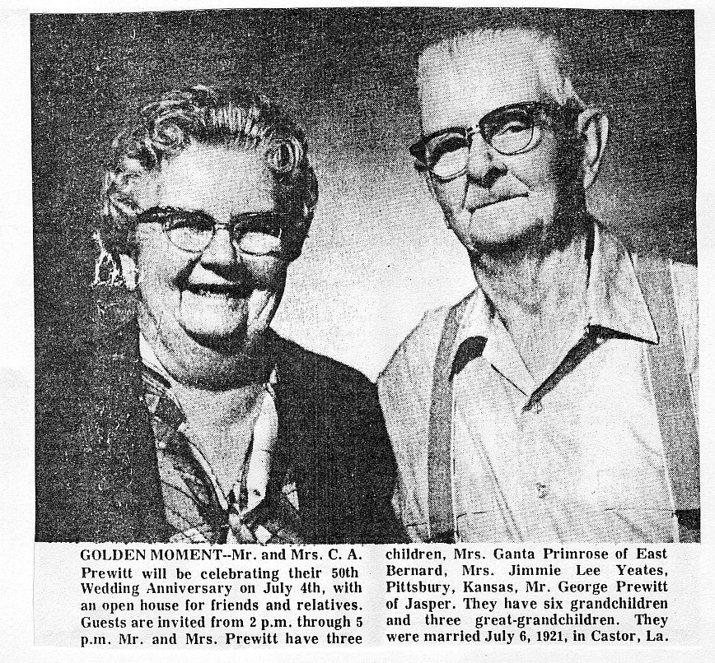

(6(11)1(11)1) GANATA PREWITT (dau. of Charlie Alexander Prewitt and Henry Lee Griffith) was born in Claiborne Parish, LA on April 17, 1922. She married first: A. G. Benton on Aug. 22, 1941, and had two children:

(6(11)1(11)11) Louis D. Benton*
(6(11)1(11)12) Sherilyn Benton*

Ganata married second: Kyle L. Primrose (b. 1924) on June 4, 1948, and had three children:

(6(11)1(11)13) Carl A. Primrose*
(6(11)1(11)14) Ronald L. Primrose*
(6(11)1(11)15) Julia Ann Primrose, b. Nov. 14, 1952 Jasper, TX

They resided in Jasper, Texas.

(6(11)1(11)15) JULIA ANN PRIMROSE (dau. of Kyle L. Primrose and Ganata Prewitt) was born in Jasper, TX on Nov. 14, 1952, and married Michael Taylor Zimmerman in Rosenberg, TX on June 23, 1973. Michael was born in San Benito, TX on Feb. 25, 1954.
Michael and Julia had a son:

(6(11)1(11)151) Michael Craig Zimmerman, b. July 14, 1980 Richmond, TX; had a son, Damian
Omega Zimmerman, b. May 29, 1999 Clear Lake, TX*

Michael was a Minister and Julia was a Homemaker. They resided in Bay City, Texas.

(6(11)1(11)3) JIMMIE LEE PREWITT (dau. of Charlie Alexander Prewitt and Henry Lee Griffith) was born in Sabine Co., TX on Aug. 23, 1930. She married Cecil Rae Yeates in Jasper Co., TX on Sept. 28, 1947, and had a son:

(6(11)1(11)31) Michael Ray Yeates*

(6(11)1(12) DELLA PREWITT (dau. of Alexander Moses Prewitt and Christi Ann Turner) was born in Jasper Co., TX on Nov. 10, 1891, and married William Pierce Womack in Jasper Co., TX on July 14, 1910. William was born in 1886 to Franklin G. Womack and Dixie Hancock.
William and Della had the following children:

(6(11)1(12)1) Odare Womack, b. 1911
(6(11)1(12)2) Charlie M. Womack, b. April 25, 1913
(6(11)1(12)3) Elizabeth Mae Womack, b. Sept. 4, 1919
(6(11)1(12)4) Annie Marie Womack, b. Sept. 4, 1921; m. 1st: George Williams; m. 2nd: F.P. Gray;
and died in Dec. 1993; br. Zion Hill Cem.*
(6(11)1(12)5) William Pierce Womack, Jr., b. March 4, 1932; died on Jan 30, 1948; br. Zion Hill
Cem*

HUGH URIAH PRUITT

William died in 1964, and Della died in Jasper Co., TX on Jan. 31, 1983. Both were buried in Zion Hill Cem., Jasper Co., Texas.

(6(11)1(12)1) ODARE WOMACK (son of William Pierce Womack and Della Prewitt) was born in 1911. He married Opal Dean, and had two daughters:

(6(11)1(12)11) Shirley Womack*
(6(11)1(12)12) Shirell Womack*

Odare died in 1988, and was buried in Hancock Cem., Jasper Co., Texas.

(6(11)1(12)2) CHARLIE M. WOMACK (son of William Pierce Womack and Della Prewitt) was born on April 25, 1913. He married Elva ? , and had a son:

(6(11)1(12)21) Jimmy Dale Womack*

Charlie died on July 13, 1936, and was buried in Zion Hill Cem., Jasper Co., Texas.

(6(11)1(12)3) ELIZABETH MAE WOMACK (dau. of William Pierce Womack and Della Prewitt) was born on Sept. 4, 1919. She married Lynn Robinson, and had the following children:

(6(11)1(12)31) Arthur Lynn Robinson*
(6(11)1(12)32) James Edward Robinson*
(6(11)1(12)33) Mary Robinson*
(6(11)1(12)34) Roy Wayne Robinson*
(6(11)1(12)35) Ruth Anna Robinson*

(6(11)2) WALTER J. PREWITT (son of Moses Alexander Prewitt and Jane Elizabeth Carruth) was born in Newton Co., TX on Aug. 15, 1850. He married Tibitha Ann Wigley in Jasper Co., TX on Nov. 11, 1875. Tibitha was born on March 6, 1850 to Francis Wigley and Sarah Ann Felder.
Walter and Tibitha had three children:

(6(11)21) Laura T. Prewitt, b. July 13, 1878 Jasper Co., TX; m. J. Hardy Griffin in Jasper Co., TX on
Nov. 27, 1901; and died on Jan. 4, 1944; br. Hancock Cem., Jasper Co., TX*
(6(11)22) Thomas Bruce Prewitt, b. July 23, 1880 Jasper Co., TX
(6(11)23) Lenora Leuticia Prewitt, b. Feb. 24, 1882 Jasper Co., TX; m. Shadrick W. Griffin in Jasper
Co., TX on March 10, 1907; and died in Jasper Co., TX on Feb. 24, 1921; br. Hancock
Cem., Jasper Co., TX*
(6(11)24) Ida Prewitt, b. 1884 Jasper Co., TX; died in Jasper Co., TX in 1886; br. Hancock Cem.,
Jasper Co., TX*

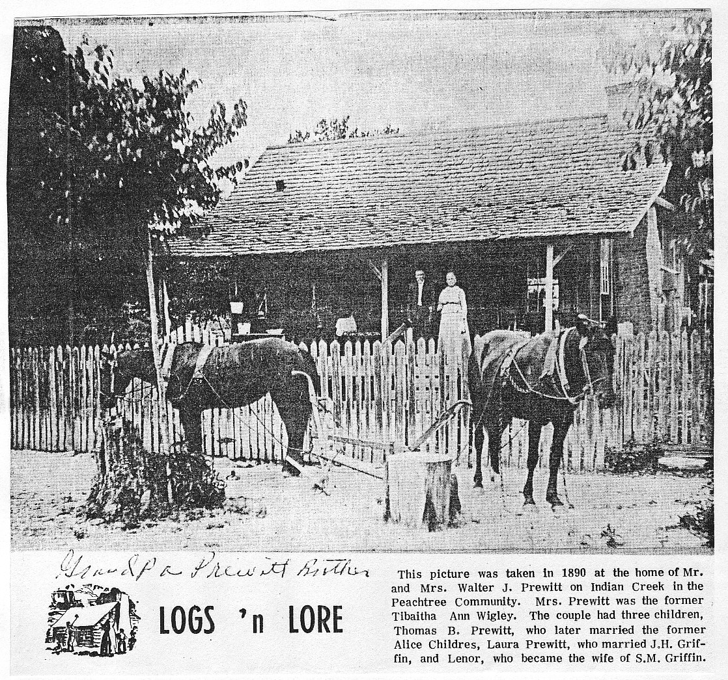

The 1880 Census, Jasper Co., TX, Vol. 19, Ed 38, sheet 8, line 1, Justice Prec. 3, lists:

Walter Prewitt 29 TX
Tabitha 29 TX
Laura T. 2 TX

Walter died in Jasper Co., TX in Aug. 1913, and Tibitha died there on July 8, 1919. Both were buried in Hancock Cem., Jasper Co., Texas.

HUGH URIAH PRUITT

(6(11)22) THOMAS BRUCE PREWITT (son of Walter J. Prewitt and Tibitha Ann Wigley) was born in Jasper Co., TX on July 23, 1880. He married first: Alice Childers on Feb. 14, 1904, and had two children:

(6(11)221) Esca M. Prewitt, b. 1906*
(6(11)222) Jall Cecil Prewitt, b. 1908*

Thomas married second: Lou Ella Sheffield on April 13, 1921, and had a daughter:

(6(11)223) Kathleen Prewitt, b. 1922*

Thomas died in Jasper Co., TX on Jan. 10, 1940, and was born in Hancock Cem., Jasper Co., Texas.

(6(11)4) LARKIN M. PREWITT (son of Moses Alexander Prewitt and Jane Elizabeth Carruth) was born in Jasper Co., TX on June 9, 1856, and married Vianne Griner. Vianne was born on Nov. 10, 1860 to William Griner and Mary Ann Nelms.
Larkin and Vianne were the parents of nine children:

(6(11)41) Dalton Boyce Prewitt, b. 1887 Jasper Co., TX; m. Cassie Kelly in Jasper Co., TX on Nov.
17, 1912; and died in Jasper Co., TX in 1955; br. Zion Hill Cem., Jasper Co., TX*
(6(11)42) Tincie Prewitt, b. Feb. 8, 1888 Jasper Co., TX; m. A. Bishop in Jasper Co., TX on Nov. 17,
1912; and died on Nov. 16, 1926; br. Zion Hill Cem., Jasper Co., TX*
(6(11)43) Lilla Jane Prewitt, b. Jan. 15, 1891 Jasper Co., TX; m. L.C. Wigley in Jasper Co., TX on
Sept. 17, 1922; and died on Aug. 31, 1964; br. Zion Hill Cem., Jasper Co., TX*
(6(11)44) infant, b. & d. 1892 Jasper Co., TX; br. Zion Hill Cem., Jasper Co., TX*
(6(11)45) Edna Gertrude Prewitt, b. 1893 Jasper Co., TX; m. C.P. Pilgrim in Jasper Co., TX on Aug.
18, 1923; and died in 1961; br. Jasper City Cem.*
(6(11)46) Thomas Briton Prewitt, b. Nov. 5, 1896 Jasper Co., TX; died in Jasper Co., TX on March
17, 1914; br. Zion Hill Cem., Jasper Co., TX*
(6(11)47) Annie Prewitt; m. David Byron on June 16, 1920; and died in 1978*
(6(11)48) Jesse Prewitt; m. Effie Marshall on Sept. 27, 1914*
(6(11)49) William Moses Prewitt, b. Nov. 21, 1900 Jasper Co., TX; m. Effie Thelma Weaver in Jasper
Co., TX on Sept. 4, 1942; and died in Austin, TX on Feb. 27, 1983*

Larkin died in Jasper Co., TX on Sept. 24, 1927, and Vianne died there on Aug. 7, 1940. Both were buried in Zion Hill Cem., Jasper Co., Texas.

JESSE PRUITT

(7) JESSE PRUITT (son of Beasley Pruitt and Eleanor Humpherys) was born in Natchez Dist., MS in 1793, and served in the 12th & 13th Consolidated Regiments, LA Militia of Capt. Beckhams Company, War of 1812. Jesse married Harriet Adams in Rapides Parish, LA in 1818. Harriet was born in South Carolina in 1802. Jesse and Harriet had four children:

(71) Elisha Pruitt, b. Sept. 27, 1818 Rapides Parish, LA
(72) Martha Pruitt, b. 1821 Rapides Parish, LA*
(73) Sarah Pruitt, b. 1824 Atascosita Dist., TX*
(74) Cynthia Pruitt, b. 1825 Atascosita Dist., TX*

The 1826 Census of Atascosita Dist., Texas (Vol. 1, no. 4, 1963 Texana), July 31, 1826, lists:

Jesse Prewitt 33 MS farmer & stockraiser
Harriet 24 SC 2 slaves over 14
Martha 5 LA
Elisha 7 LA
Sarah 2 TX
Cynthia 1 TX

On April 23, 1831, Land Titles, Texas General Land Office Houston: Beasley Prewit land on Trinity River adjoining Jessie Prewit.
Jesse and Harriet must have died in 1831. Isaac Harris was appointed guardian of Elisha Pruitt. None of the other children show up in other family listings.

(71) ELISHA PRUITT (son of Jesse Pruitt and Harriet Adams) was born in Rapides Parish, LA on Sept. 27, 1818. His parents apparently died in 1831. Isaac Harris became Elisha's guardian in 1831, and Elisha went to live with Isaac. Isaac Harris received a land grant in Bastrop Co., TX in 1832, and served in the Army of the Republic with Elisha. Elisha was a veteran of the Battle of San Jacinto in 1836. Elisha didn't participate in the battle, but was a member of Capt. Jesse Billingsley's Company, and was assigned to guard the baggage and the sick stationed in the camp opposite Harrisburg on April 21, 1836 (Land of Good Water: A Williamson Co., Texas History by Clara Stearns Scarbrough). Elisha Prewitt and Isaac Harris are listed as members of Captain Jesse Billingsley Company (The Louis W. Kemp Papers, Texas State Archives, p. 41).
Elisha Prewitt received Donation Cert. 866 for 640 acres from S. War on May 4, 1839 for being on the baggage detail at Harrisburg. 640 acres in Burnet County was paid to Elisha on Dec. 6, 1847 (Bounty and Donation Land Grants of Texas, 1835-1888, by Thomas Lloyd Miller).
The 1840 Census of Bastrop Co., Texas lists: Elisha Pruett with 1,479 acres. Elisha Prewett, Corpl. was listed with David C. Cadys Texas Mounted Rangers in the Mexican War. Mustered into service Oct. 1, 1845 and mustered out of service on Dec. 31, 1845 (Texas Veterans in the Mexican War). A supply list dated March 18, 1848, Austin, TX, made out from Elisha Prewitt to Lamar Moore, requested Capt. L.T. Rop ? pay the sum of $18.33 out of the first money drawn for his services as a member of his company of Texas rangers.
Elisha and Isaac stayed in Bastrop County until about 1849, when Elisha moved to Williamson Co., TX, and Isaac moved just across the county line to Burnet County. They apparently stayed friends, for they went to California together, and Isaac attested to Elisha's pension application in 1879.

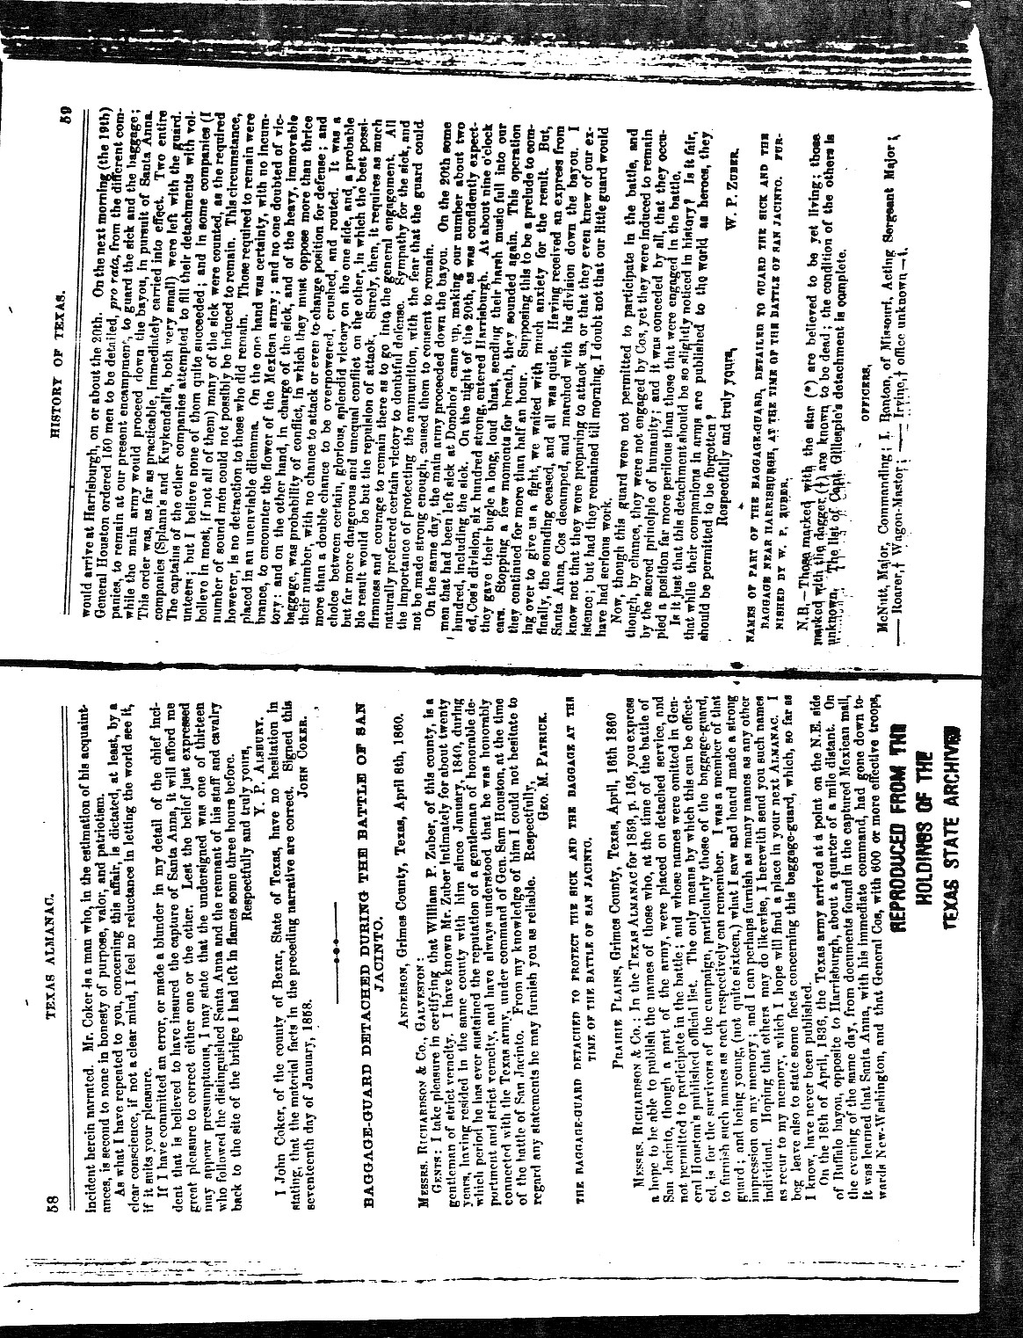
JESSE PRUITT

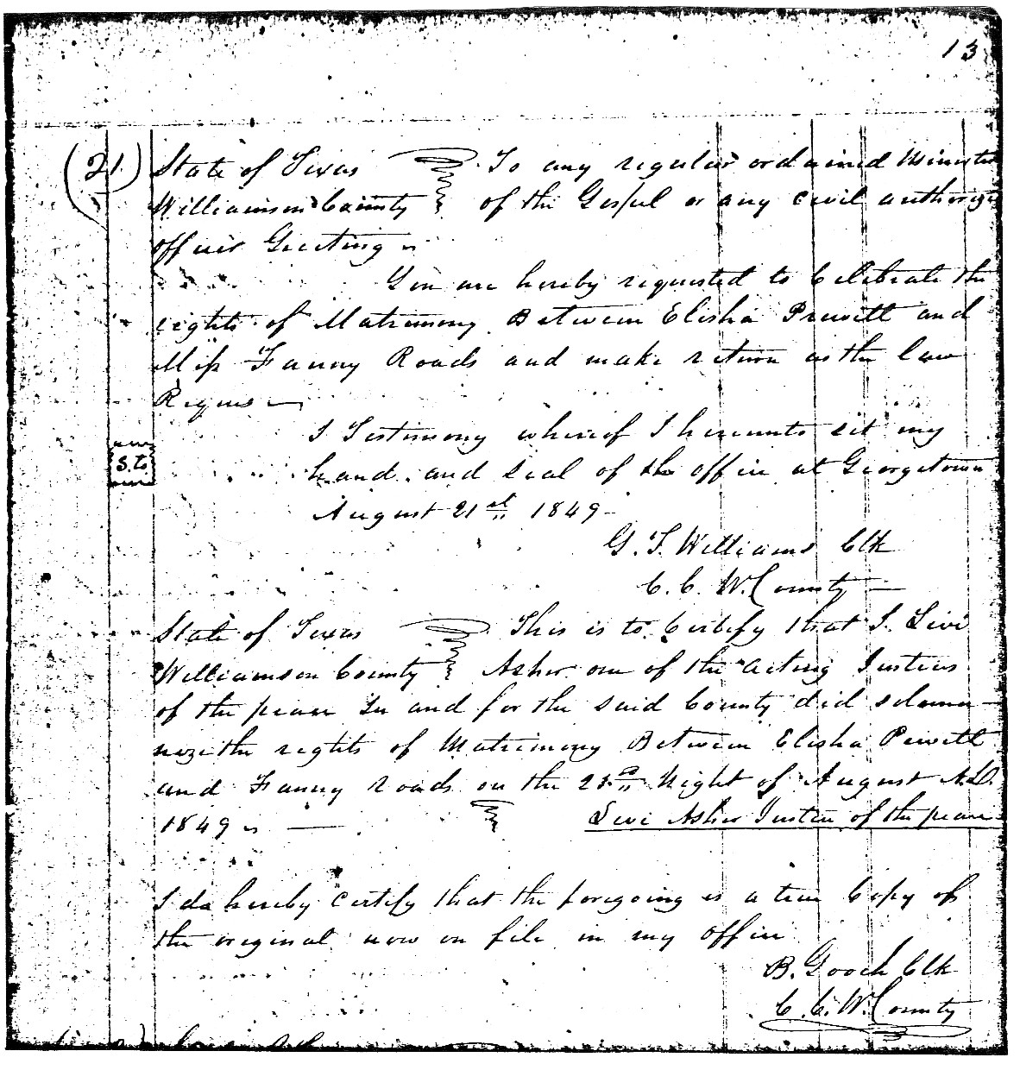

Elisha married first: Frances "Fanny" (Rhodes) Jenkins in Jollyville, TX on Aug. 23, 1849. Frances was born in Lincoln Co., NC in 1821 to Elisha Rhodes and Rachel Dillen.

Elisha and Frances were the parents of six children:

(711) James Sherod Prewitt, b. June 4, 1850 Travis Co., TX
(712) Aaron Daniel Prewitt, b. March 25, 1852 Travis Co., TX
(713) Henry Weatherton Prewitt, b. March 5, 1854 TX
(714) John Jesse Prewitt, b. Jan. 31, 1856 TX
(715) Fannie Lavinia Prewitt, b. July 12, 1858 TX
(716) Martha Sarah "Mattie" Prewitt, b. Jan. 13, 1861 Jollyville, TX

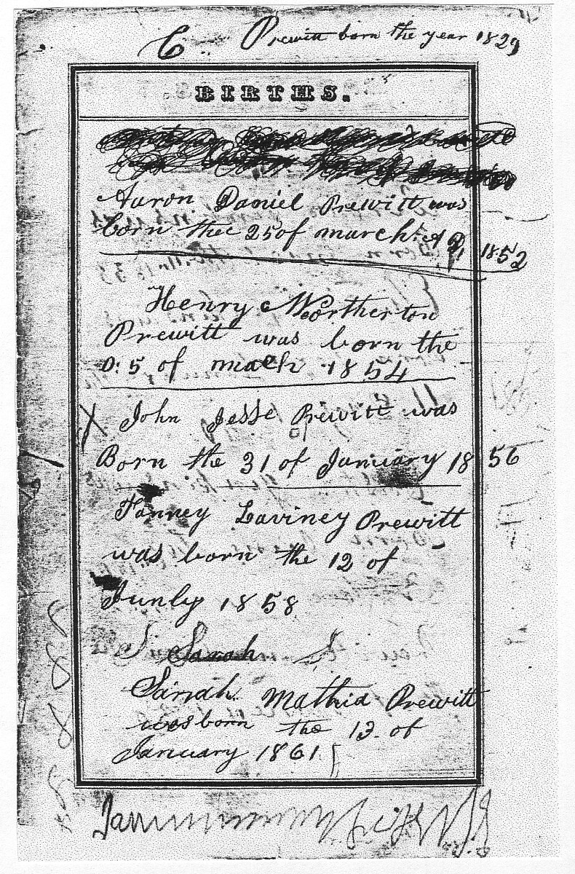

JESSE PRUITT

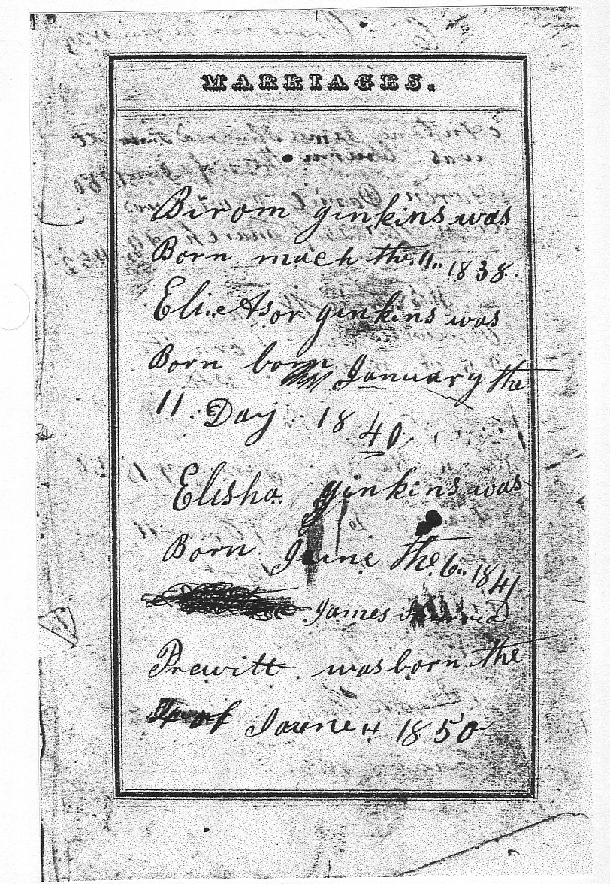

The 1850 Census, Williamson Co., TX, no. 51, lists:

Elisha Prewett 30 LA farmer $900
Frances 29 NC
Byrum Jenkins 12 NC
Eliazer Jenkins 10 NC

The 1860 Census, Travis Co., TX, P.O. Merrittown, p. 239, lists:

Elisha Prewitt 46 LA farmer
Frances 44 NC
James 9 TX
Aaron 8 TX
Henry 6 TX
John 4 TX
Ann 1 TX

In 1870, Elisha moved to Merced Co., California. Isaac Harris and his family were in California for some time before Elisha and his family moved to California. In an undated letter from Sarah Harris to Fannie Prewitt, Sarah Harris offers Sarah Prewitt and Jesse Prewitt a horse if they move to California with her. A State of California, Merced County, receipt dated 1871, for the purchase of a wagon running-gear, made out to "Faney Pruitt", from Rachel Rhodes, witnessed by: H.C. McClure and Mary Harris, shows that Elisha's wife, Fannie, his mother-in-law, Rachel, and Isaac Harris's family were with him while in California. Records have not shown the exact date Elisha returned to Texas. In a leather-bound journal Elisha kept, he recorded "the Last drive of Colorado (cattle drive) the 16th of April 1874." It is said that Elisha Prewitt returned to Texas in 1877. Isaac Harris' son, Jesse Harris, married Sarah Rhodes, sister of Fannie.

The 1880 Census, Williamson Co., TX, lists:

Elisha Prewitt 60 LA
Frances 59 NC
Aaron 28 TX
Sarah 19 TX

Frances died in Williamson Co., TX on Oct. 10, 1880. After Frances died, Elisha married second: Mrs Sarah J. Grimes, a widow, in Liberty Co., TX on May 30, 1883. Photographs from Rose Crowson's collection identifies one: taken at Apex Studio in Houston, Texas as Grandmother Grimes. Another: taken at Grondal Galleries, Round Rock, Texas is Laura Grimes, who was probably the daughter of the widow Grimes. Notes from Zettie (Jeffreys) Prewitt, spouse of Charles William Prewitt, mentions this marriage also.
Elisha died in Merced Co., CA on May 12, 1894.

Next is the affidavit of Elisha Prewitt made on Nov. 19, 1870, and attested to by Isaac Harris.

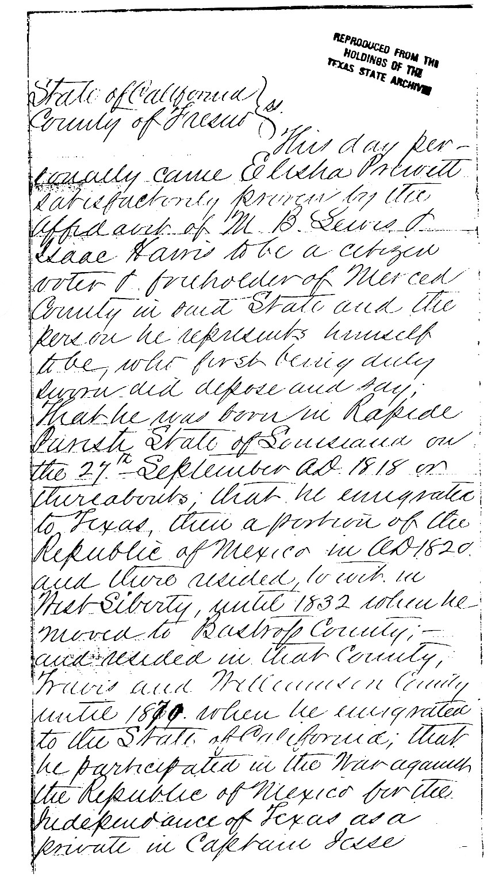
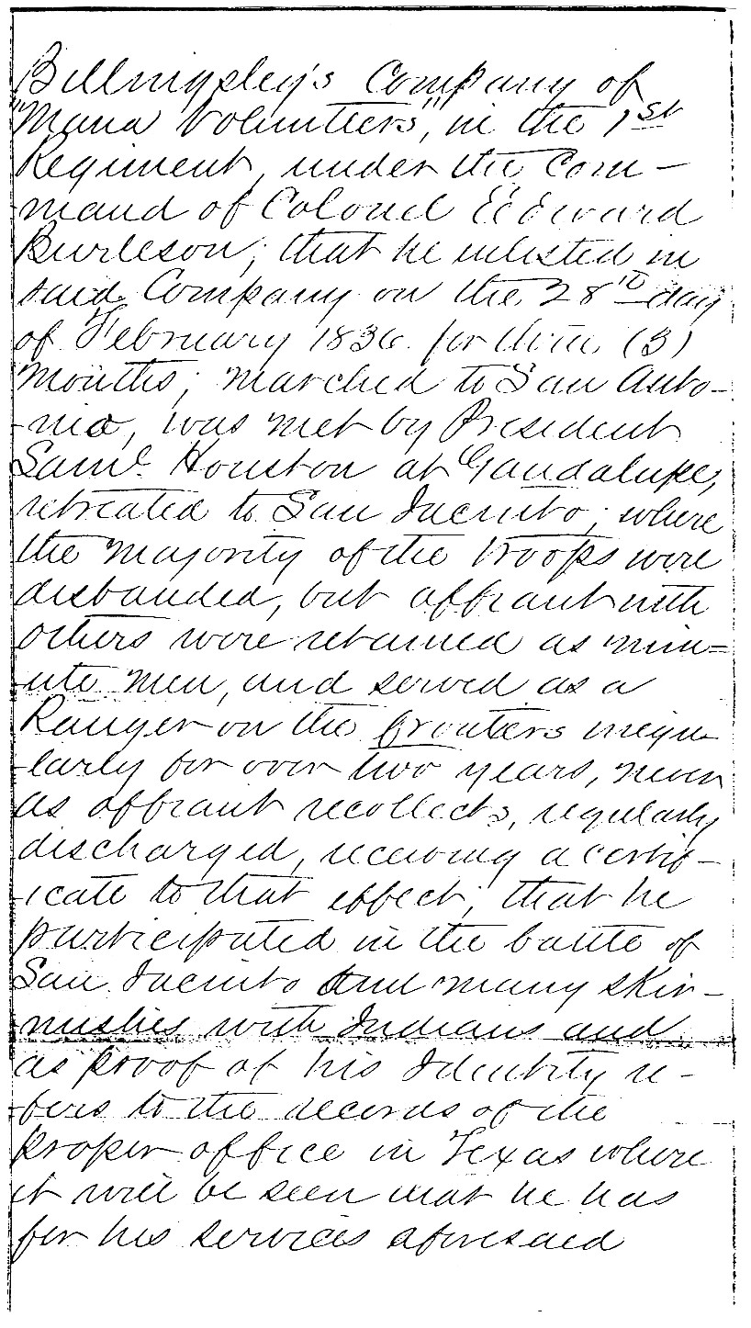
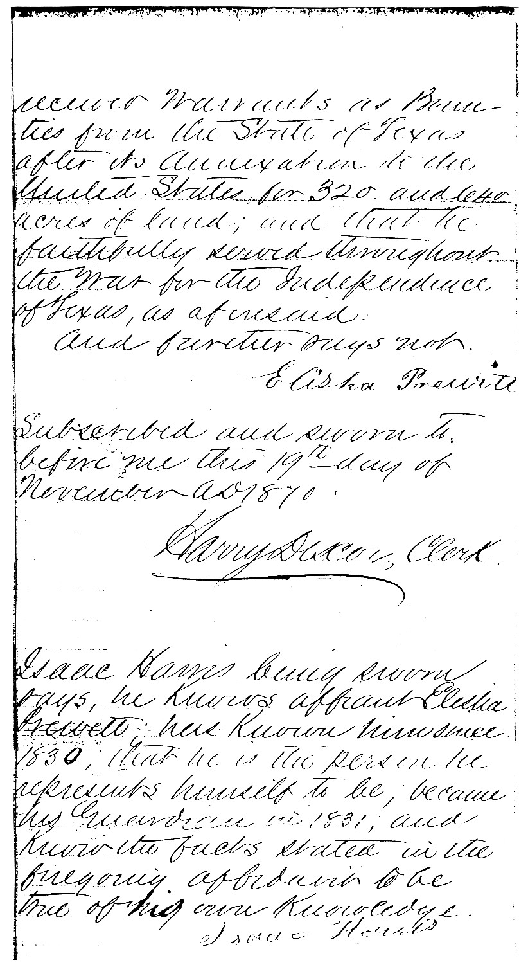

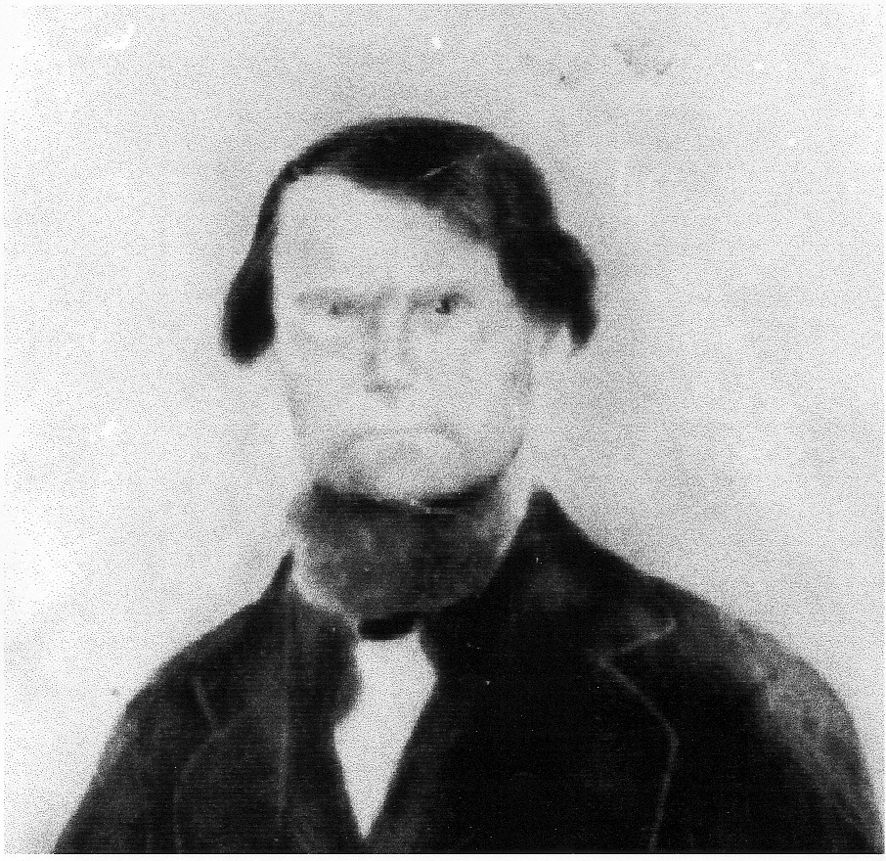

Elisha Prewitt

(711) JAMES SHEROD PREWITT (son of Elisha Prewitt and Frances Rhodes) was born in Travis Co., TX on June 4, 1850, and married Margaret Jane "Maggie" Mays in Travis Co., TX on Oct. 26, 1873. Margaret was born in Burleson Co., TX on June 18, 1858 to Napoleon Mays and Lucinda Walker.
James and Margaret had the following children:

(7111) Elisha Napoleon Prewitt, b. Sept. 17, 1874 Williamson Co., TX
(7112) Jesse Prewitt, b. April 2, 1877; m. Dolly ? *
(7113) Charles William Prewitt, b. Jan. 31, 1884
(7114) Emma Prewitt, b. Feb. 17, 1886*
(7115) Frankie Prewitt, b. July 1888*
(7116) Nellie Prewitt, b. Nov. 24, 1890
(7117) James Arthur Prewitt, b. July 7, 1893
(7118) Ruth Prewitt, b. Jan. 15, 1896*
(7119) Ethel Prewitt, b. March 11, 1898; m. Albert Dearing; resided Austin, TX in 1983*
(711(10) Alice Prewitt, b. Nov. 17, 1901

James died in Jollyville, TX on March 2, 1934, and Margaret died there on June 4, 1947. Both were buried in Rhodes Cem., Jollyville, Texas.

JESSE PRUITT

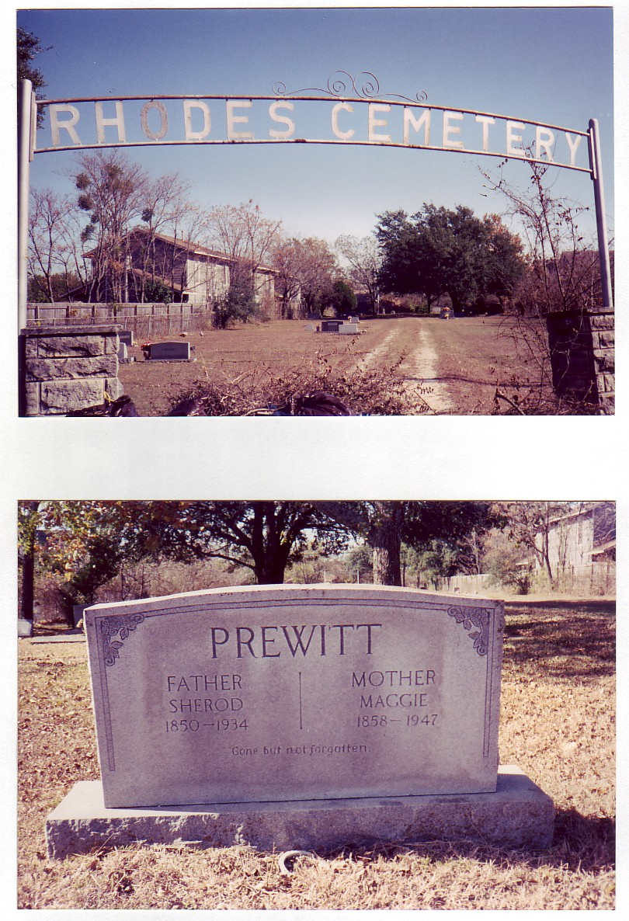

(7111) ELISHA NAPOLEON PREWITT (son of James Sherod Prewitt and Margaret Jane Mays) was born in Williamson Co., TX on Sept. 17, 1874, and married Alice Eugenia Chapman in Williamson Co., TX on Jan. 23, 1897. Alice was born in Williamson Co., TX on May 7, 1874 to William Chapman and Lavina Hyland. Elisha and Alice had a son:

(71111) Alva Prewitt, b. Dec. 4, 1898 Leander, TX

Alice died in Austin, TX on Oct. 18, 1915, and Elisha died there on May 11, 1953.

(71111) ALVA PREWITT (son of Elisha Napoleon Prewitt and Alice Eugenia Chapman) was born in Leander, TX on Dec. 4, 1898. He married Jessie Belle Johnson (b. Feb. 23, 1905 Bee Cave, TX) on Oct. 5, 1922, and had a daughter:

(711111) Shirley Irene Prewitt, b. Dec. 4, 1934 Austin, TX; m. Bruce Hall Barber (b. Oct. 4, 1929
Orange, NJ) on Dec. 17, 1955; resided Georgetown, TX*

They resided in Austin, Texas. Alva died on Feb. 15, 1987.

(7113) CHARLES WILLIAM PREWITT (son of James Sherod Prewitt and Margaret Jane Mays) was born on Jan. 31, 1884, and married Zettie Jeffreys in Williamson Co., TX on June 10, 1917. Zettie was born in Hays Co., TX on April 27, 1893, and taught school in Williamson Co., TX, where she met and married Charles.

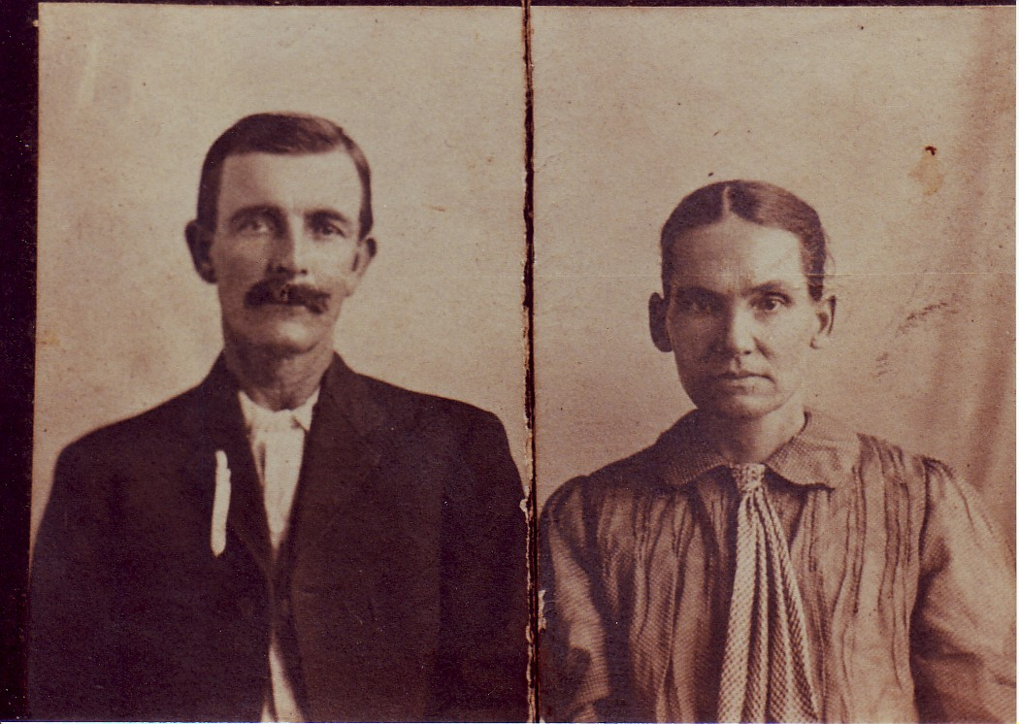

This is believed to be Charles William Prewitt and his wife Zettie Jeffreys

Identified on back as "Uncle Will Prewitt" "to Martha from Callie"
JESSE PRUITT

Charles and Zettie had four children:

(71131) Charles Jeffreys Prewitt, b. Aug. 8, 1918*
(71132) Frank Prewitt, b. Dec. 1, 1920; died in 1937*
(71133) Alton Sherrod Prewitt, b. July 28, 1922*
(71134) Betty Jane Prewitt, b. July 29, 1924; m. a McNeese*

Charles carried the mail on a rural route in the Round Rock, TX area for 30 years. Charles died on June 24, 1971.

(7116) NELLIE PREWITT (dau. of James Sherod Prewitt and Margaret Jane Mays) was born on Nov. 24, 1890. She married Alvin Cluck, and had the following children:

(71161) Evelyn Cluck*
(71162) Donald Cluck*
(71163) Pauline Cluck*
(71164) Marie Cluck*

(7117) JAMES ARTHUR PREWITT (son of James Sherod Prewitt and Margaret Jane Mays) was born on July 7, 1893. He married Bessie M. ? (b. Jan. 2, 1902), and had two children:

(71171) Peggy Prewitt*
(71172) James Prewitt*

James died on March 15, 1977, and Bessie died on Sept. 25, 1981. Both were buried in Rhodes Cem., Jollyville, Texas.

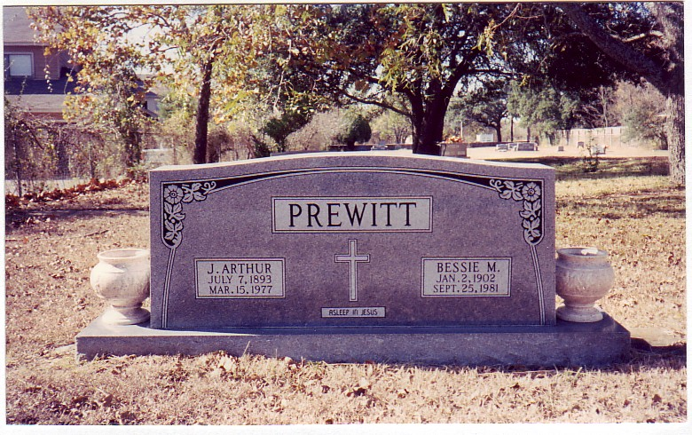

(711(10) ALICE PREWITT (dau. of James Sherod Prewitt and Margaret Jane Mays) was born on Nov. 17, 1901. She married Manfred Von Roeder, and had:

(711(10)1) Nolan Von Roeder*
(711(10)2) Carroll Von Roeder*

(712) AARON DANIEL PREWITT (son of Elisha Prewitt and Frances Rhodes) was born in Travis Co., TX on March 25, 1852.

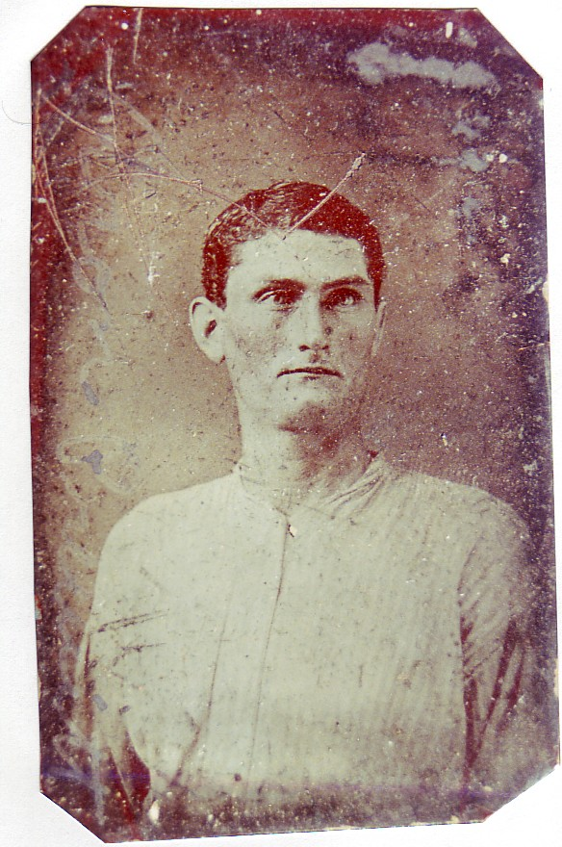

Aaron Daniel Prewitt

Aaron married Sarah E. ? (b. Dec. 1863 TX), and had the following children:

(7121) Newton W. Prewitt, b. Dec. 1889 TX*
(7122) Lavina V. Prewitt, b. April 1894 TX*

JESSE PRUITT

(7123) Jessie W. Prewitt, b. March 1897 TX*
(7124) Frederick H. Prewitt, b. March 1900 TX*

They were recorded on the 1900 Census of Travis Co., TX, Vol. 103, Ed 113, sheet 3, line 9.

(713) HENRY WEATHERTON PREWITT (son of Elisha Prewitt and Frances Rhodes) was born in Texas on March 5, 1854.
Henry wrote to Elisha Prewitt, April 15, 1880, from Peeples Valley, AZ, informing him of his whereabouts, describing the conditions of the area and advising Elisha not to look at this area as a place to sell out and move to. The area was depressed with many bankrupt businesses, lack of jobs, low wages, and trouble with Indians raiding and killing. He was living with his sister, Fanny Lavinia and brother-in-law, Charles Schliner. He requested in the letter to Elisha - "don't let anyone else know where we are."

(714) JOHN JESSE PREWITT (son of Elisha Prewitt and Frances Rhodes) was born in Texas on Jan. 31, 1856.

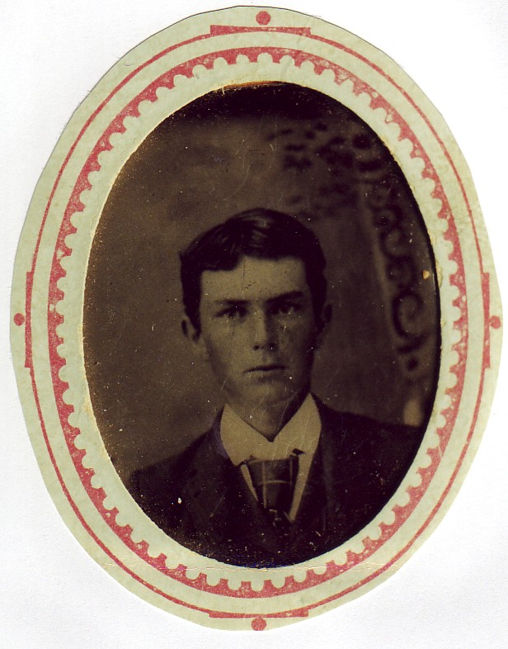

John Jesse Prewitt

(715) FANNIE LAVINIA PREWITT (dau. of Elisha Prewitt and Frances Rhodes) was born in Texas on July 12, 1858. She married Charles Schliner in Jollyville, TX, and had two daughters:

(7151) Pearl Schliner*
(7152) Pauline Schliner*

They resided in Peeples Valley, AZ in 1880. Fannie died in Petaluma, CA in Sept. 1911.

(716) MARTHA SARAH "Mattie" PREWITT (dau. of Elisha Prewitt and Frances Rhodes) was born in Jollyville, TX on Jan. 13, 1861, and married John Henry Crowson in Jollyville, TX on Aug. 27, 1882. John was born in Milam Co., TX on June 4, 1854 to William Crowson and Permela Johnson.

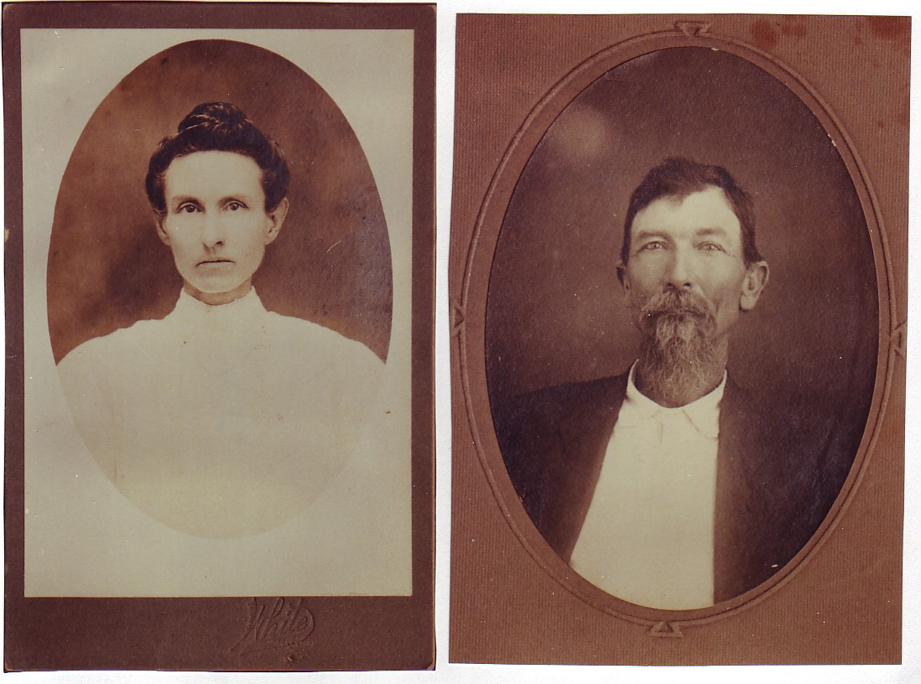

Martha Sarah Prewitt John Henry Crowson

John and Martha were the parents of nine children:

JESSE PRUITT

(7161) Fannie Crowson, b. Sept. 2, 1883 Williamson Co., TX
(7162) Eugene Crowson, b. March 2, 1885; died on April 16, 1885*
(7163) Charles Edward Crowson, b. March 28, 1886 Florence, TX
(7164) William Wood Crowson, b. May 27, 1888 Liberty, TX
(7165) Nettie Crowson, b. Jan. 22, 1891 TX
(7166) Minnie Crowson, b. Oct. 11, 1893 Williamson Co., TX
(7167) John Monroe Crowson, b. Oct. 13, 1895 Georgetown, TX
(7168) Rose Crowson, b. March 18, 1898
(7169) Octa Crowson, b. April 22, 1901

They moved to Bexar Co., Texas in 1903. John died in San Antonio, TX on Nov. 18, 1936, and was buried in San Jose Cemetery there. Martha died at the home of her daughter, Mrs. R.A. Thomasson, in Winters, TX on June 8, 1938, and was buried in Main Street Cemetery there.

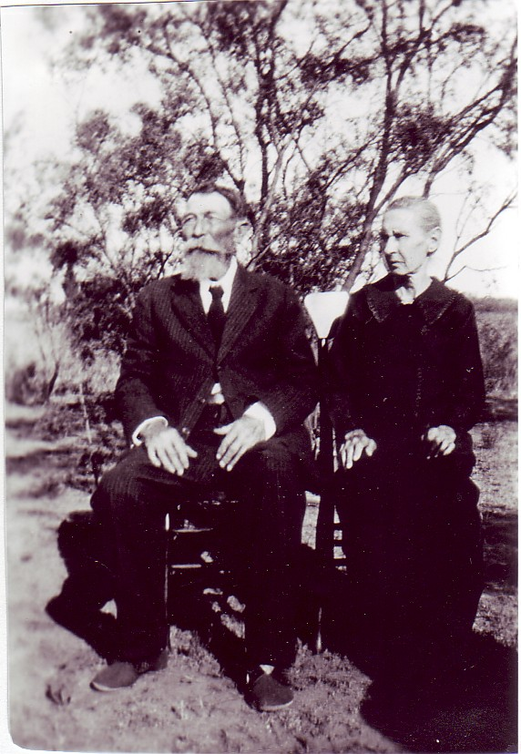

(7161) FANNIE CROWSON (dau. of John Henry Crowson and Martha Sarah Prewitt) was born in Williamson Co., TX on Sept. 2, 1883, and married Leonard C. Goats in Runnels Co., TX on July 11, 1911. Leonard was born in Texas on July 25, 1888 to Elbert Goats and Mary Arnold.
Leonard and Fannie had four children:

(71611) Felix Adolph Goats, b. April 15, 1912
(71612) Irene Goats, b. Oct. 28, 1915; m. Sam Whitfield*
(71613) J.D. Goats, b. Nov 10, 1919; served in the U.S. Army, wounded by shrapnel in the
Philippines; never married*
(71614) Julia Ruth Goats, b. Nov. 24, 1924; m. Everett Shannon*

Fannie died in Winters, TX on Sept. 5, 1936, and Leonard died there on Feb. 26, 1952.

(71611) FELIX ADOLPH GOATS (son of Leonard C. Goats and Fannie Crowson) was born on April 15, 1912. He married Ella Langley, and had two sons:

(716111) Burl Goats*
(716112) Vernon Goats*

(7163) CHARLES EDWARD CROWSON (son of John Henry Crowson and Martha Sarah Prewitt) was born in Florence, TX on March 28, 1886, and married Liddie Maud Thomasson in Truitt, TX on Sept. 2, 1906. Liddie was born in Naruna, TX on Aug. 20, 1889 to John Thomasson and Mary Rue.
Charles and Liddie were the parents of eight children:

(71631) John Edward Crowson, b. Oct. 16, 1907 Truitt, TX
(71632) Alvie Marcell Crowson, b. Oct. 14, 1910 Truitt, TX; died on Feb. 15, 1911*
(71633) Mary Martha Crowson, b. April 24, 1912
(71634) Adeline Amanda "Addie" Crowson, b. June 15, 1914
(71635) Octa Annie May Crowson, b. June 9, 1918 near Desdemona, TX
(71636) Wilburn Anthony "Slim" Crowson, b. April 9, 1922 Winters, TX; died in Strawn, TX on Dec.
6, 1993*
(71637) Minnie Elizabeth Crowson, b. July 30, 1924 Winters, TX
(71638) Raymond Alexander Crowson, b. Feb. 18, 1927 Winters, TX; died in Strawn, TX on Aug. 11,
1997*

Charles died in Lueders, TX on Aug. 12, 1956, and was buried in Lueders Cemetery. Liddie died there on Aug. 11, 1958.

(71631) JOHN EDWARD CROWSON (son of Charles Edward Crowson and Liddie Maud Thomasson) was born in Truitt, TX on Oct. 16, 1907, and married Etta Mae Thomasson in Albany, TX on March 12, 1928. Etta was born in Bonham, TX on Sept. 25, 1909 to Willis Thomasson and Maggie Kincaid.
John and Etta had the following children:

JESSE PRUITT

(716311) Eleanor May Crowson, b. March 20, 1933; m. R.D. West*
(716312) Edward Windell Crowson, b. Oct. 4, 1934 Lueders, TX
(716313) Patsy Floy Crowson, b. Nov. 16, 1938; m. 1st: Delbert Welcher; m. 2nd: Alva Joe Frazier*
(716314) John Alvin "Ruck" Crowson, b. Feb. 7, 1944 Lueders, TX
(716315) Judy Rose Crowson, b. Sept. 1945; m. John Hicks*
(716316) Elizabeth Wayne Crowson, b. July 31, 1946; m. John B. Williams*
(716317) Marilyn Ilene Crowson, b. Nov. 15, 1947; m. Buford McCarter*

John died in Lueders, TX on Feb. 1, 1978.

(716312) EDWARD WINDELL CROWSON (son of John Edward Crowson and Etta Mae Thomasson) was born in Lueders, TX on Oct. 4, 1934. He married Mary Fern Jamar in Albany, TX on May 29, 1954. Mary was born in Stamford, TX on Oct. 28, 1937 to Henry Jamar and Odean Thompson.
Edward and Mary were the parents of four children:

(7163121) Michael Edward Crowson, b. Dec. 2, 1955 Stamford, TX
(7163122) Carla Marie Crowson, b. March 24, 1957; m. Wayne Ellis*
(7163123) Teresa Floy Crowson, b. July 25, 1959; m. 1st: Roger Ellis; m. 2nd: David Darrall*
(7163124) John Richard Crowson, b. Sept. 5, 1960 Albany, TX

Edward died in Knox City, TX on Feb. 25, 1971.

(7163121) MICHAEL EDWARD CROWSON (son of Edward Windell Crowson and Mary Fern Jamar) was born on Stamford, TX on Dec. 2, 1955, and married Sandra Lynn Clinkenbeard in Anson, TX on Dec. 2, 1973. Sandra was born in Mitchell Co., TX on Dec. 19, 1957.
Michael and Sandra had two children:

(71631211) Edward Allen Crowson, b. Jan. 16, 1977*
(71631212) Kristie Michelle Crowson, n. Nov. 4, 1981*

(7163124) JOHN RICHARD CROWSON (son of Edward Windell Crowson and Mary Fern Jamar) was born in Albany, TX on Sept. 5, 1960. He married Pamela White (b. Dec. 3, 1963 Sweeney, TX) in Sweeney, TX on Dec. 8, 1980.
John and Pamela had two sons:

(71631241) Richard Wendell Crowson, b. July 4, 1981*
(71631242) Virgil Allen Crowson, b. Sept. 11, 1983*

(716314) JOHN ALVIN "Ruck" CROWSON (son of John Edward Crowson and Etta Mae Thomasson) was born in Lueders, TX on Feb. 7, 1944, and married Rita Guillette in Palmer, MA on Dec. 25, 1967. Rita was born in Ware, MA on May 6, 1945 to Lionel Guillette and Dorothy Kendall.

John and Rita were the parents of two children:

(7163141) Dorothy Mae Crowson, b. May 5, 1969*
(7163142) Robert John Crowson, b. Feb. 7, 1976*

(71633) MARY MARTHA CROWSON (dau. of Charles Edward Crowson and Liddie Maud Thomasson) was born on April 24, 1912. She married Boyd Story, and had a son:

(716331) Frank Story; died in Denver, CO on Dec. 24, 1993*

(71634) ADELINE AMANDA "Addie" CROWSON (dau. of Charles Edward Crowson and Liddie Maud Thomasson) was born on June 15, 1914. She married Charles Carlile, and had a son:

(716341) Clinton Edward Carlile, b. Aug. 7, 1945*

Adeline died on Dec. 15, 1993.

(71635) OCTA ANNIE MAY CROWSON (dau. of Charles Edward Crowson and Liddie Maud Thomasson) was born near Desdemona, TX on June 9, 1918. She married Estell Pete Cooper in Anson, TX on Dec. 18, 1944. Estell was born near Antlers, OK on May 7, 1911.
Estell and Octa had a son:

(716351) Kenneth David Cooper, b. Nov. 8, 1946*

Estell died on Aug. 20, 1991. Octa resided in Strawn, Texas.

(71637) MINNIE ELIZABETH CROWSON (dau. of Charles Edward Crowson and Liddie Maud Thomasson) was born in Winters, TX on July 30, 1924. She married first: H.D. Green, and had a son:

(716371) Clifford Wayne Green*

Minnie married second: Elmer Thompson. Minnie died in May 1989.

(7164) WILLIAM WOOD CROWSON (son of John Henry Crowson and Martha Sarah Prewitt) was born in Liberty, TX on May 27, 1888, and married Elizabeth Audrol "Bessie" Goats. Elizabeth was born in Content, TX on April 11, 1895 to Elbert Goats and Mary Arnold.
William and Elizabeth were the parents of nine children:

(71641) Lillie Viola Crowson, b. Oct. 4, 1911
(71642) Ira Clarence Crowson, b. March 1, 1913 Winters, TX
(71643) Florence Thelma Crowson, b. Sept. 16, 1914

JESSE PRUITT

(71644) Grover Edward Crowson, b. March 9, 1916 Runnels Co., TX
(71645) Mary Desma Crowson, b. Nov. 18, 1921; m. Harris L. Patterson; and died in Abilene, TX in
1997*
(71646) Mattie Rachel Crowson, b. May 15, 1923; m. Grover Ted Poole; and died in Coleman Co.,
TX on Nov. 25, 1987*
(71647) Bobbie Mae Crowson, b. July 21, 1925
(71648) Janell Crowson, b. Jan. 31, 1929; m. 1st: Dennard Everett; m. 2nd: a McAdams; and died in
Runnels Co., TX on Feb. 5, 1956*
(71649) J.W. Crowson, b. Sept. 26, 1933; died in Runnels Co., TX on Nov. 22, 1933*

William died in Abilene, TX on Aug. 10, 1966, and Elizabeth died there on June 10, 1974.

(71641) LILLIE VIOLA CROWSON (dau. of William Wood Crowson and Elizabeth Audrol Goats) was born on Oct. 4, 1911.
She married James Z. Goolsby, and had a son:

(716411) Arthur Goolsby*

Lillie died about 1991.

(71642) IRA CLARENCE CROWSON (son of William Wood Crowson and Elizabeth Audrol Goats) was born in Winters, TX on March 1, 1913, and married Susie Marie Jones in Raymondville, TX on July 25, 1934. Susie was born on Nov. 20, 1914 to Wiley Jones and Bertie Maserang.
Ira and Susie had the following children:

(716421) Betty Joan Crowson, b. March 20, 1935; m. George Frank Tapps*
(716422) Robert Wayne Crowson, b. Sept. 20, 1936; died on Dec. 19, 1943*
(716423) Mary Helen Crowson, b. Sept. 16, 1938; m. 1st: Calvin Kinchen; m. 2nd: Ted Kenneth Fox*

Ira died in Fort Worth, TX on Dec. 23, 1971.

(71643) FLORENCE THELMA CROWSON (dau. of William Wood Crowson and Elizabeth Audrol Goats) was born on Sept. 16, 1914. She married Walter White, and had the following:

(716431) Grover White*
(716432) Roy White*
(716433) June White*

Florence died on Dec. 22, 1977.

(71644) GROVER EDWARD CROWSON (son of William Wood Crowson and Elizabeth Audrol Goats) was born in Runnels Co., TX on March 9, 1916. He married (71682) Martha Geraldine Lewis in Houston, TX on July 30, 1953. Martha was born in San Antonio, TX on May 26, 1928 to Clyde Lewis and Rose Crowson. Grover and Martha had three daughters:

(716441) Mary Desma Crowson, b. Jan. 13, 1953*
(716442) Joyce Lynn Crowson, b. March 15, 1960*
(716443) Patricia Ann Crowson, b. Jan. 26, 1956; m. William Long*

Grover died in Hawley, TX on April 30, 1973.

(71647) BOBBIE MAE CROWSON (dau. of William Wood Crowson and Elizabeth Audrol Goats) was born on July 21, 1925. She married Harry Brown, and had:

(716471) Billy Brown*

(7165) NETTIE CROWSON (dau. of John Henry Crowson and Martha Sarah Prewitt) was born in Texas on Jan. 22, 1891, and married Richard Alexander Thomasson on Jan. 15, 1915. Richard was born in Bowie, TX on March 27, 1895 to George Thomasson and Jennie Darnell.
Richard and Nettie had a son:

(71651) J.R. "Buster" Thomasson, b. July 1, 1917 Rowena, TX

Richard died on April 21, 1972, and Nettie died in Dallas, TX in Sept. 1984.

(71651) J.R. "Buster" THOMASSON (son of Richard Alexander Thomasson and Nettie Crowson) was born in Rowena, TX on July 1, 1917. He married Irene Smith (b. Feb. 18, 1917) on Oct. 15, 1938, and had two daughters:

(716511) Laura Juanita Thomasson, b. Oct. 6, 1940
(716512) Lillian Juanda Thomasson, b. July 1, 1943

J.R. died in Fort Worth, TX on Nov. 8, 1986.

(716511) LAURA JUANITA THOMASSON (dau. of J.R. Thomasson and Irene Smith) was born on Oct. 6, 1940. She married Audie Eugene Patton on Aug. 12, 1958, and were the parents of four children:

(7165111) Regina Louise Patton, b. Aug. 12, 1959
(7165112) Donna Leigh Patton, b. June 8, 1961; m. Nolen E. Hodges*
(7165113) Amy Ruth Patton (twin), b. Nov. 21, 1968*
(7165114) Becky Lynn Patton (twin), b. Nov. 21, 1968*

JESSE PRUITT

(7165111) REGINA LOUISE PATTON (dau. of Audie Eugene Patton and Laura Juanita Thomasson) was born on Aug. 12, 1959. She married Jerry Mack Riggan, and had a son:

(71651111) Gregory Malcolm Riggan, b. Feb. 28, 1983*

(716512) LILLIAN JUANDA THOMASSON (dau. of J.R. Thomasson and Irene Smith) was born on July 1, 1943. She married Perry Flories in Everman, TX on June 25, 1960, and had three daughters:

(7165121) Cynthia Elaine Flories, b. Oct. 3, 1960*
(7165122) Cheryl Eileen Flories, b. Feb. 16, 1962
(7165123) Christine Elizabeth Flories, b. May 20, 1966*

(7165122) CHERYL EILEEN FLORIES (dau. of Perry Flories and Lillian Juanita Thomasson) was born on Feb. 16, 1962. She married Michael Tabner, and had a daughter:

(71651221) Samantha Mae Tabner, b. June 30, 1982*

(7166) MINNIE CROWSON (dau. of John Henry Crowson and Martha Sarah Prewitt) was born in Williamson Co., TX on Oct. 11, 1893. She married William Patrick LaRue in Angleton, TX on Sept. 9, 1929. Minnie died in El Cajon, CA on Oct. 28, 1973, and was buried in Glen Abbey Memorial Park, San Diego, California.

(7167) JOHN MONROE CROWSON (son of John Henry Crowson and Martha Sarah Prewitt) was born in Georgetown, TX on Oct. 13, 1895, and married Mary Frances Simmons in Winters, TX on Jan. 20, 1929. Mary was born in Brownwood, TX on Aug. 12, 1910 to John Simmons and Luella Wagner.
John and Mary were the parents of eight children:

(71671) Bernard Eugene Crowson, b. April 5, 1930 Winters, TX
(71672) Edwin Ray Crowson, b. & d. Nov. 17, 1931 Winters, TX*
(71673) Vernon Lee Crowson, b. & d. Aug. 22, 1932 Winters, TX*
(71674) Cloise Melvin Crowson, b. Aug. 19, 1933 Winters, TX; m. 1st: Margaret ? ; m. 2nd:
Elsie ? ; He served in the U.S. Army, 35th Infantry Regiment, 25th Infantry Division
during the Korean War, and was awarded two Bronze Stars and the Silver Star. He was
wounded three times, receiving three Purple Heart medals. He died in Jayton, TX on Sept. 29,
1993*
(71675) Kenneth Ray Crowson, b. Oct. 16, 1935 San Antonio, TX
(71676) Dorothy Allin Crowson, b. Nov. 20, 1937 Winters, TX; died on Nov. 22, 1937*
(71677) Billy Joe Crowson, b. Jan. 14, 1939 Brownwood, TX
(71678) Arnold Lynn Crowson, b. June 12, 1944 Ypsilanti, MI

John died in Chula Vista, CA on June 7, 1954, and was buried in Greenwood Memorial Park. Mary died in San Diego, CA on June 28, 1995.

(71671) BERNARD EUGENE CROWSON (son of John Monroe Crowson and Mary Frances Simmons) was born in Winters, TX on April 5, 1930. He married Vivian Steele in San Francisco, CA on Aug. 20, 1954. Vivian was born in San Mateo, CA on Sept. 14, 1929 to Rufus Steele and Veda Griffiths.
Bernard and Vivian had a daughter:

(716711) Linda Anne Crowson, b. July 11, 1955 San Mateo, CA

Bernard died in San Diego, CA on Aug. 17, 1975.

(716711) LINDA ANNE CROWSON (dau. of Bernard Eugene Crowson and Vivian Steele) was born in San Mateo, CA on July 11, 1955. She married Dennis McBride (b. April 6, 1952) on Oct. 13, 1985, and had two children:

(7167111) James Dennis McBride, b. April 3, 1988 Santa Rosa, CA*
(7167112) Kaitlin Marie McBride, b. Oct. 23, 1989 Santa Rosa, CA*

They resided in Forestville, California.

(71675) KENNETH RAY CROWSON (son of John Monroe Crowson and Mary Frances Simmons) was born in San Antonio, TX on Oct. 16, 1935, and married first: Nancy Ruth White in Ardmore, OK on June 28, 1958. Nancy was born in Ardmore, OK on Jan. 16, 1939 to Charles White and Mary Higdon.
Kenneth and Nancy were the parents of four children:

(716751) Mark Alan Crowson, b. March 27, 1959 National City, CA
(716752) Bryan Wayne Crowson, b. Aug. 14, 1960 San Diego, CA
(716753) Karen Kay Crowson, b. May 15, 1964 La Mesa, CA
(716754) Bradley Charles Crowson, b. Oct. 25, 1965 La Mesa, CA*

Kenneth married second: Gail Dean Westmoreland in Spring Valley, CA on Sept. 26, 1969. Gail was born on May 28, 1946.
Kenneth served in the U.S. Air Force, Airborne Electronic Navigational Equipment Repairman. He has worked as Electronic R & D Technician and Supervisor at Stromberg-Carlson, San Diego; Quality Engineer and Manager at Honeywell, San Diego; and was a self employed Electrical Contractor.
They resided in El Cajon, California.

(716751) MARK ALAN CROWSON (son of Kenneth Ray Crowson and Nancy Ruth White) was born in National City, CA on March 27, 1959, and graduated from the Univ. ot Texas, Arlington, TX, with a BS in Electrical Engineering. He married first: Terry Lee Garrison (b. ca 1960) in Irving, TX on Aug. 18, ?

JESSE PRUITT

Mark married second: Melissa Ann Joiner in Irving, TX on Dec. 28, 1985. Melissa was born in Savona, Italy on April 13, 1963 (original name was Marillo Amo) and adopted in 1964 by L.G. Joiner and Jacqueline McGraw.
Mark and Melissa had three children:

(7167511) Christopher Gordon Crowson, b. July 14, 1987 Fort Worth, TX*
(7167512) Courtney Mary Crowson, b. March 29, 1989 Fort Worth, TX*
(7167513) Nicholas Alan Crowson, b. July 1, 1992 Fort Worth, TX*

They resided in Hurst, Texas,

(716752) BRYAN WAYNE CROWSON (son of Kenneth Ray Crowson and Nancy Ruth Crowson) was born in San Diego, CA on Aug. 14, 1960, and married first: Roxanne Faulkner.
Bryan married second: Cinda Kathryne Yokochi in Dallas, TX on April 26, 1986. Cinda was born in Rosebella, Puerto Rico on May 19, 1959. Bryan and Cinda had two children:

(7167521) Cara Lynne Crowson, b. Jan. 1, 1990 Irving, TX (was the first baby of the new decade born
at the Irving Hospital)*
(7167522) Cordie Marie Crowson, b. Oct. 10, 1995 Irving, TX*

(716753) KAREN KAY CROWSON (dau. of Kenneth Ray Crowson and Nancy Ruth White) was born in La Mesa, CA on May 15, 1964. She married first: Duane Alvin Colman, and had a son:

(7167531) Brandon Scott Crowson, b. June 6, 1982 Dallas, TX*

Karen married second: Rick Wayne Sullivan in Irving, TX on March 15, 1985, and had a daughter:

(7167532) Jessica Lynn Sullivan, b. Aug. 5, 1986 Irving, TX*

Karen married third: Darrell Gene Luna II in Hurst, TX on July 14, 1990. Darrell was born in San Jose, CA on Feb. 9, 1971.

(71677) BILLY JOE CROWSON (son of John Monroe Crowson and Mary Frances Simmons) was born in Brownwood, TX on Jan. 14, 1939. He married first: Janet French (b. Sept. 24, 1940 MO), and had two children:

(716771) Cerrie Cee Crowson, b. April 13, 1960*
(716772) Judy Lynn Crowson, b. Aug. 2, 1961 National City, CA

Billy married second: Connie Virginia Wardell in Fort Worth, TX on Jan. 14, 1966. Connie was born in Fort Worth, TX on Feb. 17, 1934.
Billy and Connie had a son:

(716773) Eric Coby Crowson, b. June 11, 1969

(716772) JUDY LYNN CROWSON (dau. of Billy Joe Crowson and Janet French) was born in National City, CA on Aug. 2, 1961, and married first: Arnolfo DeBoda "Arnie" Mayor. Arnolfo was born in San Miguel, Philippines on Dec. 11, 1955.
Arnolfo and Judy had the following children:

(7167721) Elizabeth Mayor, b. Aug. 25, 1982 San Diego, CA*
(7167722) Melissa Mayor, b. May 17, 1984 San Diego, CA*
(7167723) Bryan Michael Vincent Mayor, b. June 28, 1986 San Diego, CA*

Judy married second: Ernest Mayor.

(716773) ERIC COBY CROWSON (son of Billy Joe Crowson and Connie Virginia Wardell) was born on June 11, 1969. He married Adriana Guerrero in Mexico City, Mexico on June 24, 1995, and had:

(7167731) Kirston Crowson, b. April 1, 1999*

(7168) ROSE CROWSON (dau. of John Henry Crowson and Martha Sarah Prewitt) was born on March 18, 1898, and married Clyde L. Lewis, Sr. about 1925. Clyde was born in Corsicana, TX on Nov. 18, 1897 to John Lewis and Mary Spires; and was a Cpl. in Company A, 23rd Infantry, stationed at Fort Sam Houston. Clyde and Rose had three children:

(71681) Clyde L. Lewis, Jr., b. Feb. 22, 1927 San Antonio, TX; Served in the U.S. Navy during WW
II aboard the destroyer USS Haradin. It was heavily damaged by Japanese Kamikaze planes
in the Sulu Sea, near the Philippines. He married Veenee Lee Rowe (b. May 14, 1925) in
Toledo, OH on Dec. 18, 1948*
(71682) Martha Geraldine Lewis, b. May 26, 1928 San Antonio, TX
(71683) Russell Franklin Lewis, b. Jan. 29, 1934 San Antonio, TX

Rose died in San Diego, CA on Aug. 12, 1951, and was buried in Glen Abbey Memorial Park there. Clyde died on March 13, 1954.

(71682) MARTHA GERALDINE LEWIS (dau. of Clyde L. Lewis, Sr. and Rose Crowson) was born in San Antonio, TX on May 26, 1928, and married first: George John Zay, Sr. George was born in New York on March 7, 1922. George and Martha had three children:

(716821) George John Zay, Jr., b. June 21, 1946 Oakland, CA; m. Deana Ann Hill (b. Dec. 8, 1958)
on Sept. 27, 1980*
(716822) Roger Lee Zay, b. Jan. 15, 1948 Oakland, CA*
(716823) Katherine Marie Zay, b. April 12, 1950*

JESSE PRUITT

Martha married second: (71644) Grover Edward Crowson in Houston, TX on July 30, 1953. Grover was born in Runnels Co., TX on March 9, 1916 to William Wood Crowson and Elizabeth Audrol Goats.
Grover and Martha had three daughters:

(716441) Mary Desma Crowson, b. Jan. 13, 1953*
(716442) Joyce Lynn Crowson, b. March 15, 1960*
(716443) Patricia Ann Crowson, b. Jan. 26, 1956; m. William Long*

Grover died in Hawley, TX on April 30, 1973. Note: George Zay, Sr. died on May 9, 1985.

(71683) RUSSELL FRANKLIN LEWIS (son of Clyde L. Lewis, Sr. and Rose Crowson) was born in San Antonio, TX on Jan. 29, 1934. He married Phyllis Hope Fraley (b. July 9, 1940), and had two sons:

(716831) Michael Ray Lewis, b. March 20, 1958*
(716832) Robert Franklin Lewis, b. March 10, 1960*

(7169) OCTA CROWSON (dau. of John Henry Crowson and Martha Sarah Prewitt) was born on April 22, 1901, and married first: Joe Lee Newgent, Sr. Joe was born in Roachdale, IN on Aug. 17, 1898.
Octa married second: Joe Lee Newgent, Sr. in Oakland, CA about 1931. Joe and Octa had:

1. Joe Lee Newgent, Jr., b. Oct. 23, 1926, step-son*

Joe died on Dec. 11, 1973.

CYNTHIA RILEY PRUITT

(8) CYNTHIA RILEY "Cinderella" PRUITT (dau. of Beasley Pruitt and Lucy Sims) was born in Rapides Parish, LA on Dec. 19, 1812. She married first: William C. Everett (b. ca 1812) in 1928, and had two daughters:

(81) Lucinda Everett, b. July 27, 1829 Liberty Co., TX
(82) Elizabeth A. "Betsy" Everett, b. Feb. 12, 1831 Liberty Co., TX

William C. Everett obtained a league of land from the Mexican Government, and that land eventually became the property of Cynthia and Benjamin Green. A league of land has 4,428 acres in it.
William died in Liberty Co., TX, and Cynthia married second: Benjamin Modelle Green in Liberty Co., TX about 1832. Benjamin was born in Catahoula Parish, LA on Aug. 18, 1810 to Richard M. Green; and was only 10 years old when the family came to Texas.

Benjamin and Cynthia had eight children:

(83) John J. Green, b. May 3, 1834 Liberty Co., TX; died in Liberty Co., TX in Oct. 1844*
(84) Narcissus Green, b. Aug. 13, 1836 Liberty Co., TX; m. N.A. Daugherty (b. 1835); and died in
Boerne, TX on Jan. 25, 1925*
(85) Martha Ann Green, b. Nov. 6, 1838 Liberty Co., TX; died in Liberty Co., TX on Oct. 1, 1843*
(86) William Benjamin Green, b. Nov. 14, 1840 Dayton, TX
(87) Francis Marion Green, b. Feb. 20, 1846 Liberty Co., TX
(88) Mary Jane Green, b. April 6, 1848 Liberty Co., TX
(89) Feliciana Green, b. July 22, 1850 Liberty Co., TX; died in Liberty Co., TX on March 15, 1855*
(8(10) Edmond Modelle Green, b. Jan. 30, 1854 West Liberty, TX

A sketch of the Town of Liberty, as laid out in May 1831, from Spanish Archives, shows Cinderella Prewitt in residence next to Beasley Prewitt (see page 3). Also shown is Reason Green, Amos Green and Fritz Green. Amos Green witnessed Beasley Prewitt's will of 1831.
Cynthia died in Liberty, TX on Oct. 6, 1871, and Benjamin died in Dayton, TX on July 17, 1895. Both were buried in French Cem., Dayton, Texas.

(81) LUCINDA EVERETT (dau. of William C. Everett and Cynthia Riley Pruitt) was born in Liberty Co., TX on July 27, 1829. She married Jessie Daniel Lum (b. 1822 LA) in Liberty, TX on Sept. 2, 1847, and had the following children:

(811) Emmet J. Lum, b. 1848 TX*
(812) Alexander P. Lum, b. 1851*
(813) Virginia E. Lum, b. 1853*
(814) Martha L. Lum, b. 1858*

Lucinda died in Liberty, TX on June 3, 1910.

(82) ELIZABETH A. "Betsy" EVERETT (dau. of William C. Everett and Cynthia Riley Pruitt) was born in Liberty, TX on Feb. 12, 1831. She married first: Archibald Clark, and had two children:

(821) George W. Clark, b. 1860*
(822) Liney Clark, b. 1862*

Elizabeth married second: Robert P. Carr, and had a son:

(823) Price E. Carr, b. 1863*

Elizabeth married third: S.S. Hopkins. Elizabeth died on Feb. 9, 1881.

(86) WILLIAM BENJAMIN GREEN (son of Benjamin Modelle Green and Cynthia Riley Pruitt) was born in Dayton, TX on Nov. 14, 1840. He married first: Frances F. Simpson (b. 1840) in Liberty, TX on Oct. 15, 1861, and had four children:

(861) Melissa Green, b. 1862 Liberty Co., TX*
(862) Neville Green, b. 1866 Liberty Co., TX*
(863) Benjamin F. Green, b. 1869 Liberty Co., TX*
(864) Maggie Green, b. 1871 Liberty Co., TX*

William married second: Melody "Melodia" Tullar (b. 1841), and had a daughter:

(865) Fannie Green, b. 1880*

William died in Mountainburg, Arkansas.

(87) FRANCIS MARION GREEN (son of Benjamin Modelle Green and Cynthia Riley Pruitt) was born in Liberty Co., TX on Feb. 20, 1846. He married Feliciann Asenith Kellar in Liberty, TX on March 25, 1868. Feliciann was born in Rapides Parish, LA on March 25, 1852 to William Henry Kellar and Minerva Caroline Pounds. Francis and Feliciann had the following children:

(871) William Benjamin "Billy" Green, b. Dec. 11, 1869 Georgetown, TX
(872) Minerva Caroline "Nervie" Green, b. Dec. 5, 1871 Georgetown, TX
(873) Francis Henry "Kay" Green, b. Jan. 12, 1874 Georgetown, TX
(874) Joseph Riley Green, b. Oct. 14, 1876 Georgetown, TX
(875) Mary Rose Ann Green, b. Nov. 21, 1879 Georgetown, TX
(876) Archie Dallas Green, b. March 23, 1882 Georgetown, TX
(877) Ward Beecher "Beech" Green, b. May 22, 1885 Georgetown, TX
(878) Edward Pruitt "Prue" Green, b. Sept. 2, 1886 Georgetown, TX
(879) John Carlton Green, b. April 10, 1889 Georgetown, TX
(87(10) Orr Toliver "Tee" Green, b. April 24, 1891 Sanco, TX
(87(11) Helen Ozella Narcissus Green, b. Oct. 26, 1893 Sanco, TX

Francis died in Sanco, TX on July 12, 1897, and was buried there. Feliciann died in San Marcos, CA on Aug. 3, 1937, and was buried in Phoenix, Arizona.

CYNTHIA RILEY PRUITT

(871) WILLIAM BENJAMIN "Billy" GREEN (son of Francis Marion Green and Feliciann Asenith Kellar) was born in Georgetown, TX on Dec. 11, 1869, and married Mary Alice Hendricks in Sanco, TX on Dec. 26, 1894. Mary was born in Cleburne, TX on Dec. 21, 1872.
William and Mary were the parents of five children:

(8711) Riley Royston Green, b. Oct. 1895 Sanco, TX
(8712)Lorena Allie Green, b. June 12, 1897 Sanco, TX
(8713) William Burton Green, b. Oct. 30, 1899 Robert Lee, TX
(8714) Birdie May O'Leary Green, b. Nov. 13, 1902 Robert Lee, TX; m. Cecil Blasingame (b. 1901)
on Oct. 31, 1926; and died on Jan. 3, 1966*
(8715) Franklin Marion Green, b. March 22, 1905 Robert Lee, TX

William died in Litchfield, AZ on Dec. 20, 1920, and was buried in Phoenix, Arizona. Mary died in Fullerton, CA on Sept. 17, 1927.

(8711) RILEY ROYSTON GREEN (son of William Benjamin Green and Mary Alice Hendricks) was born in Sanco, TX in Oct. 1895. He married Winifred Lillian Humphrey (b. 1893) on Oct. 12, 1926, and had three daughters:

(87111) Cora Lorena Green
(87112) Lillian Sue Green
(87113) Marian Alice Green

Riley died in Fullerton, CA on June 25, 1979.

(87111) CORA LORENA GREEN (dau. of Riley Royston Green and Winifred Lillian Humphrey) married Joseph Frank Tomiska, and had the following children:

(871111) Jo Ann Tomiska
(871112) William Joseph Tomiska*
(871113) Robert Royston Tomiska
(871114) Charity Lillianne Tomiska
(871115) Angelina Kathleen Tomiska; m. Michael Edward Mickelson*

(871111) JO ANN TONISKA (dau. of Joseph Frank Tomiska and Cora Lorena Green) married Donald Jerry Watson, and had two children:

(8711111) Coty Jo Watson*
(8711112) Cole B.G. Watson*

(871113) ROBERT ROYSTON TOMISKA (son of Joseph Frank Tomiska and Cora Lorena Green) married Debra Marie Suarez, and had two children:

(8711131) Karrie Marie Tomiska, b. 1981*
(8711132) Robert Joseph Tomiska, b. 1982*

(871114) CHARITY LILLIANNE TOMISKA (dau. of Joseph Frank Tomiska and Cora Lorena Green) married first: Anthony Elijah Ardelean, and had the following children:

(8711141) Crystal Ann Ardelean, b. 1978*
(8711142) Amber Lee Ardelean, b. 1980*
(8711143) Rianna Jo Ardelean, b. 1981*

Charity married second: Timothy Dean McIntosh, and had two daughters:

(8711144) Jasmine Mary McIntosh, b. 1984*
(8711145) Rose Lorena McIntosh, b. 1986*

(87112) LILLIAN SUE GREEN (dau. of Riley Royston Green and Winifred Lilliam Humphrey) married first: Armand Pierce Oueilhe, and were the parents of five children:

(871121) Ellen Lynne Oueilhe*
(871122) Karen Sue Oueilhe*
(871123) Armand Louis Oueilhe, b. 1957; died in 1971*
(871124) Gregoire Pierce Oueilhe*
(871125) Richard Elden Oueilhe, b. & d. 1965*

Lillian married second: Rolf Hagmann.

(87113) MARIAN ALICE GREEN (dau. of Riley Royston Green and Winifred Lillian Humphrey) married Robert Melvin Wilke, and had two children:

(871131) Spencer August Wilke
(871132) Pamela Sue Wilke; m. Andrew Holloman*

(871131) SPENCER AUGUST WILKE (son of Robert Melvin Wilke and Marian Alice Green) married Susan Lynne Werda, and had a daughter:

(8711311) Stephanie Ann Wilke, b. 1983*

CYNTHIA RILEY PRUITT

(8712) LORENA ALLIE GREEN (son of William Benjamin Green and Mary Alice Hendricks) was born in Sanco, TX on June 12, 1897. She married Ray Alsup (b. 1893 Sanco, TX), and had a son:

(87121) Robert Alsup, b. 1919 Sanco, TX; m. Nancy ? *

Lorena died on May 20, 1962.

(8713) WILLIAM BURTON GREEN (son of William Benjamin Green and Mary Alice Hendricks) was born in Robert Lee, TX on Oct. 30, 1899, and married Alice Elizabeth Pettijohn on Jan. 20, 1922. Alice was born in Robert Lee, TX in 1903.
William and Alice had two children:

(87131) Billy Paul Green, b. 1925 Robert Lee, TX; m. Evidna Lura Downing; and died in 1995*
(87132) Betty Lucille Green, b. 1927 Robert Lee, TX; m. William Milton Boller*

William died in Mercedes, TX on May 8, 1975.

(8715) FRANKLIN MARION GREEN (son of William Benjamin Green and Mary Alice Hendricks) was born in Robert Lee, TX on March 22, 1905. He married Eloise McKibben (b. 1911) on Aug. 7, 1930, and had a daughter:

(87151) Marian Janet Green, b. 1931 CA

Franklin died in Santa Maria, CA on Aug. 1, 1984.

(87151) MARIAN JANET GREEN (dau. of Franklin Marion Green and Eloise McKibben) was born in California in 1931. She married first: Richard Royden Bradley, and had the following children:

(871511) Scott Edwin Bradley, b. 1950 CA*
(871512) Jack Royden Bradley, b. 1952 CA*
(871513) Todd Franklin Bradley, b. 1956 CA*

Marian married second: Willard D. Lynch.

(872) MINERVA CAROLINE "Nervie" GREEN (dau. of Francis Marion Green and Feliciann Asenith Kellar) was born in Georgetown, TX on Dec. 5, 1871, and married Thomas James Yance in Robert Lee, TX on April 3, 1898. Thomas was born in Waxahachie, TX on Dec. 25, 1870.
Thomas and Minerva had two children:

(8721) Dallas Cooper Yance, b. July 5, 1900 Robert Lee, TX; died on Dec. 5, 1918*
(8722) Charles Green Yance, b. May 1903 Portales, NM; died on Feb. 28, 1924*

Thomas died in Robert Lee, TX on May 27, 1907. Minerva died in Phoenix, AZ on May 13, 1957, and was buried there.

(873) FRANCIS HENRY "Kay" GREEN (son of Francis Marion Green and Feliciann Asenith Kellar) was born in Georgetown, TX on Jan. 12, 1874. He married Rhoenie Arnold (b. Jan. 13, 1874 GA) in Robert Lee, TX on May 17, 1899, and had the following children:

(8731) Mignonette Green, b. Nov. 11, 1900 Robert Lee, TX
(8732) Golden Rodney Green, b. Feb. 3, 1904 Portales, NM
(8733) Jessamin Green, b. Nov. 14, 1911 Fort Stockton, TX
(8734) Omen Green, b. Feb. 16, 1916 Madill, OK

Rhoenie died in San Diego Co., CA on Sept. 16, 1957, and Francis died in Vista, CA on Sept. 20, 1957.

(8731) MIGNONETTE GREEN (dau. of Francis Henry Green and Rhoenie Arnold) was born in Robert Lee, TX on Nov. 11, 1900. She married first: Jesse Swindell (b. 1897 Randolph, OK), and had two children:

(87311) Vera Moil Swindell, b. 1922 Tishomingo, OK
(87312) Marvin Earl Swindell, b. 1927 La Habra, CA

Mignonette married second: William Nieman, and had two children:

(87313) Helen Frances Nieman, b. 1940 Del Mar, CA
(87314) William Kay Nieman, b. 1942 Del Mar, CA

William died in 1972, and Mignonette died in 1995.

(87311) VERA MOIL SWINDELL (dau. of Jesse Swindell and Mignonette Green) was born in Tishomingo, OK in 1922. She married first: Joe Lawrence, and had two children:

(873111) Gregory Lawrence, b. 1940*
(873112) Jessie Mae Lawrence, b. 1941 Escondido, CA

Vera married second: Russell Clifton. Vera married third: Joe Cabler, and had two children:

(873113) Robert Charles Cabler, b. 1948*
(873114) Gwen Vera Cabler, b. 1950*

Vera married fourth: a Keebler.

CYNTHIA RILEY PRUITT

(873112) JESSIE MAE LAWRENCE (dau. of Joe Lawrence and Vera Moil Swindell) was born in Escondido, CA in 1941. She married Robert Andrew Parker (b. 1936 Libby, MT), and had the following children:

(8731121) Joseph Robert Parker, b. 1962 La Mesa, CA
(8731122) Lisa Eileen Parker, b. 1965 La Mesa, CA*
(8731123) Andrew Lincoln Parker, b. 1974 La Mesa, CA*

(8731121) JOSEPH ROBERT PARKER (son of Robert Andrew Parker and Jessie Mae Lawrence) was born in La Mesa, CA in 1962. He married Peggy Sue Trull (b. 1955 Steamboat Springs, CO), and had a daughter:

(87311211) Amanda Dawn Parker, b. 1982 Los Gatos, CA*

(87312) MARVIN EARL SWINDELL (son of Jesse Swindell and Mignonette Green) was born in La Habra, CA in 1927. He married June ? , and had four children:

(873121) Weldon Earl Swindell, b. 1950*
(873122) Omen Edward Swindell, b. 1952*
(873123) Shirley Swindell*
(873124) Wanda W. Swindell, b. 1954 CA

(873124) WANDA W. SWINDELL (dau. of Marvin Earl Swindell and June) was born in California in 1954. She married a Herbster, and had two children:

(8731241) Naomi Elane Herbster, b. 1979 CA*
(8731242) Quincey Alan Herbster, b. 1981 CA*

(87313) HELEN FRANCES NIEMAN (dau. of William Nieman and Mignonette Green) was born in Del Mar, CA in 1940. She married first: a Wells, and had two daughters:

(873131) Loretta Wells, b. 1959*
(873132) Loraina Wells, b. 1959*

Helen married second: a Testa, and had a son:

(873133) Lewis Testa, b. 1966 CA*

(87314) WILLIAM KAY NIEMAN (son of William Nieman and Mignonette Green) was born in Del Mar, CA in 1942. He married ? , and had three children:

(873141) Debra Lynne Niemann, b. 1960 CA
(873142) William Niemann, b. 1961 CA*
(873143) Betsy Niemann, b. 1969 CA*

(873141) DEBRA LYNNE NIEMANN (dau. of William Kay Nieman) was born in California in 1960. She married a Buell, and had two children:

(8731411) Jennifer Buell, b. 1978 CA*
(8731412) Jamie Buell, b. 1979 CA*

(8732) GOLDEN RODNEY GREEN (son of Francis Henry Green and Rhoenie Arnold) was born in Portales, NM on Feb. 3, 1904. He married Evelyn Phyllis Hoover (b. 1906 Manitoba, Winnipeg, Canada)
and had two children:

(87321) Derrel Hoover Green, b. 1936 Los Angeles, CA
(87322) Phyllis Doree Green, b. 1938 Los Angeles, CA*

Golden and Evelyn both died in 1990.

(87321) DERREL HOOVER GREEN (son of Golden Rodney Green and Evelyn Phyllis Hoover) was born in Los Angeles, CA in 1936, and married first: Mary Uris. Derrel married second: Mary Kay Kopek, and had a daughter:

(873211) Lisa Kay Green, b. 1964*

(8733) JESSAMIN GREEN (dau. of Francis Henry Green and Rhoenie Arnold) was born in Fort Stockton, TX on Nov. 14, 1911. She married Herbert Newton Walk (b. 1907 Foss, OK), and had two sons:

(87331) Everett Keller Walk, b. 1931 San Marcos, CA; m. Linda Lolita Sotarian; and died in 1993*
(87332) Charles Willard Walk, b. 1934 Scio, OR; m. Doris Arline Sanders*

Jessamin died in 1993.

(8734) OMEN GREEN (son of Francis Henry Green and Rhoenie Arnold) was born in Madill, OK on Feb. 16, 1916. He married Ruth Elinor Waring (b. 1918 Escondido, CA), and had two daughters:

(87341) Priscilla Yvonne Green, b. 1941 Escondido, CA
(87342) Linda Kay Green, b. 1945 San Diego, CA; m. 1st: Lynn Cantwell; m. 2nd: Gordon Bohot*

CYNTHIA RILEY PRUITT

(87341) PRISCILLA YVONNE GREEN (dau. of Omen Green and Ruth Elinor Waring) was born in Escondido, CA in 1941. She married Walter Marshall Darley, and had two children:

(873411) Rhea Shannen Darley, b. 1966*
(873412) Brent Corbin Darley, b. 1970*

(874) JOSEPH RILEY GREEN (son of Francis Marion Green and Feliciann Asenith Kellar) was born in Georgetown, TX on Oct. 14, 1876. He married first: Ella Jameson (b. 1876 MO) in Robert Lee, TX on Sept. 1, 1897, and had three children:

(8741) Dewey Green, b. Sept. 1898 Silver, TX*
(8742) Lora Fay Green, b. 1899 Silver, TX; died in 1905*
(8743) Beatrice Green, b. 1902 Silver, TX*

Joseph married second: Elsie Witherspoon (b. 1876). Joseph died in Dublin, TX on Dec. 20, 1904.

(875) MARY ROSE ANN GREEN (dau. of Francis Marion Green and Feliciann Asenith Kellar) was born in Georgetown, TX of Nov. 21, 1879, and married George Edgar Scott in Lubbock, TX on May 30, 1900. George was born in 1865 in Winnebago Co., Wisconsin.
George and Mary were the parents of the following children:

(8751) Billy Knight Green, b. 1898 Robert Lee, TX; died in 1919*
(8752) George Irving Scott, b. March 26, Lubbock, TX
(8753) Grant Imason Scott, b. Feb. 4, 1904 Portales, NM
(8754) Joseph Paul Scott, b. April 3, 1906 Lacy, NM
(8755) Kitty Carol Scott, b. March 24, 1908 Portales, NM
(8756) Bethany Rose Scott, b. July 20, 1909 Floyd, NM
(8757) Francis Joy Scott, b. July 2, 1911 Floyd, NM
(8758) Teddy Roosevelt Scott, b. Jan. 10, 1916 Floyd, NM
(8759) Dallas Texas Scott, b. Feb. 12, 1919 Phoenix, AZ

George died in Phoenia, AZ on April 3, 1950. Mary died in Cottonwood, AZ on Dec. 21, 1967, and was buried in Prescott, Arizona.

(8752) GEORGE IRVING SCOTT (son of George Edgar Scott and Mary Rose Ann Green) was born in Lubbock, TX on March 26, 1901. He married Ella May Thompson, and had the following children:

(87521) David Paul Scott*
(87522) Elsie Sue Scott*
(87523) Donald Alfred Scott*
(87524) Ethel May Scott*
(87525) Sharon Rose Scott*

George died in Phoenix, AZ on Jan. 1, 1965.

(8753) GRANT IMASON SCOTT (son of George Edgar Scott and Mary Rose Ann Green) was born in Portales, NM on Feb. 4, 1904. He married Hazel Vivian Levy (b. 1909), and had two children:

(87531) Grant Harvey Scott, b. 1929 Phoenix, AZ
(87532) Lola Beth Scott, b. 1931

Grant died in Bakersfield, CA in 1958.

(87531) GRANT HARVEY SCOTT (son of Grant Imason Scott and Hazel Vivian Levy) was born in Phoenix, AZ in 1929. He married Ida Borgen Whetten, and had the following:

(875311) Ralph Scott, b. 1949*
(875312) Trudy Jean Scott, b. 1951
(875313) Carolyn Dianne Scott, b. 1953
(875314) Phyllis Lavonne Scott, b. 1955

(875312) TRUDY JEAN SCOTT (dau. of Grant Harvey Scott and Ida Borgen Whetten) was born in 1951. She married Donald Floyd, and had four children:

(8753121) Charlene Floyd, b. 1973*
(8753122) Christina Floyd, b. 1975*
(8753123) Carol Floyd*
(8753124) Richard Grant Floyd*

(875313) CAROLYN DIANNE SCOTT (dau. of Grant Harvey Scott and Ida Borgen Whetten) was born in 1953. She married Mark Pentecost, and had two children:

(8753131) Shirley Jean Pentecost*
(8753132) William Pentecost*

(875314) PHYLLIS LAVONNE SCOTT (dau. of Grant Harvey Scott and Ida Borgen Whetten) was born in 1955. She married Rex Hatfield, and had:

(8753141) Jeffrey Hatfield*
(8753142) Tessa Hatfield*

(87532) LOLA BETH SCOTT (dau. of Grant Imason Scott and Hazel Vivian Levy) was born in 1931. She married Tom Warren, and had the following children:

CYNTHIA RILEY PRUITT

(875321) Linda Warren, b. 1950*
(875322) Jimmy Grant Warren, b. 1951*
(875323) Shirley Warren, b. 1954*
(875324) Katrina Warren, b. 1960*
(875325) Tommy Lee Warren, b. 1962*

(8754) JOSEPH PAUL SCOTT (son of George Edgar Scott and Mary Rose Ann Green) was born in Lacy, NM on April 3, 1906. He married Gertrude Doris Lester, and had four children:

(87541) Constance Irene Scott; m. Otho Bernard Culley*
(87542) Loretta Gail Scott
(87543) John Phillip Scott*
(87544) Lawrence Kenneth Scott*

Joseph died in Prescott, AZ in March 1976.

(87542) LORETTA GAIL SCOTT (dau. of Joseph Paul Scott and Gertrude Doris Lester) married first: Shelby Gordon Lee, and had a daughter:

(875421) Pam Lee

Loretta married second: Richard Davis.

(875421) PAM LEE (dau. of Shelby Gordon Lee and Loretta Gail Scott) married Dan Emick, and had:

(8754211) Tiffany Emick*

(8755) KITTY CAROL SCOTT (dau. of George Edgar Scott and Mary Rose Ann Green) was born in Portales, NM on March 24, 1908. She married Frank Alvin Wing, and had five children:

(87551) Frank Allan Wing; m. Dorothy Melveena De Breau*
(87552) Norman Vail Wing
(87553) Carol Dawn Wing
(87554) Lotus Thalia Wing
(87555) Steven Thor Wing

Frank died in 1967.

(87552) NORMAN VAIL WING (son of Frank Alvin Wing and Kitty Carol Scott) married Darlene Jean Van Tassel, and had four children:

(875521) Shawn Lamar Wing; died in 1976*
(875522) Marla Dayne Wing; m. John Leo Davis*
(875523) Chalea Ardeth Wing*
(875524) Lok Thalo Wing*

(87553) CAROL DAWN WING (dau. of Frank Alvin Wing and Kitty Carol Scott) married Robert Earl Schwanbeck, and were the parents of six children:

(875531) Robert Leif Schwanbeck; m. Dee Dee Kitchen*
(875532) Brett Erin Schwanbeck; m. Linda Darlene Martin*
(875533) Derek Layne Schwanbeck; m. Kimberly Kay Schimmer*
(875534) Robin Dee Schwanbeck; m. Donnie Lee Martin*
(875535) April Christine Schwanbeck; m. Colin Eugene Campbell*
(875536) Loren Bruce Schwanbeck; m. Lenore Lynette*

(87554) LOTUS THALIA WING (dau. of Frank Alvin Wing and Kitty Carol Scott) married Robert Joe Wilkins, and had three children:

(875541) Joel Elliot Wilkins, b. & d. 1960*
(875542) Kevin Harley Wilkins, b. 1963*
(875543) Summer Lotus Wilkins, b. 1965; m. Edward J. Dunnington*

(87555) STEVEN THOR WING (son of Frank Alvin Wing and Kitty Carol Scott) married Sylvia Louise Roth, and had three children:

(875551) Kimberly Vail Wing, b. 1962; m. Reblen B. Ingersoll*
(875552) Thor Allan Wing, b. 1966*
(875553) Norman Brek Wing, b. 1968*

(8756) BETHANY ROSE SCOTT (dau. of George Edgar Scott and Mary Rose Ann Green) was born in Floyd, NM on July 20, 1909. She married first: Samuel Randolph Smith, and had two children:

(87561) Sammy Smith; m. Jake Waite*
(87562) Wendell Smith*

Bethany married second: Roy Crabb, and had a son:

(87563) Scott Dale Crabb

(87563) SCOTT DALE CRABB (son of Roy Crabb and Bethany Rose Scott) married Julie Gillette, and had two children:

CYNTHIA RILEY PRUITT

(875631) Travis Dale Crabb, b. 1975*
(875632) Natalie Ann Crabb, b. 1977*

(8757) FRANCIS JOY SCOTT (son of George Edgar Scott and Mary Rose Ann Green) was born in Floyd, NM on July 2, 1911. He married Alexia Willard, and had the following children:

(87571) Georgia Frances Scott*
(87572) Dallas Jack Scott*

Francis died in Prescott, AZ on Aug. 26, 1967.

(8758) TEDDY ROOSEVELT SCOTT (son of George Edgar Scott ans Mary Rose Ann Green) was born in Floyd, NM on Jan. 10, 1916. He married Frances L. Miller, and had two children:

(87581) Teddy Arthur Scott*
(87582) Bethany Jill Scott*

Teddy died in Ogden, UT in 1972.

(8759) DALLAS TEXAS SCOTT (son of George Edgar Scott and Mary Rose Ann Green) was born in Phoenix, AZ on Feb. 12, 1919. He married Amanda Merrillda Dickens in Flagstaff, AZ on Jan. 2, 1943, and had three children:

(87591) Dallas Jean Scott, b. 1953 Flagstaff, AZ*
(87592) Gregory Kane Scott, b. 1955 Flagstaff, AZ*
(87593) Zane Brand Scott, b. 1957 Flagstaff, AZ*

Dallas died on Aug. 4, 1965.

(876) ARCHIE DALLAS GREEN (son of Francis Marion Green and Feliciann Asenith Kellar) was born in Georgetown, TX on March 23, 1882. He married Kitty Elizabeth Smith (b. 1887 Hico, TX) on April 17, 1903, and had seven children:

(8761) George Landon Green, b. June 24, 1904 Portales, NM
(8762) Ward Prue Green, b. Sept. 28, 1906 Portales, NM
(8763) Joseph Carlton Green, b. March 19, 1909 Portales, NM
(8764) Felicia Rose Green, b. Dec. 8, 1911 Portales, NM
(8765) Kay Shields Green, b. Dec. 24, 1914 Litchfield Park, AZ; died in Phoenix, AZ in March 1921*
(8766) Jerome Dallas Green, b. June 9, 1916 Robert Lee, TX
(8767) Gene Baker Green, b. Sept. 18, 1927 Avondale, AZ

Archie died in Phoenix, AZ on April 27, 1936, and was buried there. Kitty died in 1960.

(8761) GEORGE LANDON GREEN (son of Archie Dallas Green and Kitty Elizabeth Smith) was born in Portales, NM on June 24, 1904. He married first: Ruby Lugardito Machado, and had a son:

(87611) George Patrick Green, b, 1929 Vista, CA; m. Christine Chapius*

George married second: Margaret M. Machado. George died in 1984. (Ruby died in 1987)

(8762) WARD PRUE GREEN (son of Archie Dallas Green and Kitty Elizabeth Smith) was born in Portales, NM on Sept. 28, 1906, and married Edna Idell Brown in Yuma, AZ on March 18, 1933. Edna was born in Arnett, OK in 1909.
Ward and Edna had a son:

(87621) Dallas Monroe "Monte" Green, b. 1935 Vista, CA

Ward died in Rogue River, OR on May 16, 1969.

(87621) DALLAS MONROE "Monte" GREEN (son of Ward Prue Green and Edna Idell Brown) was born in Vista, CA in 1935. He married Roberta Jane Vale Hatheway (b. 1935 Windber, PA), and had three children:

(876211) Tracy Lee Green, b. 1956 Covina, CA
(876212) Carolyn Jean Green, b. 1958 Glendora, CA
(876213) Dallas Hatheway Green, b 1968 La Mesa, CA; m Heidi Marie Briano (b 1968 Upland, CA)*

(876211) TRACY LEE GREEN (dau. of Dallas Monroe Green and Roberta Jane Vale Hatheway) was born in Covina, CA in 1956. She married Stephen John Lewis (b. 1957 Bay Shore, NY), and had:

(8762111) Shannon Leigh Lewis, b. 1981 San Diego, CA*

(876212) CAROLYN JEAN GREEN (dau. of Dallas Monroe Green and Roberta Jane Vale Hatheway) was born in Glendora, CA in 1958. She married Steven William Barnard (b. 1955 Lynwood, CA), and had two daughters:

(8762121) Katherine Anne Barnard, b. 1986 Glendora, CA*
(8762122) Laura Elizabeth Barnard, b. 1988 Glendora, CA*

(8763) JOSEPH CARLTON GREEN (son of Archie Dallas Green and Kitty Elizabeth Smith) was born in Portales, NM on March 19, 1909, and married Helen Margaret Harding in Yuma, AZ on Nov 6, 1931.

CYNTHIA RILEY PRUITT

Helen was born in Escondido, CA in 1910. Joseph and Helen had a daughter:

(87631) Marlene Helen Green, b. 1932 Escondido, CA

Joseph died in Escondido, CA on March 22, 1976. Helen died in 1985.

(87631) MARLENE HELEN GREEN (dau. of Joseph Carlton Green and Helen Margaret Harding) was born in Escondido, CA in 1932. She married Donald Bernard Marlette, and had two daughters:

(876311) Susan Elizabeth Marlette*
(876312) Dione Marie Marlette*

(8764) FELICIA ROSE GREEN (dau. of Archie Dallas Green and Kitty Elizabeth Smith) was born in Portales, NM on Dec. 8, 1911, and married Troy Byron Havins in Florence, AZ on Feb. 20, 1929. Troy was born in Robert Lee, TX in 1908.
Troy and Felicia were the parents of three children:

(87641) George Weldon Havins, b. 1929 Phoenix, AZ
(87642) Barbara Troy Havins, b. 1933 Vista, CA
(87643) Dorothy Jo Ann Havins, b. 1938 San Diego, CA

Troy died in 1973, and Felicia died in 1991.

(87641) GEORGE WELDON HAVINS (son of Troy Byron Havins and Felicia Rose Green) was born in Phoenix, AZ in 1929. He married Freeda Cleo Sloan (b. 1927 Upland, CA), and had three children:

(876411) Darrell Lee Havins, b. 1956 San Diego, CA
(876412) Kelly Jo Ann Havins, b. 1959 Escondido, CA
(876413) Kerry Louise Havins, b. 1960 Escondido, CA

(876411) DARRELL LEE HAVINS (son of George Weldon Havins and Freeda Cleo Sloan) was born in San Diego, CA in 1956. He married Linda Ann Jones (b. 1955 San Antonio, TX), and had the following:

(8764111) Heather Ray Havins, b. 1976 Escondido, CA*
(8764112) Andrea June Havins, b. 1981 Escondido, CA*
(8764113) Troy Michael Havins, b. 1984 Poway, CA*

(876412) KELLY JO ANN HAVINS (son of George Weldon Havins and Freeda Cleo Sloan) was born in Escondido, CA in 1959. She married David Paine, and had:

(8764121) Chandler Paine, b. 1994 San Diego, CA*

(876413) KERRY LOUISE HAVINS (dau. of George Weldon Havins and Freeda Cleo Sloan) was born in Escondido, CA in 1960. She married Paul Schultz, and had two children:

(8764131) Haley Schultz, b. 1993*
(8764132) Kyle George Schultz, b. 1994*

(87642) BARBARA TROY HAVINS (dau. of Troy Byron Havins and Felicia Rose Green) was born in Vista, CA in 1933. She married William Allen Brinly (b. 1931 Escondido, CA), and had the following children:

(876421) Michael Allen Brinly, b. 1951 Escondido, CA
(876422) Barbara Lynn Brinly, b. 1953 Escondido, CA
(876423) Linda Lorraine Brinly, b. 1955 Escondido, CA
(876424) Erin Rose Brinly, b. 1956 Escondido, CA

(876421) MICHAEL ALLEN BRINLY (son of William Allen Brinly and Barbara Troy Havins) was born in Escondido, CA in 1951. He married Rose G. Alvarez (b. 1954 Oceanside, CA), and had a daughter:

(8764211) Vanessa Rose Brinly, b. 1977 Escondido, CA*

(876422) BARBARA LYNN BRINLY (dau. of William Allen Brinly and Barbara Troy Havins) was born in Escondido, CA in 1953. She married John D. Harvey (b. 1951 Yuma, AZ), and had four children:

(8764221) Jennifer Monique Harvey, b. 1972 Escondido, CA*
(8764222) Eric Scott Harvey, b. 1976 Escondido, CA*
(8764223) Faith Nadine Harvey, b. 1979 Escondido, CA*
(8764224) Andrew James Harvey, b. 1983 Poway, CA*

(876423) LINDA LORRAINE BRINLY (dau. of William Allen Brinly and Barbara Troy Havins) was born in Escondido, CA in 1955. She married Gregory Jack Krogh (b. 1954 Escondido, CA), and had:

(8764231) Travis Gregory Krogh, b. 1979 Escondido, CA*
(8764232) Evan Allen Krogh, b. 1984 Escondido, CA*

(876424) ERIN ROSE BRINLY (dau. of William Allen Brinly and Barbara Troy Havins) was born in Escondido, CA in 1956. She married Fred Allyn Lassen (b. 1949 Winona, MN), and had three children:

CYNTHIA RILEY PRUITT

(8764241) Rita Kay Lassen, b. 1977 Escondido, CA*
(8764142) Nathan Allyn Lassen, b. 1980 Escondido, CA*
(8764243) Jonathan Troy Lassen, b. 1983 Escondido, CA*

(87643) DOROTHY JO ANN HAVINS (dau. of Troy Byron Havins and Felicia Rose Green) was born in San Diego, CA in 1938. She married Clell Richard Lundy (b. 1937 Caldwell, ID), and had:

(876431) Abbe Suzanne Lundy, b. 1957 Escondido, CA
(876432) Glen Morgan Lundy, b. 1960 Escondido, CA

(876431) ABBE SUZANNE LUNDY (dau. of Clell Richard Lundy and Dorothy Jo Ann Havins) was born in Escondido, CA in 1957. She married Gary Paul Sorensen (b. 1957 Los Angeles, CA), and had:

(8764311) Page Lundy Sorensen, b. 1986 San Diego, CA*
(8764312) Kelsey Delane Sorensen, b. 1988 San Diego, CA*

(876432) GLEN MORGAN LUNDY (son of Clell Richard Lundy and Dorothy Jo Ann Havins) was born in Escondido, CA in 1960. He married Karen Lee Sorensen (b. 1963 Inglewood, CA), and had three children:

(8764321) Taylor Morgan Lundy, b. 1986 San Diego, CA*
(8764322) Hannah Rose Lundy, b. 1987 Stanford, CA*
(8764323) Richard Haden Lundy, b. 1991 San Diego, CA*

(8766) JEROME DALLAS GREEN (son of Archie Dallas Green and Kitty Elizabeth Smith) was born in Robert Lee, TX on June 9, 1916, and married Edith May Wickham in Vista, CA on Jan. 6, 1939. Edna was born in South Gate, CA in 1920. Jerome and Edith were the parents of two children:

(87661) Marilyn Alice Green, b. 1942 South Gate, CA
(87662) Stephen Dallas Green

Jerome died in Vista, CA on May 9, 1979.

(87661) MARILYN ALICE GREEN (dau. of Jerome Dallas Green and Edith May Wickham) was born in South Gate, CA in 1942. She married first: John Raymond Williams, and had a daughter:

(876611) Deborah Joanne Williams; m. Frank Klingman*

Marilyn married second: Delbert Lamb.

(87662) STEPHEN DALLAS GREEN (son of Jerome Dallas Green and Edith May Wickham) married Catherine McCreery, and had three daughters:

(876621) Aimee Melissa Green, b. 1976*
(876622) Alison Emily Green, b. 1978*
(876623) Amanda Catherine Green, b. 1980*

(8767) GENE BAKER GREEN (son of Archie Dallas Green and Kitty Elizabeth Smith) was born in Avondale, AZ on Sept. 18, 1927. He married first: Juanita Scales (b. 1925 Grand Junction, CO), and had two sons:

(87671) James Dale Green*
(87672) Troy Gene Green*

Gene married second: Wanda Sue Hawkins (b. 1933 Cleburne, TX), and had the following:

(87673) Shiela Dawn Green, b. 1953*
(87674) Rodney Ray Green, b. 1955 San Bernardino, CA; died in 1956*
(87675) Jeanne Diane Green, b. 1959*

(877) WARD BEECHER "Beech" GREEN (son of Francis Marion Green and Feliciann Asenith Kellar) was born in Georgetown, TX on May 22, 1885, and married Winnie Alice Green in Robert Lee, TX on Oct. 18, 1907. Winnie was born in Chattanooga, TN on Sept. 16, 1887.
Ward and Winnie were the parents of four children:

(8771) Finis Archie "Phineas" Green, b. Dec. 21, 1908 Robert Lee, TX; m. Hazel Burk; and died on
Nov. 14, 1937*
(8772) Felicia Ann Elizabeth Green, b. Dec. 18, 1910 Robert Lee, TX; m. Carl Preston Acree in
Avondale, AZ on Feb. 3, 1927*
(8773) Riley Childress Green, b. Oct. 27, 1913 Randolph, OK; died in 1986*
(8774) Billy Prue Green, b. Nov. 25, 1916 Robert Lee, TX; died on Feb. 20, 1947*

Ward died in Phoenix, AZ on Jan. 3, 1929, and was buried there. Winnie died in Los Angeles, CA on Dec. 5, 1959.

(878) EDWARD PRUITT "Prue" GREEN (son of Francis Marion Green and Feliciann Asenith Kellar) was born in Georgetown, TX on Sept. 2, 1886. He married Ophia Childress in Robert Lee, TX on Oct. 6, 1912. Ophia was born in Robert Lee, TX on Feb. 16, 1890 to John Henry Childress, Jr. and Sarah Melinda Jones. Edward and Ophia had three children:

(8781) Helen Minerva Green, b. Aug. 31, 1913 Robert Lee, TX
(8782) John R. Green, b. May 21, 1915 Robert Lee, TX
(8783) Lois Louise Green, b. Jan. 23, 1923 Litchfield Park, AZ

CYNTHIA RILEY PRUITT

Ophia died in Phoenix, AZ on July 8, 1956, and Edward died there on May 14, 1964. Both were buried in Memory Lawn Cemetery there.

(8781) HELEN MINERVA GREEN (dau. of Edward Pruitt Green and Ophia Childress) was born in Robert Lee, TX on Aug. 31, 1913, and married first: Don Babbitt Standage in Globe, AZ on Oct. 3, 1930. Don was born in Mesa, AZ on Aug. 6, 1913 to Joseph Leonard Standage and Rosemary Babbitt.
Don and Helen had a daughter:

(87811) Alice Marie Standage, b. March 18, 1933 Avondale, AZ

Helen married second: George Vernon Dees, and third: Samuel R. Smith. Helen died in St. Johns, AZ on Aug. 19, 1950, and was buried in Morman Cemetery there. (Don died in Newport Beach, CA on July 2, 1967, and was buried in Mesa City Cem., Mesa, Arizona.

(87811) ALICE MARIE STANDAGE (dau. of Don Babbitt Standage and Helen Minerva Green) was born in Avondale, AZ on March 18, 1933, and married James Madison Maxwell in Wickenburg, AZ on June 1, 1955. James was born in Gore, OK on July 18, 1931 to George Henry Little and Mallie Myrtle Bodine. James and Alice had three daughters:

(878111) Deborah Lynne Maxwell, b. Dec. 5, 1953 Phoenix, AZ
(878112) Leslie Ann Maxwell, b. March 13, 1956 Glendale, AZ; m. 1st: John Stephen Simmons (b.
1954) on April 21, 1974; Div. 1978; m. 2nd: Donald Ray Swancy (b. Dec. 8, 1952
Weatherford, TX) in Fort Worth, TX on Dec. 30, 1982*
(878113) Caron Paige Maxwell, b. Dec. 23, 1958 Fort Worth, TX

James died in Fort Worth, TX on Dec. 6, 1997. Alice resided in Weatherford, Texas.

(878111) DEBORAH LYNNE MAXWELL (dau. of James Madison Maxwell and Alice Marie Standage) was born in Phoenix, AZ on Dec. 5, 1953, and married first: Donald Lee Cotton. Deborah married second: Richard Eugene Thomas II in Austin, TX on June 3, 1975. Richard was born in Springfield, MO on Nov. 18, 1951 to Richard Eugene Thomas and Betty Louise Wilkerson.
Richard and Deborah had two sons:

(8781111) Timothy James Thomas, b. Sept. 21, 1972 Austin, TX
(8781112) Richard Eugene Thomas III, b. June 10, 1976 Weisbaden, Germany*

Deborah married third: Larry Levon Bright (b. 1945 Ozark, AZ).

(8781111) TIMOTHY JAMES THOMAS (son of Richard Eugene Thomas II and Deborah Lynne Maxwell) was born in Austin, TX on Sept. 21, 1972, and married Suezette Marie Miller in Weatherford, TX on Nov. 8, 1991. Suezette was born in Fort Worth, TX on Jan. 13, 1973.

Timothy and Suezette had a son:

(87811111) Christian James Thomas, b. Dec. 5, 1993 Fort Worth, TX*

(878113) CARON PAIGE MAXWELL (dau. of James Madison Maxwell and Alice Marie Standage) was born in Fort Worth, TX on Dec. 23, 1958. She married John Weller Clark (b. Aug. 22, 1954 Ada, OK) in Fort Worth, TX on Nov. 20, 1988, and had three children:

(8781131) Jeffrey Scott Clark, b. April 30, 1989 Arlington, TX*
(8781132) Maxwell Alexander Clark, b. April 22, 1991 Arlington, TX*
(8781133) Caitlin Michelle Clark, b. April 20, 1992 Arlington, TX*

(8782) JOHN R. GREEN (son of Edward Pruitt Green and Ophia Childress) was born in Robert Lee, TX on May 21, 1915, and married Demia Henry in Phoenix, AZ on Nov. 24, 1938. Demia was born in Phoenix, AZ on Sept. 10, 1917 to George T. Henry and Mary Lucinda Harris.
John and Demia had two sons:

(87821) John Pruitt Green, b. Feb. 12, 1940 Phoenix, AZ
(87822) Thomas Henry Green, b. Nov. 6, 1941 Phoenix, AZ

John died in Goodyear, AZ on Nov. 1, 1970.

(87821) JOHN PRUITT GREEN (son of John R. Green and Demia Henry) was born in Phoenix, AZ on Feb. 12, 1940, and married Eila Lee Hinkle in Phoenix, AZ on March 16, 1968. Eila was born in Missouri on Dec. 3, 1943 to Everett Hinkle and Louise.
John and Eila had two children:

(878211) Brooke Anjanette Green, b. May 15, 1970
(878212) John Ryan Green, b. Aug. 1, 1975*

(878211) BROOKE ANJANETTE GREEN (dau. of John Pruitt Green and Eila Lee Hinkle) was born on May 15, 1970. She married Gary Holtzman in April 1997, and had a daughter:

(8782111) Shelby Elizabeth Holtzman, b. Aug. 26, 1999 GA*

(87822) THOMAS HENRY GREEN (son of John R. Green and Demia Henry) was born in Phoenix, AZ on Nov. 6, 1941, and married first: Toby Ann Walden. Thomas married second: Thelma Sue Spurlock on July 8, 1983. Thelma was born in Ajo, AZ on Nov. 15, 1961 to Billy Jo Spurlock and Mary Katherine Cooper. Thomas and Thelma had two children:

(878221) Amber Raylyn Green, b. Feb. 1, 1984 Phoenix, AZ*

CYNTHIA RILEY PRUITT

(878222) Marnie Rene Green, b. Feb. 21, 1986 Phoenix, AZ*

(8783) LOIS LOUISE GREEN (dau. of Edward Pruitt Green and Ophia Childress) was born in Litchfield Park, AZ on Jan. 23, 1923, and married Ernest Lafayette Singleton in Lordsburg, NM on Dec. 24, 1941. Ernest was born in Travis Peak, TX in 1920.
Ernest and Lois had three children:

(87831) Virginia Lee Singleton, b. March 17, 1943 Phoenix, AZ
(87832) Edward Wright Singleton, b. June 3, 1947 Phoenix, AZ
(87833) Ernest Don Singleton, b. July 15, 1950 Phoenix, AZ

Lois died in Bertram, TX on Oct. 27, 1998.

(87831) VIRGINIA LEE SINGLETON (dau. of Ernest Lafayette Singleton and Lois Louise Green) was born in Phoenix, AZ on March 17, 1943. She married Eugene Allen Sonka at Luke AFB, Maricopa Co., AZ on March 21, 1963. Eugene was born in Crosby, TX on Sept. 20, 1941.
Eugene and Virginia had two sons:

(878311) Matthew Aaron Sonka, b. April 15, 1966 Houston, TX
(878312) Jeffrey Allen Sonka, b. May 23, 1969 Houston, TX; m. Michelle Elaine Shinn (b. March 25,
1969 Lakewood, NJ) in Havelock, NC on Aug. 4, 1990*

(878311) MATTHEW AARON SONKA (son of Eugene Allen Sonka and Virginia Lee Singleton) was born in Houston, TX on April 15, 1966. He married Loretta Ayn Jones (b. Nov. 28, 1971 Jasper, TX) in Las Vegas, NV on Aug. 17, 1995, and had a son:

(8783111) James Allen Sonka, b. April 13, 1998 Houston, TX*

(87832) EDWARD WRIGHT SINGLETON (son of Ernest Lafayette Singleton and Lois Louise Green) was born in Phoenix, AZ on June 3, 1947, and married Joyce Ann David in Tucson, AZ on June 23, 1966. Joyce was born in Evansville, IN on Nov. 7, 1948 to Bain Edward David and Ida Lee Bentley.
Edward and Joyce had two daughters:

(878321) Shannon Don Singleton, b. May 29, 1969 Odessa, TX
(878322) Meredith Ann Singleton, b. Oct. 31, 1970 Midland, TX

(878321) SHANNON DON SINGLETON (dau. of Edward Wright Singleton and Joyce Ann David) was born in Odessa, TX on May 29, 1969. She married Frank Trumbull Bedard in Litchfield Park, AZ on April 15, 1989, and had a daughter:

(8783211) Delrae Don Bedard, b. Oct. 9, 1989*

(878322) MEREDITH ANN SINGLETON (dau. of Edward Wright Singleton and Joyce Ann David) was born in Midland, TX on Oct. 31, 1970.

(8783221) Morgan Odessa Singleton, b. Oct. 27, 1989*
(8783222) Garrett Bain Singleton, b. July 21, 1998*

(87833) ERNEST DON SINGLETON (son of Ernest Lafayette Singleton and Lois Louise Green) was born in Phoenix, AZ on July 15, 1950. He married Annabelle Geer (b. Aug. 13, 1953 OH), in Lawton, OK on Aug. 6, 1970, and had two sons:

(878331) Eric Don Singleton, b. Feb. 13, 1971 Tucson, AZ*
(878332) Nolan Edward Singleton, b. May 14, 1975 San Manuel, AZ*

(879) JOHN CARLTON GREEN (son of Francois Marion Green and Feliciann Asenith Kellar) was born in Georgetown, TX on April 10, 1889. He married Olive Nora Bell Smith (b. Feb. 11, 1901 Lubbock, TX) in Phoenix, AZ on April 10, 1920, and had the following children:

(8791) Smith Bernard Green, b. Dec. 3, 1921 Phoenix, AZ
(8792) Aubrey Dale Green, b. Dec. 23, 1924 Phoenix, AZ
(8793) Audrey Florene Green, b. March 4, 1930 Avondale, AZ

John died in Avondale, AZ on Nov. 28, 1936, and was buried in Phoenix, Arizona. Olive died in 1957.

(8791) SMITH BERNARD GREEN (son of John Carlton Green and Olive Nora Bell Smith) was born in Phoenix, AZ on Dec. 3, 1921, and married Virginia Madge Raban in St. Johns, AZ on May 10, 1943. Virginia was born in St. Johns, AZ in 1926. Smith and Virginia had three children:

(87911) Gary Russell Green, b. 1945 Tempe, AZ
(87912) Mitchell Dale Green, b. 1950 St. Johns, AZ
(87913) Patty Diane Green, b. 1955 Tucson, AZ

(87911) GARY RUSSELL GREEN (son of Smith Bernard Green and Virginia Madge Raban) was born in Tempe, AZ in 1945. He married Ronnyl Gayle Lethbridge (b. 1947 San Bernardino, CA) and had:

(879111) Jaci Green, b. 1971 Del Rio, TX*
(879112) Todd Russell Green, b. 1972 Del Rio, TX; m. Leslie Anne Greene*
(879113) Mindi Green, b. 1975 Shiloh Valley, IL; m. Micah S. Brown*
(879114) Brad Russell Green, b. 1977 Huntington Beach, CA*

CYNTHIA RILEY PRUITT

(87912) MITCHELL DALE GREEN (son of Smith Bernard Green and Virginia Madge Raban) was born in St. Johns, AZ in 1950. He married Carolyn K. Berrett (b. 1952 Murray, UT), and had the following children:

(879121) J'rel Aubrey Green, b. 1974 Murray, UT*
(879122) J'nae Amber Green, b. 1975 Murray, UT*
(879123) Jaron Mitchell Green, b. 1976 Murray UT*
(879124) Gavin Mitchell Green, b. 1980 Murray, UT*
(879125) Gina April Green, b. 1987 Murray, UT*

(87913) PATTY DIANE GREEN (dau. of Smith Bernard Green and Virginia Madge Raban) was born in Tucson, AZ in 1955. She married Monte Gene Christopherson (b. 1951 Gooding, ID), and had five children:

(879131) Jared Russell Christopherson, b. 1975 Gooding, ID*
(879132) Scott Ryan Christopherson, b. 1976 Twin Falls, ID*
(879133) Kevin Lee Christopherson, b. 1978 Twin Falls, ID*
(879134) Traci Ann Christopherson, b. 1980 Twin Falls, ID*
(879135) Holly Ann Christopherson, b. 1986 Boise, ID*

(8792) AUBREY DALE GREEN (son of John Carlton Green and Olive Nora Bell Smith) was born in Phoenix, AZ on Dec. 23, 1924, and married first: Ruby Joyce Cozzens in Yuma, AZ on April 20, 1949. Ruby was born in Salt Lake City, UT in 1928.
Aubrey and Ruby were the parents of three children:

(87921) Cynthia Lee Green, b. 1955 San Francisco, CA
(87922) David Michael Green, b. 1963 Redlands, CA
(87923) Glenn Allen Green, b. 1965 Van Nuys, CA*

Ruby died in 1995. Aubrey married second: Jewel Delena Quesenberry (b. 1928 Hellier, KY). They resided in Booneville, Arkansas.

(87921) CYNTHIA LEE GREEN (dau. of Aubrey Dale Green and Ruby Joyce Cozzens) was born in San Francisco, CA in 1955. She married first: Robertson Calvin Beauchamp III (b. 1955 Phoenix, AZ), and had three children:

(879211) Carla Dyan Beauchamp, b. 1977 Camp Pendleton, Oceanside, CA*
(879212) Silver Brooke Beauchamp, b. 1979 NAS, Millington, TN*
(879213) Ruby Desiree Beauchamp. b. 1980 Yuma, AZ*

Cynthia married second: Clifford Dean Sproul (b. 1956 Jackson, CA), and had the following children:

(879214) Curtis Scott Sproul, b. 1985 Yuma, AZ*
(879215) Richard Cameron Sproul, b. 1987 Yuma, AZ*
(879216) Andrew Dale Lee Sproul, b. 1987 Oceanside, CA*
(879217) Sara Caitlin Sproul, b. 1989 Yuma, AZ*

(87922) DAVID MICHAEL GREEN (son of Aubrey Dale Green and Ruby Joyce Cozzens) was born in Redlands, CA in 1963. He married Julie Louise McMahon (b. 1958 San Diego, CA), and had:

(879221) Donovan Michael Green, b. 1986 San Diego, CA*
(879222) Stephanie Michele Green, b. 1986 San Diego, CA; died in 1987*
(879223) Andrew Dale Green, b. 1987 Oceanside, CA*
(879224) Sierra Rachelle Green, b. 1989 San Diego, CA*

(8793) AUDREY FLORENE GREEN (dau. of John Carlton Green and Olive Nora Bell Smith) was born in Avondale, AZ on March 4, 1930, and married first: Gary Wayne Fisher in Yuma, AZ on Oct. 26, 1946. Gary was born in Eagle Grove, IA in 1929.
Audrey and Gary were the parents of five children:

(87931) Donna Lynn Fisher, b. 1947 Oceanside, CA*
(87932) Sharon Lee Fisher, b. 1949 San Diego, CA
(87933) Debora Lynn Fisher, b. 1950 Vista, CA
(87934) Jon Layne Fisher, b. 1951 Oceanside, CA; m. Kathy ? *
(87935) Kenneth Michael Fisher, b. 1953 Semi, CA

Audrey married second: Claude Bates, and had a daughter:

(87936) Danena Rae Bates, b. 1958 Ventura, CA

Audrey married third: Frank Person (b. 1922 New York City, NY; died in 1968)

(87932) SHARON LEE FISHER (dau. of Gary Wayne Fisher and Audrey Florene Green) was born in San Diego, CA in 1949. She married George Lawrence Metzger, and had three sons:

(879321) Christopher Lawrence Metzger, b. 1964 Ventura, CA*
(879322) Scott Lawrence Metzger, b. 1965 Ventura, CA
(879323) Anthony Lawrence Metzger, b. 1967 Ventura, CA

(879322) SCOTT LAWRENCE METZGER (son of George Lawrence Metzger and Sharon Lee Fisher) was born in Ventura, CA in 1965. He married Peggy ? , and had:

(8793221) Shara Lee Metzger, b. 1986 Canoga Park, CA*

CYNTHIA RILEY PRUITT

(879323) ANTHONY LAWRENCE METZGER (son of George Lawrence Metzger and Sharol Lee Fisher) was born in Ventura, CA in 1967. He married Nancy Kathleen Sanford (b. 1966 Bakersfield, CA), and had two children:

(8793231) Amber Marie Metzger, b. 1990 San Bernardino, CA*
(8793232) Michael Anthony Metzger, b. 1994 Riverside, CA*

(87933) DEBORA LYNN FISHER (dau. of Gary Wayne Fisher and Audrey Florene Green) was born in Vista, CA in 1950. She married first: William C. Noss (b. 1940), and had two children:

(879331) Ricky Noss, b. 1967 Van Nuys, CA*
(879332) Cindy Lynn Noss, b. 1969 CA*

Debora married second: Steven League (b. 1948), and had two daughters:

(879333) Jenifer Rae League, b. 1973 Van Nuys, CA*
(879334) Laura Jean League, b. 1975

Debora married third: Ellis Lee Bell, and fourth: Paul Anthony.

(879334) LAURA JEAN LEAGUE (dau. of Steven League and Debora Lynn Fisher) married Donald Van Buren, and had a daughter:

(8793341) Victoria Lynn Van Buren, b. 1995*

(87935) KENNETH MICHAEL FISHER (son of Gary Wayne Fisher and Audrey Florene Green) was born in Semi, CA in 1953. He married Nancy ? , and adopted a daughter:

1. Shelly Michelle Fisher, b. 1972*

Kenneth died in 1997.

(87936) DANENA RAE BATES (dau. of Claude Bates and Audrey Florene Green) was born in Ventura, CA in 1958. She married first: Chris Prendeble, and had three children:

(879361) Daine R. Prendeble, b. 1974 Semi, CA*
(879362) Marie Lynn Prendeble, b. 1976 Sacramento, CA*
(879363) Rebecca Lynn Prendeble, b. 1982 Sacramento, CA*

Danena married second: David Meza, and had two daughters:

(879364) Naomi Ruth Meza, b. 1987 Sacramento, CA*
(879365) Ruth Abigaile Meza, b. 1989 Sacramento, CA*

(87(10) ORR TOLIVER "Tee" GREEN (son of Francis Marion Green and Feliciann Asenith Kellar) was born in Sanco, TX on April 24, 1891, and married Bennie Cleo Posey in Duncan, OK on Jan. 19, 1913. Bennie was born in Floresville, TX on July 26, 1891.
Orr and Bennie were the parents of six children:

(87(10)1) Mavis Alberta Green, b. Sept. 14, 1914 Quannah, TX; m. Grady Vinson Rapier in Lords-
burg, NM on Dec. 31, 1939*
(87(10)2) Mertice Adelle "Mertie" Green, b. June 4, 1916 Robert Lee, TX; died in Colorado on Dec.
25, 1918*
(87(10)3) Dallas Carlton Green, b. Dec. 11, 1917 Randolph, OK; died in Colorado on Dec. 11, 1918*
(87(10)4) Garland Tee Green, b. April 22, 1919 Craig, CO
(87(10)5) Raymond Posey Green, b. Feb. 23, 1921 Litchfield Park, AZ
(87(10)6) Dovie Lou Green, b. May 30, 1924 Avondale, AZ

Orr died in Mesa, AZ on Jan. 4, 1966, and was buried in Phoenix, Arizona. Bennie died in 1986.

(87(10)4) GARLAND TEE GREEN (son of Orr Toliver Green and Bennie Cleo Posey) was born in Craig, CO on April 22, 1919, and married first: Jean Shirley Genung. Garland married second: Yvonne Mae Melby, and had two sons:

(87(10)41) Jimmy Duane Green*
(87(10)42) Jeffrey Lee Green*

Garland died in 1969.

(87(10)5) RAYMOND POSEY GREEN (son of Orr Toliver Green and Bennie Cleo Posey) was born in Litchfield Park, AZ on Feb. 23, 1921, and married Marie Baudean Marquer in New Orleans, LA on March 11, 1944. Marie was born in New Orleans, LA in 1921.
Raymond and Marie had the following children:

(87(10)51) Raymond Marquer Green, b. 1951 New Orleans, LA
(87(10)52) Marian Marie Green, b. 1954 Scottsdale, AZ
(87(10)53) Brian Scott Green

Marie died in 1997.

(87(10)51) RAYMOND MARQUER GREEN (son of Raymond Posey Green and Marie Baudean Marquer) was born in New Orleans, LA in 1951. He married Laurel Lei Neeley (b. 1951 Phoenix, AZ), and had a son:

CYNTHIA RILEY PRUITT

(87(10)511) Matthew Toliver Green, b. 1980*

(87(10)52) MARIAN MARIE GREEN (dau. of Raymond Posey Green and Marie Baudean Marquer) was born in Scottsdale, AZ in 1954. She married first: David Gene Anderson, and had two children:

(87(10)521) Adrienne Bennie Anderson, b. 1978*
(87(10)522) Nicolas Raymond Anderson, b. 1980*

Marian married second: Rob Garland.

(87(10)53) BRIAN SCOTT GREEN (son of Raymond Posey Green and Marie Bandean Marquer) married Martha Ann "Marcy" Stenger, and had a daughter:

(87(10)531) Briana Marie Green, b. 1988*

(87(10)6) DOVIE LOU GREEN (dau. of Orr Toliver Green and Bennie Cleo Posey) was born in Avon- dale, AZ on May 30, 1924, and married Emery Nolan Morrison in Tempe, Arizona. Emery was born in Denver, CO in 1922. Emery and Dovie had two daughters:

(87(10)61) Rebecca Lee Morrison
(87(10)62) Kimberly Ann Morrison

Emery died in 1997.

(87(10)61) REBECCA LEE MORRISON (dau. of Emery Nolan Morrison and Dovie Lou Green) married first: Donald Carlson. Rebecca married second: Charles Nicholas Peck, and had a son:

(87(10)611) John-Luke Dallas Peck, b. 1985*

(87(10)62) KIMBERLY ANN MORRISON (dau. of Emery Nolan Morrison and Dovie Lou Green) married Errol Vaughn Samuelson, and had two children:

(87(10)621) Shae Samuelson, b. 1978*
(87(10)622) Casey Sean Samuelson*

(87(11) HELEN OZELLA NARCISSUS GREEN (dau. of Francis Marion Green and Feliciann Asenith Kellar) was born in Sanco, TX on Oct. 26, 1893. She married Isaac Demarcas Peterson (b. Aug. 19, 1881 Cass Co., NE) in Florence, AZ on Oct. 26, 1928, and had two sons:

(87(11)1) Isaac Bernard Peterson, b. Dec. 8, 1929 Phoenix, AZ; died in Phoenix, AZ on Dec. 9, 1929*
(87(11)2) Francis Marion Peterson, b. Oct. 28, 1932 Avondale, AZ

Isaac died in Phoenix, AZ on April 27, 1943, and Helen died there on Nov. 28, 1969.

(87(11)2) FRANCIS MARION PETERSON (son of Isaac Demarcas Peterson and Helen Ozella Narcissus Green) was born in Avondale, AZ on Oct. 28, 1932. He married Walda Jean Smart (b. 1934), and had the following children:

(87(11)21) Lucinda Kay Peterson*
(87(11)22) Linda Rae Peterson*
(87(11)23) Frank Dale Peterson*

Francis died in 1991.

(88) MARY JANE GREEN (dau. of Benjamin Modelle Green and Cynthia Riley Pruitt) was born in Liberty Co., TX on April 6, 1848. She married Ludwig Joachim Von Roeder (b. 1836 TX) in Liberty Co., TX on June 28, 1864, and had nine children:

(881) Ervin Von Roeder, b. 1866 Yorktown, TX; m. 1st: Nettie Chambless (died 1897); m. 2nd: Annie
Elizabeth Walker (1884-1960); and died in 1912*
(882) Ben Green Von Roeder, b. 1867; died in 1880*
(883) Frances Edmon "Eddie" Von Roeder, b. 1870; died in 1890*
(884) Hynie Von Roeder, b. 1872; died in 1880*
(885) Relina Von Roeder, b. 1874; m. Jim Chambler*
(886) Otto Von Roeder, b. 1876 Beeville, TX; m. 1st: Delia Rix; m. 2nd: Minnie Hayes; m. 3rd: Pearl
Little; and died in 1962*
(887) Jessie Joahim "Mac" Von Roeder, b. 1879*
(888) John Benjamin Von Roeder, b. 1881 Sarco, TX
(889) William Lee Von Roeder, b. 1884; died in 1900*

Ludwig died in 1912, and Mary died in Indio, CA on Jan. 27, 1940.

(888) JOHN BENJAMIN VON ROEDER (son of Ludwig Joachim Von Roeder and Mary Jane Green) was born in Sarco, TX in 1881. He married first: Margaret Dora Lou Rutledge (b. 1890 Zavalla, TX), and had:

(8881) infant, b. & d. 1907*
(8882) Lola Idez Von Roeder, b. 1908 Mineral, TX

Margaret died in 1928. John married second: Bertha ? , and third: Margaret Lee. John died in 1959.

CYNTHIA RILEY PRUITT

(8882) LOLA IDEZ VON ROEDER (dau. of John Benjamin Von Roeder and Margaret Dora Lou Rutledge) was born in Mineral, TX in 1908. She married first: Rev. Robert J. Kennedy (b. 1900 New Rockford, ND), and had two children:

(88821) William Garrett Kennedy, b. 1933 Mineral, TX
(88822) Lavonne Leatrice Kennedy, b. 1936 San Antonio, TX

Robert died in 1950. Lola married second: Leonard Clark, and third: Jack Cunningham. Lola died in 1996.

(88821) WILLIAM GARRETT KENNEDY (son of Robert J. Kennedy and Lola Idez Von Roeder) was born in Mineral, TX in 1933, and married first: Lynn Williams. William married second: Marie Boussard (b. 1937 Benton, AR), and had the following children:

(888211) Steele Kirk Kennedy, b. 1960*
(888212) Roberta Jo Kennedy, b. 1961*
(888213) Todd Keith Kennedy, b. 1962*
(888214) Wendy Gale Kennedy, b. 1964*
(888215) Jillana Denine Kennedy, b. 1966*

William married third: Carol Grace Potter.

(88822) LAVONNE LEATRICE KENNEDY (dau. of Robert J. Kennedy and Lola Idez Von Roeder) was born in San Antonio, TX in 1936. She married Robert William Auburn (b. 1933 San Antonio, TX), and had two children:

(888221) Donald Joseph Auburn, b. 1962*
(888222) Virginia Ann Auburn, b. 1967*

(8(10) EDMOND MODELLE GREEN (son of Benjamin Modelle Green and Cynthia Riley Pruitt) was born in West Liberty, TX on Jan. 30, 1854. He married Alma Tullar (b. 1854), on Jan. 9, 1873, and had a son:

(8(10)1) Edmond Lee Green, b. 1874 Dayton, TX

Alma died in 1875. Edmond died in Liberty Co., TX on Nov. 16, 1881, and was buried in Old French Cem., Dayton, Texas.

(8(10)1) EDMOND LEE GREEN (son of Edmond Modelle Green and Alma Tullar) was born in Dayton, TX in 1874. He married Martha Elizabeth Presslar, and had the following children:

(8(10)11) Wayne Modella Green, b. 1899 Robert Lee, TX
(8(10)12) Alma Ora Green, b. 1900 Hereford, TX
(8(10)13) Alden Aubrey Green, b. 1902 Hereford, TX
(8(10)14) Edward Reviere Green, b. 1903 Jericho, TX

Martha died in 1904. Edmond married second: Catherine Maud Tulley, and had three children:

(8(10)15) Barney Howard Green*
(8(10)16) Edmond Leroy Green, b. Robert Lee, TX
(8(10)17) Frank Radford Green*

Edmond died in 1961.

(8(10)11) WAYNE MODELLA GREEN (son of Edmond Lee Green and Martha Elizabeth Presslar) was born in Robert Lee, TX in 1899. He married first: Pearl Cherry (b. 1908), and had a son:

(8(10)111) Neil Green, b. 1925 Robert Lee, TX*

Pearl died in 1925. Wayne married second: Dorothy McQuiston (b. 1909 Smithfield, UT), and had four children:

(8(10)112) Milo Lee Green, b. 1933 Los Angeles, CA; m. Patricia Joyce Dean (b. 1937 Los Angeles)*
(8(10)113) Robert Riley Green*
(8(10)114) Wayne Neal Green*
(8(10)115) Joanne Green*

Wayne died in 1983, and Dorothy died in 1990.

(8(10)12) ALMA ORA GREEN (dau. of Edmond Lee Green and Martha Elizabeth Presslar) was born in Hereford, TX in 1900. She married first: Houston White (b. 1898 Hereford, TX), and had a son:

(8(10)121) Wayne Patrick White, b. 1922 Hereford, TX; m. Gladys Simmons*

Alma married second: James E. Robison, and had five children:

(8(10)122) Lyndol Robison*
(8(10)123) Jimmie A. Robison; m. a Terrell*
(8(10)124) Bettie Joyce Robison; m. Jake Cole*
(8(10)125) Joe Ernest Robison; m. Nancy Ann Kennedy*
(8(10)126) Viola Louise "Bootsie" Robison*

Alma died in 1963.

CYNTHIA RILEY PRUITT

(8(10)13) ALDEN AUBREY GREEN (son of Edmond Lee Green and Martha Elizabeth Presslar) was born in Hereford, TX in 1902. He married Jessie Lane, and had the following children:

(8(10)131) Norman Aubrey Green*
(8(10)132) James Arthur Green*
(8(10)133) Jessie Marie Green*
(8(10)134) Hugh T. Green*
(8(10)135) Thomas Green*
(8(10)136) Charlotte L. Green*

(8(10)14) EDWARD REVIERE GREEN (son of Edmond Lee Green and Martha Elizabeth Presslar) was born in Jericho, TX in 1903. He married first: Katy Simmons, and had a son:

(8(10)141) Herbert Gwen Green, b. 1931 Dayton, TX

Edward married second: Ludie L. McClendon (b. 1903 Tarkington, TX). Ludie died in 1989.

(8(10)141) HERBERT GWEN GREEN (son of Edward Reviere Green snd Katy Simmons) was born in Dayton, TX in 1931. He married Minnie Jean Story, and had a son:

(8(10)1411) Herbert Green*

(8(10)16) EDMOND LEROY GREEN (son of Edmond Lee Green and Catherine Maud Tulley) was born in Robert Lee, Texas. He married first: Catherine Thornton, and had a daughter:

(8(10)161) Dorothy K. Green; m. a Weaver*

Edmond married second: Julia Jackson. Edmond died in 1994.

BEASLEY PRUITT, JR.

(9) BEASLEY PRUITT, JR. (son of Beasley Pruitt and Lucy Sims) was born in Rapides Parish, LA on Dec. 25, 1816, and married first: Eulalia Terzile Dugat on July 2, 1837. Eulalia (pronounced Du Gaugh) was born in 1816. Beasley and Eulalia had two daughters:

(91) Sophia Pruett; died in infancy*
(92) Amanda Melvina Pruett, b. 1840 Liberty Co., TX*

Beasley Prewitt is listed on the Index to Military Rolls of the Republic of Texas 1835-1845, serving under Company Commander Reason Green.
Beasley married second: Rebecca Linney in Liberty Co., TX in 1845. Rebecca was born in Catahoula Parish, LA on June 22, 1829 to Michael Linney and Elizabeth Weeks.
Beasley and Rebecca had ten children:

(93) Edmond Pruett, b. March 22, 1846 Liberty Co., TX
(94) Riley Pruett, b. 1848 Liberty Co., TX
(95) William P. Pruett, b. July 28, 1851 Liberty Co., TX; died in Liberty Co., TX on July 20, 1861; br.
French Cem.*
(96) Colbert Fullman Pruett, b. 1854 Liberty Co., TX
(97) Richard Modelle Pruett, b. Dec. 11, 1857 Liberty Co., TX; died in Liberty Co., TX on Oct. 22,
1861; br.French Cem.*
(98) Lucy Pruett, b. Dec. 8, 1860 Dayton, TX; m. D. Stafford Cole in Liberty Co., TX on Nov. 12,
1879; and died in Liberty Hill, TX on Feb. 12, 1902*
(99) Beasley Pruett III, b. March 18, 1863 Liberty Co., TX; died in Liberty Co., TX on Nov. 12, 1863;
br. French Cem.*
(9(10) James Pruett, b. Oct. 22, 1864 Liberty Co., TX; died on June 23, 1882*
(9(11) Henry Pruett, b. April 29, 1869 Liberty Co., TX; m. Bessie Dean Lawrence on Nov. 12, 1890;
and died in Baytown, TX on May 15, 1945*
(9(12) Price Pruett, b. Dec. 14, 1871 Dayton, TX; m. Georgia Estelle Lawrence on Nov. 17, 1901; and
died in Baytown, TX on July 3, 1941*

The 1840 Census of Liberty Co., TX shows: Beasly Pruit, 4 town lots, 7 slaves, 1 silver watch and 6 work horses.
The 1850 Census, Liberty Co., TX, no. 206, Sept. 13, 1850, lists:

Beasley Pruett 35 LA farmer $1150
Rebecca 20 LA
Amanda 10 TX
Edmond 4 TX
Riley 2 TX

The 1860 Census, Liberty Co., TX, P.O. West Liberty, p. 299, lists: Beasly Prewit. The 1870 Census, Liberty Co., TX, W. Liberty Prec. 4, p. 143, lists: Beasley Pruitt.
Beasley died in Dayton, TX on Sept. 21, 1874, and was buried in French Cem., Dayton, Texas.

The 1880 Census, Liberty Co., TX, Vol. 22, Ed 44, sheet 6, line 8, Comm. Prec. South West, lists:

Rebecca Pruett 48 LA
James 14 TX
Henry 11 TX
Price 8 TX

Rebecca died in Liberty Hill, TX on March 21, 1885, and was buried in French Cem., Dayton, Texas.

(93) EDMOND PRUETT (son of Beasley Pruitt, Jr. and Rebecca Linney) was born in Liberty Co., TX on March 22, 1846, and married first: Lucinda "Lou" Abshier. Lucinda was born in Louisiana on April 12, 1843. The 1870 Census, Liberty Co., TX, W. Liberty Prec. 4, p. 142, lists: Edmond Pruitt. The 1880 Census, Liberty Co., TX, Dayton, sheet 238, lists: Edward Pruett.
Lucinda died on May 16, 1889, age 46y 1m 4da, and was buried in French Cem., Dayton, Texas. Edmond married second: Minerva Frances "Minnie" (Waring) Day. Minerva was born on June 3, 1867.
Edmond and Minerva had:

(931) Edmund Day Pruett; m. Ethel Littler*
(932) Nash Pruett, b. Aug. 12, 1895; died on Aug. 18, 1895; br. French Cem.*

Edmond died on May 2, 1918, and Minerva died on June 15, 1937, age 70y 12da. Both were buried in French Cem., Dayton, Texas.

(94) RILEY PRUETT (dau. of Beasley Pruitt, Jr and Rebecca Linney) was born in Liberty Co., TX in 1848. She married William Simpson, and had two children:

(941) William Simpson, Jr.*
(942) Betty Simpson*

(96) COLBERT FULLMAN PRUETT (son of Beasley Pruitt, Jr. and Rebecca Linney) was born in Liberty Co., TX in 1854. He married Kate W. Beale (b. 1858 TX) in Liberty Co., TX on Feb. 24, 1875, and had the following children:

(961) Beasley Pruett, b. 1877 TX*
(962) Edward Pruett, b. 1879 TX*

The 1880 Census, Liberty Co., TX, City Dayton, Vol. 22, Ed 44, sheet 5, line 22, Comm. Prec. South West, lists:
Colbert Pruett 25 TX
Katie 22 TX
Beasley 3 TX
Edward 1 TX

EDMOND PRUITT

(10) EDMOND PRUITT (son of Beasley Pruitt and Lucy Sims) was born in Rapides Parish, LA on Sept. 5, 1819. He married Martha Caroline Munson (b. 1822).
The 1840 Census of Liberty Co., TX, lists: Edmond Pruit, 4,428 acres, 19 slaves, 1 silver watch, 350 cattle and 22 work horses.
Edmond Prewitt is listed on the Index to Military Rolls of the Republic of Texas, 1835-1845, serving under Company Commander Reason Green.
Edmond died in 1845, and Martha died in 1860.

INDEX

A

ABRALL, Robert 4; ACREE, Carl Preston 104; ABSHIER, "Lou" 120; Lucinda 120; ADAMS, Augusta 39; Harriet 12,59; ALEXANDER, John 7; ALLEN, Emily Drucinda 33; Henry Watkins 31; John 7; Nathaniel 29; ALSUP, Robert 91; Ray 91; ALVAREZ, Rose G. 102; AMO, Marillo 83; ANDERSON, Adrienne Bennie 113; David Gene 113; Nicolas Raymond 113; ANTHONY, Paul 111; ARNOLD, Mary 76,78; Phoenie 92; ARRANAGA, Antonio 27; ARDELEAN, Amber Lee 90; Anthony Elijah 90; Crystal Ann 90; Rianna Jo 90; AUBURN, Donald Joseph 115; Robert William 115; Virginia Ann 115;

B

BABBITT, Rosemary 105; BALLOW, William 5; BARBER, Bruce Hall 70; BARNARD, Katherine Anne 100; Laura Elizabeth 100; Steven William 100; BARTH, 6; BATES, Claude 110; Danena Rae 110,111; BEAUCHAMP, Carla Dyan 109; Robertson Calvin 109; Ruby Desiree 109; Silver Brooke 109; BECKHAM, Capt. 29,59; BEDARD, Frank Trumbull 107; Delrae Don 108; BEALE, Kate W. 120; BELL, Ella Byrd 38; Ellis Lee 111; BENNET, Joane 4; BENNETT, Joane 4; BENTLEY, Ida Lee 107; BENTON, A.G. 54; Louis D. 54; Sherilyn 54; BERKLEY, Gov. 4; BERRETT, Carolyn K. 109; BERRY, John 27; BILLINGSLEY, Capt. Jesse 59; BISHOP, A. 57; BLASINGAME, Cecil 89; BODINE, Mallie Myrtle 105; BOHOT, Gordon 94; BOLLER, William Milton 91; BONNER, Margaret 47; BOOKER, Edward 8; BOUSSARD, Marie 115; BRABHAM, Ellen 29; BRADLEY, Jack Royden 91; Richard Royden 91; Scott Edwin 91; Todd Franklin 91; BRIANO, Heidi Marie 100; BRIGHT, Larry Levon 105; BRINLY, Barbara Lynn 102; Erin Rose 102; Linda Lorraine 102; Michael Allen 102; Vanessa Rose 102; William Allen 102; BROWN, Billy 80; Edna Idell 100; Harry 80; Micah S. 108; BRUNSON, Matthew 29; BUCHANAN, Alice Marguerite 39; BUELL, 94; Jamie 94; Jennifer 94; BURK, Hazel 104; BURTON, Josiah 7; Robert 7; BYRD, Eva 37; William 5,6; BYRON, David 57;

C

CABLER, Gwen Vera 92; Joe 92; Robert Charles 92; CADY, David C. 59; CAMPBELL, 11; Colin Eugene 98; John 11; CANNON, Jno 5; CANTWELL, Lynn 94; CARBAJAL, Jose M.J. 27; Jose Maria 27; CARDWELL, Nathaniel 6; Thomas 6; Thos 5; CARLILE, Charles 78; Clinton Edward 78; CARLSON, Donald 113; CARPLIGHTS, Pole 4; CARR, Robert P. 88; Price E. 88; William 49; CARRUTH, Jane E. 44,45; Jane Elizabeth 39; Walter 39; CARTER, George 8; CHABERT, Amelia 34; CHAMBLER, Jim 114; CHAMBLESS, Kittie 114; CHANT, Andrew 4; CHAPIUS, Christine 100; CHAPMAN, Alice Eugenia 70; William 70; CHERRY, Pearl 116; CHILDERS, Alice 57; CHILDRES, Alice 56; CHILDRESS, John Henry, Jr. 104; Ophia 104; CHRISTOPHERSON, Holly Ann 109; Jared Russell 109; Kevin Lee 109; Monte Gene 109; Scott Ryan 109; Traci Ann 109; CLARK, Archibald 87; Caitlin Michelle 106; George W. 88; Herman 49; Jeffrey Scott 106; John Weller 106; Leonard 115; Liney 88; Maxwell Alexander 106; CLARKE, Allanson 6; William 4; CLIFTON, Russell 92; CLINKENBEARD, Sandra Lynn 77; CLINTON, Thomas 30; CLUCK, Alvin 71; Donald 71; Evelyn 71; Marie 71; Pauline 71; COATES, John 5; COLE, Jake 116; D. Stafford 119; COLEMAN, Duane Alvin 83; COOPER, Estell Pete 78; Kenneth David 78; Mary Katherine 106; COTTON, Donald Lee 105; COWARD, Irene 47; Cordia 51; COZZENS, Ruby Joyce 109; CRABB, Natalie Ann 99; Roy 98; Scott Dale 98; Travis Dale 99; CROWSON, "Addie" 76,78; Adeline Amanda 76,78; Alvie Marcell 76; Arnold Lynn 81; Bernard Eugene 81,82; Betty Joan 79; Billy Joe 81; Bobbie Mae 79,81; Bradley Charles 82; Brandon Scott 83; Bryan Wayne 82,83; Cara Lynne 83; Carla Marie 77; Cerrie Cee 83; Charles Edward 75,76; Christopher Gordon 83; Cloise Melvin 81; Cordie Marie 83; Courtney Mary 83;
C

CROWSON, Dorothy Allin 81; Dorothy Mae 78; Edward Allen 77; Edward Windell 77; Edwin Ray 81; Eleanor May 77; Elizabeth Wayne 77; Eric Coby 84; Eugene 75; Fannie 75,76; Florence Thelma 78,79; Grover Edward 79,80,85; Ira Clarence 78,79; J.W. 79; Janell 79; John Alvin 77; John Edward 76; John Henry 74; John Monroe 75,81; John Richard 77; Joyce Lynn 80,85; Judy Lynn 83,84; Judy Rose 77; Karen Kay 82,83; Kenneth Ray 81,82; Kristie Michelle 67; Kriston 74; Lillie Viola 68,69; Linda Anne 72; Mary Desma 69,70,75; Mary Helen 69; Marilyn Ilene 67; Mark Alan 72; Mary Martha 66,68; Mattie Rachel 69; Michael Edward 67; Minnie 65,71; Minnie Elizabeth 66,68; Nettie 65,70; Nicholas Alan 73; Octa 65,75; Octa Annie May 66,68; Patricia Ann 70,75; Patsy Floy 67; Raymond Alexander 66; Richard Wendell 67; Robert John 68; Robert Wayne 69; Rose 65,74; "Ruck" 67; "Slim" 66; Teresa Floy 67; Vernon Lee 71; Virgil Allen 67; William 64; William Wood 65,68,75; Wilburn Anthony 66; CULLEY, Otho Bernard 87; CUNNINGHAM, Alice L. 21; Alice Laura 23; D.A. 21; Daniel Ambrose 23; Jack 105;

D

DABBS, James 6; Joseph 6; Rebecca 5,6; DANIEL, William 8; DARLEY, Brent Corbin 95; Rhea Shannen 95; Walter Marshall 95; DARNELL, Jennie 80; DARRALL, David 77; DAVID, Bain Edward 107; Joyce Ann 107; DAVIS, John Leo 98; Richard 97; DAY, Minerva Frances 120; DEAN, Annie 53; Opal 55; Patricia Joyce 116; DEARING, Albert 68; DeBREAU, Dorothy Melveena 97; DEES, George Vernon 105; de la GARZA, Jose Julian 27; DENHAM, Dewill T. 33; DENT, Frances 36; DICKENS, Amanda Merrillda 99; DILLEN, Rachel 61; DOWNING, Evidna Lura 91; DUCRAY, Mary 6; Nicholas 6; DUGAT, Eulalia Terzile 119; DuGAUGH, 119; DuJAY, Joyce 37; DUNNINGTON, Edward J. 98; DURBIN, Calvin 33;

E

EASLY, Robert 5; EAST, Tho 5; EDWARDS, Mattie Allena 36; ELLIS, Roger 77; Wayne 77; EMICK, Dan 97; Tiffany 97; EVERETT, "Betsy" 87; Dennard 79; Elizabeth A. 87; Lucinda 87; William 26; William C. 87;

F

FAULK, John 27; FAULKNER, Mattie 51; Roxanne 83; FELAN, Jose Maria 27; FIELD, Ann 5; John 5; Mary 5; Thomas 5,6; FELDER, Sarah Ann 55; FISHER, Deborah Lynn 110,111; Donna Lynn 110; Gary Wayne 110; Jon Layne 110; Kenneth Michael 110,111; Sharon Lee 110; Shelly Michelle 111; FLORIES, Cheryl Eileen 81; Christine Elizabeth 81; Cynthia Elaine 81; Perry 81; FLOYD, Carol 96; Charlene 96; Christina 96; Donald 96; Richard Grant 96; FLUKER, Robert 30; FOSTER, Julian Ann Elizabeth 53; FOX, Ted Kenneth 79; FRALEY, Phyllis Hope 85; FRAZIER, Alva Joe 77; FRENCH, Janet 83;

G

GAIGSBY, Sallie A. 51; GALLENT, Jennie Alettia 35; GARLAND, Rob 113; GARNER, George S. 29,30; GARRISON, Terry Lee 82; GEER, Annabelle 100; GENUNG, Jean Shieley 112; GIANNAKAKKIS, Andrew 37; Emily 27; Isidro 37; GILLETTE, Julie 98; GILLIAM, Argyle Lee 36; Paula Lee 36; William Argyle 35; GOATS, "Bessie" 78; Burl 76; Elbert 76,78; Elizabeth Audrol 78,85;

INDEX

G

GOATS, Felix Adolph 76; Irene 76; J.D. 76; Julia Ruth 76; Leonard C. 76; Vernon 76; GOOD, 49; GOOLSBY, Arthur 79; James Z. 79; GORDON, Edith 48; GRAHAM, Evelyn 48; GRAY, F.P. 54; GREEN, Aimee Melissa 104; Alison Emily 104; Alden Aubrey 116,117; Alma Ora 116; Amanda Catherine 104; Amber Raylan 106; Amos 13,27,87; Andrew Dale 110; Archie Dallas 88,99; Aubrey Dale 108,109; Audrey Florene 108,110; Barney Howard 116; Beatrice 95; "Beech" 88,104; Benjamin 87; Benjamin F. 88; Benjamin Modelle 87; Betty Lucille 91; "Billy" 88,89; Billy Knight 95; Billy Paul 91; Billy Prue 104; Brad Russell 108; Brian Scott 112,113; Brianna Marie 113; Brooke Anjanette 106; Carolyn Jean 100; Charlotte L. 117; Clifford Wayne 78; Cora Lorene 89; Cynthia Lee 109; Dallas Carlton 112; Dallas Hatheway 100; Dallas Monroe 100; David Michael 109,110; Derrel Hoover 94; Dewey 95; Donavan Michael 110; Dorothy K. 117; Dovie Lou 112,113; Edmond Lee 115; Edmond Leroy 116,117; Edmond Modelle 87,115; Edward Pruitt 88; Edward Reviere 116,117; Fannie 88; Felicia Ann Elizabeth 104; Felicia Rose 99,101; Feliciana 87; Finis Archie 104; Francis Henry 88,92; Francis Marion 87,88; Frank Radford 116; Franklin Marion 89,91; Fritz 13,87; Garland Lee 112; Gary Russell 108; Gavin Mitchell 109; Gene Baker 99,103; George Landon 99,100; George Patrick 100; Gina April 109; Glenn Allen 109; Golden Rodney 92,94; H.D. 78; Helen Minerva 104,105; Helen Ozella Narcissus 88,113; Herbert 117; Herbert Gwen 117; Hugh T. 117; Jaci 108; Jaron Mitchell 109; James Arthur 117; James Dale 104; Jeanne Diane 194; Jeffrey Lee 112; Jessie Marie 117; Jimmy Duane 112; Jerome Dallas 99,103; Jessamin 92,94; Joanne 116; John 4; John Carlton 88,108; John J. 87; John Pruitt 106; John R. 104; John Ryan 106; Joseph Carlton 99,100; Joseph Riley 88,95; J'nae Amber 109; J'rel Aubrey 109; "Kay" 88,92; Kay Shields 99; Lillian Sue 89,90; Linda Kay 94; Lisa Kay 94; Lois Louise 104,107; Lora Fay 95; Lorena Alice 89,91; Maggie 88; Marian Alice 89,90; Marian Janet 91; Marian Marie 112,113; Marilyn Alice 103; Marlene Helen 101; Marnie Rene 107; Martha Ann 87; Mary Jane 87,114; Mary Rose Ann 88,95; Matthew Toliver 113; Mavis Alberta 112; Melissa 88; "Mertie" 112; Mertice Adelle 112; Mignonette 92; Milo Lee 116; Mindi 108; Minerva Caroline 88,91; Mitchell Dale 108,109; "Monte" 100; Narcissus 87; Neil 116; "Nervie" 88,91; Neville 88; Norman Aubrey 117; Omen 92,94; Orr Toliver 88, 112; Patty Diane 108,109; "Phineas" 104; Phyllis Doree 94; Priscilla Yvonne 94,95; "Prue" 88; Raymond Marquer 112; Raymond Posey 112; Reason 13,87,119,121; Richard M. 87; Riley Childress 104; Riley Royston 89; Robert Riley 116; Rodney Ray 104; Sheila Dawn 104; Sierra Rochelle 110; Smith Bernard 108; Stephen Dallas 103,104; Stephanie Michele 110; "Tee" 88,112; Thomas 117; Thomas Henry 106; Todd Russell 108; Tracy Lee 100; Troy Gene 104; Ward Beecher 88,104; Ward Prue 99,100; Wayne Modella 116; Wayne Neal 116; William Benjamin 87,88,89; William Burton 89,91; Winnie Alice 104; GREENE, Leslie Anne 108; GREENHOUGH, John 6; GRIFFIN, J.H. 56; J. Hardy 55; Margaret 35; S.M. 56; Sallie 48; Shadrick W. 55; GRIFFITH, John Henry 53; Henry Lee 53; GRIFFITHS, Veda 82; GRIMES, Laura 64; Widow 64; GRINER, Vianne 57; William 57; GUERRERO, Adriana 84; GUILLETTE, Lionel 77; Rita 77; GUYNES, John 29;

H

HAGMAN, Rolf 90; HALL, Britton 29; Henry 29,30; Pricilla 30; Priscilla 29; HANCOCK, Augustine 51; Bertie F. 49; Betty 48; "Bootie" 49; Dixie 48,54; Dora 50; Earl 49,51; Elizabeth 48; John 48,49; John A. 49; John Earl 51; Lena 49; Loree 49,51; Rebecca Ann 49; Sadie 49; William H. 49; HARDIN, B.W. 27; Benjamin W. 27; William 27; HARDING, Helen Margaret 100; HARRIS, Isaac 59; Jesse 64; Mary 64; Mary Lucinda 106; Samuel 8; Sarah 64; Sydney 38; HARVEY, Andrew James 102; Eric Scott 102; Faith Nadine 102; Jennifer Monique 102; John D. 102; HARWOOD, Thomas 4; HATFIELD, Jeffrey 96; Rex 96; Tessa 96; HATHEWAY, Roberta Jane Vale 100;

H

HAVINS, Andrea June 101; Barbara Troy 101,102; Darrell Lee 101; Dorothy Jo Ann 101,103; George Weldon 101; Heather Ray 101; Kelly Jo Ann 101; Kerry Louise 101,102; Troy Byron 101; Troy Michael 101; HAWKINS, Wanda Sue 194; HAYES, Annie 40; Minnie 114; HENDRICKS, Mary Alice 89; HENRY, Demia 106; George T. 106; HERBSTER, 93; Naomi Elane 93; Quincey Alan 93; HICKS, John 77; HIGDON, Mary 82; HIGLEDY, John 6; HILL, Deana Ann 84; HINKLE, Elia Lee 106; Everett 106; HOCKADAY, William 4; HODGE, Phillip R. 29; Phylip 30; HODGES, Nolen E. 80; Phillip R. 29,30; HOLLOMAN, Andrew 90; HOLT, James 8; HOLTON, Albert 51; Clara 51; Della 51; J.C. 51; James Lucas 51; Jim 52; Mildred 51; William H. 51; HOLTZMAN, Gary 106; Shelby Elizabeth 106; HOOVER, Evelyn Phyllis 94; HOPKINS, S.S. 88; HUCKABY, John 7; HUGGINS, William H. 28; HUMPERS, John 30; HUMPHERYS, Eleanor 11; HUMPHREY, Winifred Lillian 89; HUMPHREYS, Elen 25; Eleanor 8; James 30; HUMPHRIES, Elen 26; James 29; HUMPRES, Thomas 30; HYLAND, Lavina 70;

I

IRBY, Gillian Lee 36; Samuel Wale 36; INGERSOLL, Reblen B. 98;

J

JACKSON, Julia 117; JAMAR, Mary Fern 77; Henry 77; JAMESON, Ella 95; JEFFERSON, Malinda Susan 34; JEFFREYS, Zettie 64,70; JENKINS, Byrum 64; Eliazer 64; Fanny 61; Frances 61; JOHNS, William 7; JOHNSON, Isaac 30; Jessie Belle 70; Permelia 74; JOHNSTON, Hugh B. 27; JOINER, L.G. 83; Melissa Ann 83; JONES, Ed 6; Edw 5; Edward 5.6; Gilbert 5; Hugh 5.6; Linda Ann 101; Loretta Ayn 107; Mary 6; Sarah Melinda 104; Susie Marie 79; Wiley 79;

K

KEEBLER, 92; KELLAR, Feliciann Asenith 88; William Henry 88; KELLY, Cassie 57; KENDALL, Dorothy 77; KENNEDY, Jillana Denine 115; Lavonne Leatrice 115; Nancy Ann 116; Rev. Robert J. 115; Robert Jo 115; Steele Kirk 115; Todd Keith 115; Wendy Gale 115; William Garrett 115; KENNER, Martha Ann 33; KENT, William 7; KIDD, Kathryn 36; KINCAID, Maggie 76; KIRBY, Heidi 35; Stacie 35; Steve 35; Steven Bean 35; KITCHEN, Calvin 79; Dee Dee 98; KLINGMAN, Frank 103; KNOTT, James 7; KOPEK, Mary Kay 94; KROGH, Evan Allen 102; Gregory Jack 102; Travis Gregory 102;

L

LAMB, Delbert 103; LANE, Jessie 117; LANGLEY, Ella 76; LANKFORD, Sallie Florence 38; LaRUE, William Patrick 81; LASSEN, Fred Allyn 102; Jonathan Troy 103; Nathan Allyn 103; Rita Kay 103; LAWRENCE, Bessie Dean 119; Georgia Estelle 119; Gregory 92; Jessie Mae 92,93; Joe 92; LAWS, Malrie 37; LEAGUE, Jenifer Rae 111; Laura Jean 111; Steven 111; LEE, Alice Caroline 35; Allison 38; Ann Millican 34; Annie C. 33; Archie Cecil 36; Barbara Elaine 35; C.C. 31; Charles C. 30; Charles Coxe 33; Cunningham Coxe 33,36; Cunningham Coxe, Jr. 36; Edgar 37; Elbert Frank 36,37; Eugene Earl 36; Harold Douglas 36,37; Henry Watkins Allen 33,37; Homer 34,38; Homer, Jr. 38; Ida Nita 38; Irma 33,35; Iva Edwina 36,37; Ivan Morgan 38; Ivon, Jr. 38,39; Ivon III 39; Ivon IV 39; James L. 38; James William 33,38; John C. 38; John Pruitt 33; Joseph A. 33; Lamar Christopher 39; Laurie 38;

INDEX

L

LEE, "Leg Leg" 33,34; Leslie Ann 39; Lillian Obeline 33,34; Llewlyn Gallent 35; Lula Bertral 38; Margaret 114; Mark 37; Mary Agnes 33; "May May" 33; Morgan 38; Myrandah 31; Nancy 37; O.M. 31; Obadiah Moses 33; Pam 87; Richard Henry 29; Robert E. 28; Robert Edward 23,25; Robert Edward II 25; Ruth Allen 28; Shelby Gordon 87; Sterling Scott 29; Sydney Anne 27; W. Mc 23; W.T. 21; William E. 23; William Ivon 28; LESTER, Gertrude Doris 87; LETHBRIDGE, Ronnyl Gayle 98; LEVY, Hazel Vivian 86; LEWIS, Clyde 70; Clyde L., Sr. 74; Clyde L., Jr. 74; John 7,74; Martha Geraldine 70,74; Michael Ray 75; Robert Franklin 75; Russell Franklin 74,75; Shannon Leigh 90; Stephen John 90; LINNEY, Michael 109; Rebecca 109; LITTLE, Ethel 110; LIVELY, Geneva 39; LONG, William 70,75; LORMAND, Ethel Mae 24; Willis 24; LOW, John 5; LUM, Alexander P. 77; Emmet J. 77; Jessie Daniel 77; Martha L. 77; Virginia E. 77; LUNA, Darrell Gene II 73; LUNDY, Abbe Suzanne 93; Clell Richard 93; Glen Morgan 93; Hannah Rose 93; Richard Haden 93; Taylor Morgan 93; LYNCH, Willard D. 81; LYNN, Jane Caroline 25; Louis 25; Louis, Jr. 25; Robert 25;

M

MACHADO, Margaret M. 100; Ruby Lugardito 100; MADDOX, Frances 7; John 7; MADERO, J. Francisco 27; Jose Francisco 12,27; MADISON, John 5; MANING, Richard 7; MARLETTE, Dione Marie 101; Donald Bernard 101; Susan Elizabeth 101; MARQUER, Marie Baudean 112; MARSHALL, Effie 57; Jon 4; MARTIN, Donnie Lee 98; Linda Darlene 98; MASERANG, Bertie 79;MAXWELL, Caron Paige 105,106; Deborah Lynne 105; James Madison 105; Leslie Ann 105; MAYOR, "Arnie" 84; Arnolfo DeBoda 84; Bryan Michael Vincent 84; Elizabeth 84; Ernest 84; Melissa 84; MAYS, Joseph 8; "Maggie" 68; Margaret Jane 68; Mattox 8; Napoleon 68; McADAMS, 79; McBRIDE, Dennis 82; James Dennis 82; Kaitlin Marie 82; McCARTER, Buford 77; McCLENDON, Ludie L. 117; McCLURE, H.C. 64; McCREERY, Catherine 104; McDANIEL, Henry 8; McDONALD, Mae 47; McFARLAND, Catherine 40; McGEHEE, James 6; McGRAW, Jacqueline 83; McINTOSH, Jasmine Mary 90; Rose Lorena 90; Timothy Dean 90; McKIBBEN, Eloise 91; McLEOD, Dicie 40; McMAHON, Julie Louise 110; McNEESE, 71; McQUEEN, P.J. 51; McQUISTON, Dorothy 116; MELBY, Yvonne Mae 112; MERRIMAN, John 7; METZGER, Amber Marie 111; Anthony Lawrence 110,111; Christopher Lawrence 110; George Lawrence 110; Michael Anthony 111; Scott Lawrence 110; Shara Lee 110; MEZA, David 111; Naomi Ruth 122; Ruth Abigaile 112; MICKELSON, Michael Edward 89; MILLER, Frances L. 99; Suezette Marie 105; MOORE, Lamar 59; MORGAN, "Elma" 37; Mary Elvira 37; MORRIS, Jon 4; Robert 7; MORRISON, Emery Nolan 113; Kimberly Ann 113; Rebecca Lee 113; MOSEY, Robert 7; MRAZ, Margaret 35; MUNSON, Martha Caroline 121; MURRELL, Frances 6;

N

NEELEY, Laurel Lei 112; NEETLES, Mrs. 30; NELMS, Mary Ann 57; NEVILS, Ellen 34; NEWGENT, Joe Lee, Sr. 85; Joe Lee, Jr. 85; NEWMAN, James Frederick 34; James Harvey 34; James Lee 34; Judith Ann 34,35; Mary Katherine 34; Melanie Jean 34; NIEMAN, Helen Frances 92,93; William 92; William Kay 92,93; NIEMANN, Betsy 94; Debra Lynne 94; William 94; NORTON, Hilda 35; NOSS, Cindy Lynn 111; Ricky 111; William C. 111;

O

ORR, George 27; OUEILHE, Armand Louis 90; Armand Pierce 90; Ellen Lynne 90; Gregoire Pierce 90; Karen Sue 90; Richard Elden 90;

P

PACE, Rebecca 49; PADILLA, Gen. Jose Antonio 11; PAINE, Chandler 102; David 101; PALMER, Edward 6; PARKER, Amanda Dawn 93; Andrew Lincoln 93; Ann 47; Douglass 47; Frank 47; Henry 47; Henry, Jr. 47; Joseph Robert 93; Lisa Eileen 93; Lois Mae 47; Marjorie 47; "Peck" 47; Robert Andrew 93; Ruth 47; William C. 47; PATTERSON, Harris L. 79; PATTON, Amy Ruth 80; Audie Eugene 80; Becky Lynn 80; Donna Leigh 80; Regina Louise 80,81; PECK, Charles Nicholas 113; John-Luke Dallas 113; PENTECOST, Mark 96; Shirley Jean 96; William 96; PERSON, Frank 110; PETERSON, Francis Marion 114; Frank Dale 114; Isaac Bernard 114; Isaac Demarcas 113; Linda Rae 114; Lucinda Kay 114; PETTIJOHN, Alice Elizabeth 91; PILGRIM, C.P. 57; PITRE, Gannob James 34; Holland Joseph 34; Laura Elizabeth 34; Loulan Joseph 34; PLEASANTS, 6; Jno 6; POOLE, Grover Ted 79; POSEY, Bennie Cleo 112; POTT, Booker 8; POTTER, Carol Grace 115; POUNDS, Minerva Caroline 88; PRATT, Roger 6; PRENDEBLE, Chris 111; Daine R. 111; Marie Lynn 111; Rebecca Lynn 111; PRESSLAR, Martha Elizabeth 115; PRIMROSE, Carl A. 54; Julia Ann 54; Kyle L. 54; Ronald L. 54; PROUIT, Mary 6; Roger 6;
PREWITT - PRUITT - PRUETT, all spellings: A.C. 48; A.M. 40,41,42,33; Aaron Daniel 62,72; Agnes 8,47; Alexander 8,39,45; Alexander M. 43,44; Alexander Moses 39,40,50; Alice 68,72; Alton Sherrod 71; Alva 70; Alvin Ray 47; Amanda Melvina 119; Andrew 3; Andrew Jackson 51; Andrew O.K. 40,51; Ann 46; Annie 57; Beasley 8,11,12,13,25,26,27,28,29,59,87,119,120; Beasley, Sr. 28; Beasley, Jr. 11,12,119; Beasley III 119; Benjamin 8; Betty Jane 71; Betty Sue 48; Blewitt 47; Brenda Sue 47; Britton 29; Buzeles 11; Byrd 8; C.A. 53; Camuel Otis 48,49; Carvis 48; Charity 11; Charles Jeffreys 71; Charles M. 51,53; Charles Ray 49; Charles Ruel 48,49; Charles William 64,68,70; Charlie Alexander 40,53; Christiana 3; Christine 47; Dalton Boyce 57; Della 40,54; Dewayne 49; Donald 47; Dora C. 40,49; "Eckie" 39,40,43; Edna Gertrude 57; Edmon 31; Edmond 11,12,25,26,27,119,120,121; Edmund Day 120; Edward 120; Elender 31; Elisha 12,59,64,65,68,73; Elisha Napoleon 68,70; Elizabeth 8,11,29,31,40; "Ellen" 29,30; Ellender 29; Elton Lequin 49; Emma 68; Esca M. 57; Ethel 68; Faney 64; Fannie 64; Fannie Lavina 62,74; Field 8; Frank 71; Frankie 68; Frederick H. 73; Hanata 53,54; George Donald 53; Hazel 47; Henry 3,5,6,7,8,29,32,119; Henry M. 39; Henry Weatherton 62,73; Hugh 3,29; Hugh Uriah 11,29; Huriah 7; Ida 55; Isham 7,8; Jall Cecil 57; James 11,32,71,119; James Arthur 68,71; James B. 30; James Edward 48; James R.B. 31; James R. Britton 29; James Sherod 62,68; Jane 29,30,31; Jeremiah 8; Jesse 11,12,25,26,57,59,64,68; Jessie W. 73; "Jim" 40; Jimmie Lee 53,54; Joaik 32; John 3,4,5; John Isaiah 31; John Isiah 29; John Jesse 62,73; John Matthew 40,48; Joseph 7,8; Kathleen 57; Larkin Camuel 40,48; Larkin M. 39,57; Laura 56; Laura T. 55; Lavina V. 72; Lela Mae 48; Lenora Leuticia 55; Levi 32; Leucretia 30; Levina 32; Leweresy 31; Lilla Jane 57; Linda Gay 49; "Lizzie" 40; Lucretia 29,30; Lucy 119; M.A. 39; M. Catherine 49; M. James 40; Manady 30; Maranda 31; Martha 12,59; Martha J. 39; Martha Sarah 62,74; Marvin Allen 48; Marvin M. 48; Mary 29,30,32; Mathew 3; Mathilda 47; Mathilda J. 40; Matilda 29,30; "Mattie" 62,74; Michael 8; Minnie E. 48; Miranda 30; Moses 30,31; Moses A. 39; Moses Alexander 29,39; Myrandah 29,31,33; Narcissa 29,30,31; Nash 120; Nellie 68,71; Newton W. 72; Peggy 71; Peggy Jane 47; Polly 29,31,32; Price 119; Pricilla 29,30; Priscilla 29,30,31; Priscilla Elizabeth 39; Prissiller 30; Ray 51; Rebecca 7,120; Reginald 3; Rhonda 32; Richard 3; Richard Modelle 119; Riley 31,119,120; Robert Lee 53; Roy Alvin 47; Ruth 68; Sallie Ann 51; Sally 11; Sarah 11,12,59,64; Shirley Irene 70; Sistena 11; Sophia 119; Stephen 4; Tabitha 32; Tabitha D. 30; Thomas 3,4,5,7,47; Thomas Alvin 47; Thomas B. 56; Thomas Briton 57; Thomas Bruce 55,57; Tincie 57; Uriah 7,8,11,29,30, 31; Uriah, Sr. 7; Uriah, Jr. 7,8,11; Uriah III 8;

INDEX

PREWITT - PRUITT- PRUETT, all spellings: Walter 56; Walter J. 39,55,56; William 3,5; William Cade 47; William Moses 40,47,57; William P. 119; Young H. 30; Young Henry 29,30,32; Zettie 64;

Q

QUESENBERRY, Jewel Delena 109;

R

RABAN, Virginia Madge 108; RAPIER, Grady Vinson 112; READ, Osie 39; William 1; REEVES, 6; Fra 5,6; Frances 6; RHODES, Elisha 61; "Fanny" 61; Frances 61; Rachel 64; Sarah 64; RIGGAN, Gregory Malcolm 81; Jerry Mack 81; RIX, Delia 114; ROBBINS, Hattie 47; ROBINSON, Arthur Lynn 55; James Edward 55; Lynn 55; Mary 55; Roy Wayne 55; Ruth Anna 55; ROBISON, Betty Joyce 116; "Bootsie" 116; James E. 116; Jimmie A. 116; Joe Ernest 116; Lyndol 116; Viola Louise 116; ROE, Myrta 38; ROGERS, Lucy 8,11,25; ROOTE, John 4; ROSE, Amy 36; Hallie Ruth 36; James Hilliard, Jr. 36; James Hilliard III 36; James Hilliard IV 36; Kimberly 36; Paula Gilliam 36; "Penny" 36; ROSS, Mary Jane 29; ROTH, Sylvia Louise 98; ROWE, Veenee Lee 84; RUE, Mary 76; RUTLEDGE, Margaret Dora Lou 114;

S

SAMUELSON, Casey Sean 113; Errol Vaughn 113; Shae 113; SANDERS, Doris Arline 94; SANFORD, Nancy Kathleen 111; SCALES, Juanita 104; SCARBOROUGH, Georgia 49; SCHIMMER, Kimberly Kay 98; SCHLINER, Charles 73,74; Pauline 74; Pearl 74; SCHULTZ, Haley 102; Kyle George 102; Paul 102; SCHWANBECK, April Christine 98; Brett Erin 98; Derek Layne 98; Loren Bruce 98; Robert Earl 98; Robert Leif 98; Robin Dee 98; SCOTT, Bethany Jill 99; Bethany Rose 95,98; Carolyn Dianne 96; Constance Irene 97; Dallas Jack 99; Dallas Jean 99; Dallas Texas 95,99; David Paul 95; Donald Alfred 95; Elsie Sue 95; Ethel May 95; Francis Joy 95,99; George Edgar 95; George Irving 95; SCOTT, Georgia Frances 99; Grant Harvey 96; Grant Imason 95,96; Gregory Kane 99; John Phillip 97; Joseph Paul 95,97; Kitty Carol 95,97; Lawrence Kenneth 97; Lola Beth 96; Loretta Gail 97; Phyllis Lavonne 96; Ralph 96; Sharon Rose 95; Teddy Arthur 99; Teddy Roosevelt 95,99; Trudy Jean 96; Zane Brand 99; SERADINO, Charles 38; SEYNTCLERE, John 3; SHANNON, Everett 76; SHEFFIELD, Lou Ella 57; SHINN, Michelle Elaine 107; SIMMONS, Gladys 116; John 81; John Stephen 105; Katy 117; Mary Frances 81; SIMPSON, Betty 120; Frances F. 88; William 120; William, Jr. 120; SIMS, Lucy 8,11,12,28; SINGLETON, Edward Wright 107; Eric Don 108; Ernest Don 107,108; Ernest Lafayette 107; Garrett Bain 108; Meredith Ann 107,108; Morgan Odessa 108; Noland Edward 108; Shannon Don 107; Virginia Lee 107; SLOAN, Freeda Cleo 101; SMART, Walda Jean 114; SMITH, Barbara Sue 39; Irene 80; Kitty Elizabeth 99; Laura Elizabeth 51; Olive Nora Bell 108; Sammy 98; Samuel Randolph 98; Tamsen 3; Wendell 98; SONKA, Eugene Allen 107; James Allen 107; Jeffrey Allen 107; Matthew Aaron 107; SORENSEN, Gary Paul 103; Karen Lee 103; Kelsey Delane 103; Page Lundy 103; SOTARIAN, Linda Lolita 94; SPIRES, Mary 84; SPROUL, Andrew Dale Lee 110; Clifford Dean 109; Curtis Scott 110; Richard Cameron 110; Sara Caitlin 110; SPURLOCK, Billy Jo 106; Thelma Sue 106; STANDAGE, Alice Marie 105; Don Babbitt 105; Joseph Leonard 105; STEELE, Rufus 82; Vivian 82; STENGER, "Marcy" 113; Martha Ann 113; STEPHENSON, Adell Jeanette 33; Annie Ula 33; Daisy Edgar 33; Eli Schart 32; George Mayes 33; Joseph William 32; Martha 32; Mary 30,32; Mary Minerva 33; Priscilla 32; Reason Green 32,33; Reason Green, Jr. 33; Rupert Cleveland 33; Uriah Prewitt 32;
S

STEPHENSON, William 30,32; STEWART, Cody Alexander 35; Richard Alexander 35; Richard Lee 35; STINE, Timothy Drost 35; STONE, Ashley Ida 37; Gerald David 37; Gerald David, Jr. 37; Mary 5; Sabrina Anne 37; William Herd 37; STORY, Boyd 78; Caroline M. 29; Frank 78; Minnie Jean 117; STOTT, Bob 51; Robert E. 51; Thomas 48; Thomas, Jr. 48; Willie Jane 51; STRAHN, Patricia Jean 37; Ralph 37; SUAREZ, Debra Marie 90; SULLIVAN, Jessica Lynn 83; Rick Wayne 83; SWANCY, Donald Ray 105; SWINDELL, Jesse 92; Marvin Earl 92,93; Omen Edward 93; Shirley 93; Vera Moil 92; Wanda W. 93; Weldon Earl 93;

T

TABNER, Michael 81; Samantha Mae 81; TAPPS, George Frank 79; TAYLOR, William 7; TERRELL, 116; TESTA, 93; Lewis 93; THOMAS, Christian James 106; David M. 51; John 4; Richard Eugene 105; Richard Eugene II 105; Richard Eugene III 105; Tee 51; Timothy James 105; THOMASSON, "Buster" 80; Etta Mae 76; George 80; J.R. 80; John 76; Laura Juanita 80; Liddie Maud 76; Lillian Juanda 80,81; Mrs. R.A. 75; Richard Alexander 80; Willis 76; THOMPSON, Ella Mae 95; Elmer 78; Odean 77; THORNTON, Catherine 117; TOWNSEND, Thomas 8; THRASHER, Robert 4; TILLMAN, Mary Ellen 29; TOMISKA, Angelina Kathleen 89; Charity Lillianne 89,90; Jo Ann 89; Joseph Frank 79; Karrie Marie 80; Robert Joseph 80; Robert Royston 79,80; William Joseph 79; TOWNSEND, Thomas 11; TRULL, Peggy Sue 93; TULLAR, Alma 115; Melodia 88; "Melody" 88; TULLEY, Catherine Maud 116; TURNER, C.A. 41; Christi Ann 40; Maddison A. 40; TURPIN, Michl 5; Phil 5;

U

URIS, Mary 94;

V

VAN BUREN, Donald 111; Victoria Lynn 111; VON ROEDER, Ben Green 114; Carroll 72; "Eddie" 114; Ervin 114; Frances Edmon 114; Hynie 114; Jessie Joahim 114; John Benjamin 114; VON ROEDER, Lola Idez 114,115; Ludwig Joachim 114; "Mac" 114; Manfred 72; Nolan 72; Otto 114; Relina 114; VAN TASSEL, Darlene Jean 97;

W

WAGNER, Luella 81; WAITE, Jake 98; WALDEN, Toby Ann 106; WALES, Elizabeth 39; WALK, Charles Willard 94; Everett Keller 94; Herbert Newton 94; WALKER, Annie Elizabeth 114; Lucinda 68; WARDELL, Connie Virginia 83; WARING, Minerva Frances 120; "Minnie" 120; Ruth Elinor 94; WARREN, Jimmy Grant 97; Katrina 97; Linda 97; Shirley 97; Tom 96; Tommy Lee 97; WATSON, Cole B.G. 89; Coty Jo 89; Donald Jerry 89; John 5,8; WEAVER, 117; Effie Thelma 57; WEBB, Giles 6; Lorraine 36; WEEKS, Elizabeth 119; WELCHER, Delbert 77; WELLS, 93; Loraina 93; Loretta 93; WERDA, Susan Lynne 90; WEST, Jordan 29,30; R.D. 67; Tabitha D. 32; William 30; WESTMORELAND, Gail Dean 82; WHETTEN, Ida Borgen 96; WHITE, Charles 82; Grover 79; Houston 116; June 79; Nancy Ruth 82; Pamela 77; Roy 79; Walter 79; Wayne Patrick 116; WHITFIELD, Sam 76; WICKHAM, Edith May 103; WIGLEY, Francis 55; L.C. 57; Tibitha Ann 55,56; WILBORN, Martha Lorenda 33; WILKE, Pamela Sue 90; Robert Melvin 90; Spencer August 90; Stephanie Ann 90; WILKERSON, Betty Louise 105;

INDEX

W

WILKINS, Joel Elliot 98; Kevin Harley 98; Robert Joe 98; Summer Lotus 98; WILLARD, Alexia 99;
WILLIAMS, Deborah Joanne 103; George 54; John B. 77; John Raymond 103; Lynn 115; Robert 30; WILSON, John 4,6; WINFREE, Jacob 7; WING, Carol Dawn 97,98; Chalea Ardeth 98; Frank Allan 97; Frank Alvin 97; Kimberly Vail 98; Lok Thalo 98; Lotus Thalia 97,98; Marla Dayne 98; Norman Brek 98; Norman Vail 97; Shawn Lamar 98; Steven Thor 97,98; Thor Allan 98; WINTER, Ann 4; WITHERSPOON, Elsie 95; WOMACK, Annie 48; Annie Marie 54; Charlie M. 54,55; Elizabeth Mae 54,55; Franklin G. 48,54; Jimmy Dale 55; Odare 54,55; Shirell 55; Shirley 55; William 7; William Pierce 54; William Pierce, Jr. 54; WOODSON, John 7; Teston 7; WRIGHT, Velvia 49;

Y

YANCE, Charles Green 91; Dallas Cooper 91; Thomas James 91; YEATES, Cecil Rae 54; Michael Ray 54; YOKOCHI, Cinda Kathryne 83; YOUNGBLOOD, Lucretia 31; Martin 29,30; Uriah 29,30;

Z

ZAY, George, Sr. 85; George John, Sr. 84; George John, Jr. 84; Katharine Marie 84; Roger Lee 84; ZIMBARDI, Cindy 39; ZIMMERMAN, Damian Omega 54; Michael Craig 54; Michael Taylor 54;

Abilene, TX - Taylor Co. Arnett, OK - Ellis Co.
Ada, OK - Pontotoc Co. Austin, TX - Travis Co.
Ajo, AZ - Pima Co. Avondale, AZ - Maricopa Co.
Albany, TX - Shackelford Co. Bakersfield, CA - Bakersfield Co.
Angleton, TX - Brazoria Co. Bastrop, TX - Bastrop Co.
Anson, TX - Jones Co. Batchelor, LA - Pointe Coupee Parish
Antlers, OK - Pushmataha Co. Baton Rouge, LA - E. Baton Rouge Parish
Arcola, LA - St. Helena Parish Bay City, TX - Matagorda Co.
Ardmore, OK - Carter Co. Bay Shore, NY - Queens Co.
Arlington, TX - Tarrant Co. Baytown, TX - Harris Co.

Beaumont, TX - Jefferson Co. Fort Worth, TX - Tarrant Co.
Bee Cave, TX - Travis Co. Foss, OK - Washita Co.
Beeville, TX - Bee Co. Fullerton, CA - Orange Co.
Benton, AR - Saline Co. Galveston, TX - Galveston Co.
Bertram, TX - Burnet Co. Georgetown, TX - Williamson Co.
Boerne, TX - Kendall Co. Glendale, AZ - Maricopa Co.
Boise, ID - Ada Co. Glendora, CA - Los Angeles Co.
Bonham, TX - Fannin Co. Globe, AZ - Gila Co.
Booneville, AR - Logan Co. Gooding, ID - Gooding Co.
Bowie, TX - Montague Co. Goodyear, AZ - Maricopa Co.
Brownwood, TX - Brown Co. Gore, OK - Sequoyah Co.
Caldwell, ID - Canyon Co. Grand Junction, CO - Mesa Co.
Canoga Park, CA - Ventura Co. Havelock, NC - Pamlico Co.
Castor, LA - Bienville Parish Hawley, TX - Jones Co.
Centerville, MS - Itawamba Co. Hellier, KY - Pike Co.
Central, LA - E. Baton Rouge Parish Hereford, TX - Deaf Smith Co.
Chattanooga, TN - Hamilton Co. Hico, TX - Hamilton Co.
Chula Vista, CA - San Diego Co. Houston, TX - Harris Co.
Clear Lake, TX - Galveston Co. Huntington Beach, CA - Orange Co.
Cleburne, TX - Johnson Co. Hurst, TX - Tarrant Co.
Content, TX - Runnels Co. Inglewood, CA - Los Angeles Co.
Corsicana, TX - Navarro Co. Indio, CA - Riverside Co.
Cottonwood, AZ - Yavapai Co. Irving, TX - Dallas Co.
Covina, CA - Los Angeles Co. Jackson, CA - Amador Co.
Covington, LA - St. Tammany Parish Jasper, TX - Jasper Co.
Craig, CO - Moffat Co. Jayton, TX - Kent Co.
Crosby, TX - Liberty Co. Jericho, TX - Foard Co.
Cut Off, LA - Lafourche Parish Jollyville, TX - Williamson Co.
Dallas, TX - Dallas Co. Kinder, LA - Allen Parish
Dayton, TX - Liberty Co. Knox City, TX - Knox Co.
Deerford, LA - E. Baton Rouge Parish La Habra, CA - Los Angeles Co.
Del Mar, CA - San Diego Co. Lakewood, NJ - Ocean Co.
Del Rio, TX - Val Verde Co. La Mesa, CA - San Diego Co.
Denver, CO - Denver Co. Las Vegas, NV - Clark Co.
Desdmona, TX - Eastland Co. Lawton, OK - Comanche Co.
Dublin, TX - Erath Co. Leander, TX - Williamson Co.
Duncan, OK - Stephens Co. Libby, MT - Lincoln Co.
Eagle Grove, IA - Wright Co. Liberty, TX - Liberty Co.
El Cajon, CA - San Diego Co. Liberty Hill, TX - Williamson Co.
Escondido, CA - San Diego Co. Litchfield Park, AZ - Maricopa Co.
Evansville, IN - Vanderburgh Co. Lordsburg, NM - Hidaglo Co.
Everman, TX - Tarrant Co. Los Angeles, CA - Los Angeles Co.
Flagstaff, AZ - Yavapai Co. Los Gatos, CA - Santa Clara Co.
Florence, AZ - Pima Co. Lubbock, TX - Lubbock Co.
Florence, TX - Williamson Co. Lueders, TX - Shackelford Co.
Floresville, TX - Wilson Co. Lynwood, CA - Los Angeles Co.
Floyd, NM - Roosevelt Co. Madill, OK - Marshall Co.
Forestville, CA - Sonoma Co. Mercedes, TX - Hidalgo Co.
Fort Stockton, CA - Pecos Co. Merryville, LA - Beauregard Parish

Mesa, AZ - Maricopa Co. Sarco, TX - Goliad Co
Midland, TX - Midland Co. Scottsdale, AZ - Maricopa Co.
Millington, TN - Shelby Co. Semi, CA - Ventura Co.
Mineral, TX - Bee Co. Shiloh Valley, IL - St. Clair Co.
Mountainburg, AR - Crawford Co. Silver, TX - Coke Co.
Murray, UT - Salt Lake Co. Smithfield, UT - Rich Co.
National City, CA - San Diego Co. South Gate, CA - Los Angeles Co.
Naruna, TX - Burnet Co. Springfield, MO - Greene Co.
New Orleans, LA - Orleans Parish Spring Valley, CA - San Diego Co.
Newport Beach, CA - Orange Co. Stamford, TX - Jones Co.
New Rockford, ND - Eddy Co. Stanford, CA - Santa Clara Co.
Oakland, CA - Alameda Co. Steamboat Springs, CO - Routt Co.
Oceanside, CA - San Diego Co. St. Johns, AZ - Apache Co.
Odessa, TA - Ector Co. Strawn, TX - Palo Pinto Co.
Ogden, UT - Weber Co. Sweeney, TX - Brazoria Co.
Ozark, AZ - Dale Co. Tarkington, TX - Prairie Co.
Palmer, MA - Hampden Co. Tempe, AZ - Maricopa Co.
Peeples Valley, AZ - Yavapai Co. Tishomingo, OK - Johnston Co.
Petaluma, CA - Sonoma Co. Toledo, OH - Lucas Co.
Phoenix, AZ - Maricopa Co. Travis Peak, TX - Williamson Co.
Portales, NM - Roosevelt Co. Tucson, AZ - Pima Co.
Poway, CA - San Diego Co. Twin Falls, ID - Twin Falls Co.
Prescott, AZ - Yavapai Co. Yorktown, TX - De Witt Co.
Quannah, TX - Hardeman Co. Upland, CA - San Bernardino Co.
Randolph, OK - Johnston Co. Van Nuys, CA - Los Angeles Co.
Raymondville, TX - Willacy Co. Ventura, CA - Ventura Co.
Redlands, CA - San Bernardino Co. Vista, CA - San Diego Co.
Richmond, TX - Fort Bend Co. Ware, MA - Hampshire Co.
Riverside, CA - Riverside Co. Waxahachie, TX - Ellis Co.
Roachdale, IN - Putnam Co. Weatherford, TX - Parker Co.
Robert Lee, TX - Coke Co. West Helena, AR - Phillips Co.
Rogue River, OR - Jackson Co. West Liberty, TX - Liberty Co.
Rosenberg, TX - Fort Bend Co. Whittier, CA - Los Angeles Co.
Round Rock, TX - Williamson Co. Wickenburg, AZ - Maricopa Co.
Rowena, TX - Runnels Co. Windber, PA - Somerset Co.
Sacramento, CA - Sacramento Co. Winona, MN - Winona Co.
Salt Lake City, UT - Salt Lake Co. Winters, TX - Runnels Co.
San Antonio, TX - Bexar Co. York, AL - Sumter Co.
San Benito, TX - Hidalgo Co. Yuma, AZ - Yuma Co.
San Bernardino, CA - San Bernardino Co. Zavalla, TX - Angelina Co.
Sanco, TX - Coke Co.
San Diego, CA - San Diego Co.
San Francisco, CA - San Francisco Co.
San Jose, CA - Santa Clara Co.
San Manuel, AZ - Pinal Co.
San Marcos, CA - San Diego Co.
San Mateo, CA - San Mateo Co.
Santa Maria, CA - Santa Barbara Co.
Santa Rosa, CA - Sonoma Co.

BEASLEY PRUITT - HIS DESCENDANTS

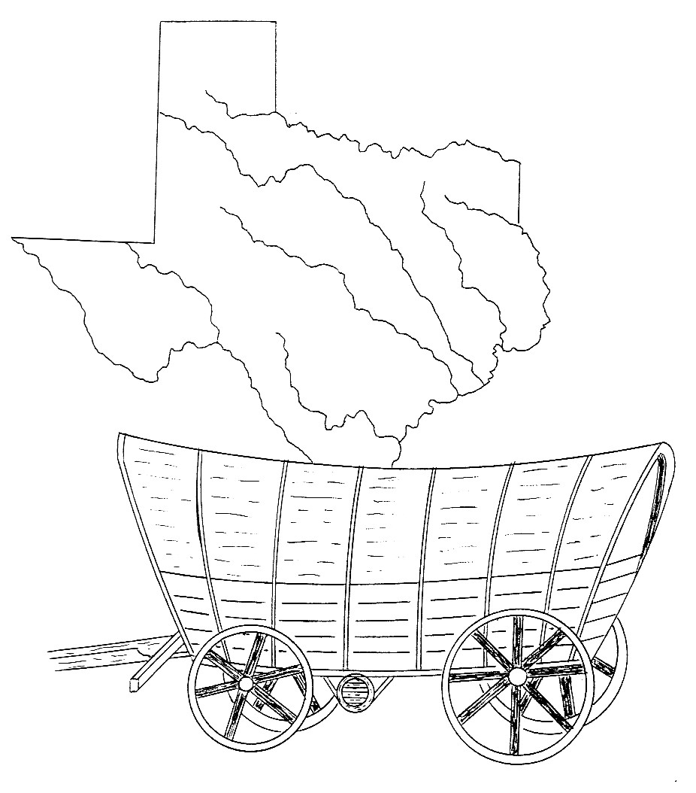

By Richard A. Prewitt

